Welcome & Announcements, Friendship Information, & Sharing Christ’s Peace

Prelude: “Love of the Father” Gibbons /arr. Paxton
Let us prepare our hearts and minds for worship.

Call to Worship
Leader: Come, people of God, for this is Children’s Sabbath.
People: Today we celebrate children, and we accept the challenge of lifting up God’s children everywhere.
Leader: Come, children of God, celebrate God’s grace.
People: We come as little children into the loving arms of Christ.

*Opening Hymn: “Jesus Loves Me” Blue Hymnal, #304

*Prayer of Confession (Unison) (from Children’s Defense Fund)
Creator God, You have made each of us in Your image, and yet we fail to reflect your love and justice. You have created every child in Your image, and yet we do not treat every child as a precious reflection of You. We see some children as valued treasures, and others as lost causes. We invest our time, money and hopes in some children, while we squander the great potential of others. Open our eyes, we pray to see that every child is made in Your image and belongs to You. Help us to love, protect and nurture all children. We pray these things in the name of the One who came to us as a child wrapped in swaddling clothes and lying in a manger. Amen.

*Silent Reflection

*Assurance of Pardon

*Gloria Patri (Glory Be to the Father…) Blue Hymnal, #579

Scripture “Matthew 18:1-5” (page 1526)
“Matthew 19:13-15” (page 1528)
“Hebrews 13:1-2” (page 1878)
Leader: The word of the Lord.
People: Thanks be to God.

Children's Time
Please join in singing one verse of Jesus Loves Me as the children come forward.

Special Music: “All Hail the Power of Jesus’ Name” Arr. by Hal Hopson

Sermon: “Welcome the Child” Rev. Kimby Young

* Profession of Faith –Statement Affirming Children See insert

*Hymn “Child of Blessing, Child of Promise” Blue Hymnal, #498

Pastoral Prayer & Lord’s Prayer: Please Pray for Jackie Lang, Lila Orr, Chuck Motter, Erma Knight, Leo Pickell, Corky Scarlett, Debi Crowell Crist, Jane McGuire, Hudson Inglehart, Glenn Schulz, Boston DeWald, Beth Ekdohl, Lanny John Turner, Larry Bartel, Byron McManus, Margaret Davidson, Ann Ferguson, Keith W. Smith, Roland Jack, Rob Kuhauz, Denny Harris, Richard Hatfield, Jackson Tijerina

Offertory: “Medley of Children's Hymns”

*Doxology Blue Hymnal, #592

Prayer of Dedication

*Closing Hymn: “Hymn of the Child” Insert

Benediction

Postlude: “Savior, Like a Shepherd Lead Us” Bradbury

*Those who are comfortably able will please stand

Kimby Young, Pastor; Sandy Rieger, Worship Assistant;
Robyn Forkner, Pianist; Alice Rollf, Organist; Chancel Choir;
Dean Faulk, Music Ministries; Heather Rutler, Worship Transcription

Ushers October 2017
Sandy Nellor; Joni Meyer; Brian & Denise Bockus; LeMoyne & Donnie Zimmerman

Bible Reading for Sunday, October 29 is Matthew 7:24-29; Ephesians 2:13-22

Sunday, October 22, Worship Pillar Meeting 11:15 AM
Monday, October 23, Deacons 6:30 PM
Wednesday, October 25, Bells 6:00 PM; Choir 7:00 PM; Cantata 8:00 PM
Sunday, October 29, Fall Gathering, Halloween Party 6:00 PM

Operation Christmas Child donation is for October: Socks, Underwear, T-Shirts, Shoes.

Deacons Food Drive Sunday, October 15 – November 12. Bring a non-perishable items.

Financial Report Close of September Income - $19,703.07 Expense - $22,312.54. A full report is available upon request from the treasurer or the Congregational Life Pillar.

Volunteering at the Joy Closet we are in desperate need of help anytime Thursdays and Saturdays. We could also use any groups such as prayer group, bible study group, youth group etc. Please let me know if you or anyone has any interested. Thank you, Ginger Crist

The choir is working on the Christmas Cantata ‘Comfort and Joy’. We would like to extend an invitation to anyone who would like to join us just for the Cantata. Rehearsals are held on Wednesday evenings from 8:00 - 9:00 p.m. after normal choir rehearsal.

Substitute Teachers are needed for our Sunday School classes occasionally, including November 5 & 12. To volunteer contact Nancy Falkner or Pastor Kimby.

Mark Hutton Installation at Ottawa Presbyterian Church – Today, October 22, 3 p.m. He was the guest pastor here on July 30. If you are interested in attending the installation service and carpooling, please let Pastor Kimby know.

Fall Gathering, Sunday, October 29 at 6:00 PM. Chili, Food, Fun and Fellowship. Costume
Contest for all ages! Games for the little ones. Please sign up needed for chili supper: chili, corn bread, fritos, saltines crackers, desserts, shredded cheese. Sign up if you plan to attend.

Ladies Night Thursday, November 2, 6:30 PM, soup supper, with soup being provided. Bring a side dish, (sandwiches, crackers, etc.) and or dessert. Harvesters will be there for a presentation. We ask for food donations of non-perishable food items.

Worship at Meadowbrook & Medicalodge – During November our church will be responsible for leading worship at 2 of Gardner facilities. Worship is each Sunday starting at 3:15 PM. The most important part of this service is visiting with the residents. Please volunteer to Pastor Kimby or anyone on the Mission Pillar if you would be willing to help lead.

Sunday, November 5 at 10:00 AM Congregational “Election” Meeting to elect Elders, Deacons and Nominating Committee 2018.

Sunday, October 22, 2017
9:00 AM

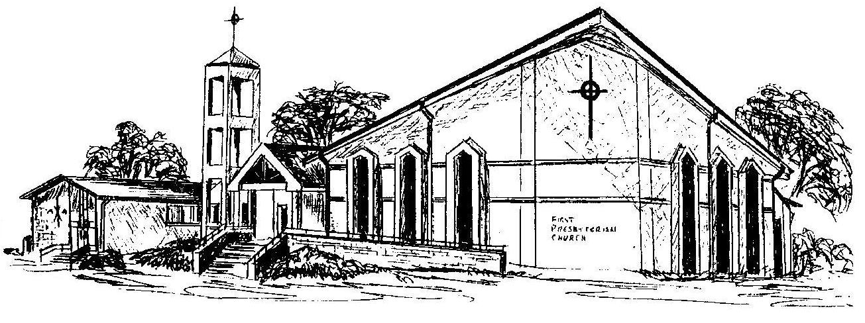

First Presbyterian Church
In the heart of Gardner since 1866 ~ Serving from the heart of God

Welcome - Thank you for joining us for worship today. Please fill out a visitor information card found in the pew racks and place those in the offering plate so that we may follow up with you in the future. Your presence with us today has been a blessing to us, we hope that you have felt the presence of God and the welcome of this congregation.

