Welcome & Announcements, Friendship Information, & Sharing Christ’s Peace
Prelude: “If Thou But Suffer God to Guide Thee” Neumark
Let us prepare our hearts and minds for worship.

Call to Worship (adapted from Psalm 24 and 25)
Leader: The earth is the Lord’s and all that is in it, the world and all who dwell therein.
People: For God has founded it upon the seas and established it on the waters.
Leader: To you O Lord, we lift our souls; in You, our God, we trust.
People: Show us your ways; teach us your paths; guide us in your truth; for you are our God and our hope is in You all day long.

*Opening Hymn: “All Creatures of Our God and King” Red Hymnal, #64

*Prayer of Confession (Unison)
God of endless patience, forgive us. We have complained. We have worried. We have tried to handle our own problems. We have been frightened into complacency. We have been lulled into inaction. We have neglected your call. We have not trusted you. Forgive us. Inspire us again to hear and to follow. Remind us again of your gifts to us and your promise for us. Help us to believe and to hope in you, by the grace of your merciful Son, Jesus. Amen.

*Silent Reflection

*Assurance of Pardon

*Gloria Patri (Glory Be to the Father…) Red Hymnal, #623

Scripture “Exodus 16:2-15” (page 112)
“Philippians 4:11-13” (page 1830)
Leader: The word of the Lord.
People: Thanks be to God.

Children's Time
Please join in singing one verse of Jesus Loves Me as the children come forward.

Special Music: “I Can Only Imagine” Bart Millard, Arr. by Mark Hayes

Sermon: “Yes…And” Rev. Kimby Young

*Profession of Faith The Apostle's Creed Red Hymnal, inside back cover
*Hymn “If You Will Only Let God Guide You” Red Hymnal, #600

Pastoral Prayer & Lord’s Prayer: Please Pray for Jackie Lang, Anastasia Zimmerman, Lila Orr, Vespersia Pennington, Chuck Motter, Marie Maddox,Bell and Bettge Families, Erma Knight, Mark Bowman, Nicole Clifton, Leo Pickell, Larry Hancock, Corky Scarlett, Debi Crowell Crist, Jane McGuire, Hudson Inglehart, John Freund, Glenn Schulz, Boston DeWald, Beth Ekdohl, Lanny John Turner, Larry Bartl, Byron McManus, Margaret Davidson, Ann Ferguson, Keith W. Smith, Roland Jack, Rob Kuhauz, Denny Harris, Richard Hatfield, Jackson Tijerina

Offertory: “He Cares for Me” Murray / Ellis
*Doxology Red Hymnal, #625

Prayer of Dedication

*Closing Hymn: “Be Still, My Soul” Red Hymnal, #347

Benediction

Postlude: “God is Our Refuge” Price
*Those who are comfortably able will please stand

Kimby Young, Pastor; Brenda Jones, Worship Assistant; Robyn Forkner, Pianist
Chancel Choir, Special Music; Alice Rollf, Organist
Heather Rutler, Worship Transcription; Dean Faulk, Music Ministries

Ushers September 2017
Debbie Pickell; Kim & Karen Liu; Ron & Connie Crabbs; Wayne Rollf

Bible Reading for Sunday, October 1 is Matthew 14: 13-21; 15:32-39

Sunday, September 24, Worship Pillar 11:45 AM
Monday, September 25, Deacons 6:30 PM
Monday, September 25, Stewardship Planning Meeting 8:00 PM
Wednesday, September 27, Bells 6:00 PM; Nominating Committee & Chancel Choir 7:00 PM
Thursday, September 28, Women’s Bible Study 7:00 PM

The Mission Pillar is having a Fair Trade Sale today with coffee, tea, chocolate, and other items. Fair Trade products create trading partnerships that are based on respect and seek greater equity.

Rev. Kimby will teach Presbyterians 101 at 10:15 AM on Sun, mornings. This is an overview comparing PC USA to other denominations. The class will cover history, core beliefs, polity, changes thru the years and possible future directions, as well as any questions you bring.

Seekers & Servants Sunday School Class is starting a new study “Just Like Jesus” by Max Lucado. The class meets in the Library at 10:15 AM.

Operation Christmas Child donation is for October: Socks, Underwear, T-Shirts, Shoes

Financial Report Close of August Income - $16,440.08, Expense - $17,905.13. Again this month our receipts were lower than expenses, please consider additional giving to help us balance our budget. A full report is available upon request from the treasurer or the Congregational Life Pillar.

Volunteering at the Joy Closet we are in desperate need of help anytime Thursdays and Saturdays. We could also use any groups such as prayer group, bible study group, youth group etc. Please let me know if you or anyone has any interested. Thank you, Ginger Crist

Church Family Day at Worlds of Fun! On Sun., Oct. 1, you are invited to join us at Worlds of Fun. We will leave church at noon and return at 7 pm.

Women’s Fellowship Group will meet Wednesday October 4th, 2017 at 10:00 AM. Peggy Beach will provide both devotions and refreshments. The meeting is open to all women of our congregation. We will meet in Fellowship Hall. Pat Rankin has completed 9 additional bags for Safe home. They have been delivered along with 2 additional boxes to Safe home.

Blessing of the Animals, Saturday, October 7, 4 PM. We will meet on the lawn (or in fellowship hall if weather requires a move.) Creatures of all kinds are welcome. Pictures may be brought for larger animals. Please bring animals on leashes, or in cages. This celebration is open to the community.

Wednesday October 11th the choir will begin working on the Christmas Cantata ‘Comfort and Joy’. We would like to extend an invitation to anyone who would like to join us just for the Cantata. Rehearsals will be held on Wednesday evenings from 8:00 to 9:00 p.m. after normal choir rehearsal.

Substitute Teachers are needed for our Sunday School classes occasionally, including October 15. To volunteer contact Nancy Falkner or Pastor Kimby.

Fall Gathering, Sunday, October 29 at 6:00 PM. Chili, Food, Fun and Fellowship. Costume
Contest for all ages! Games for the little ones. Please sign up needed for chili supper: chili, corn bread, fritos, saltines crackers, desserts, shredded cheese. Sign up if you plan to attend.

Sunday, September 24, 2017
9:00 AM

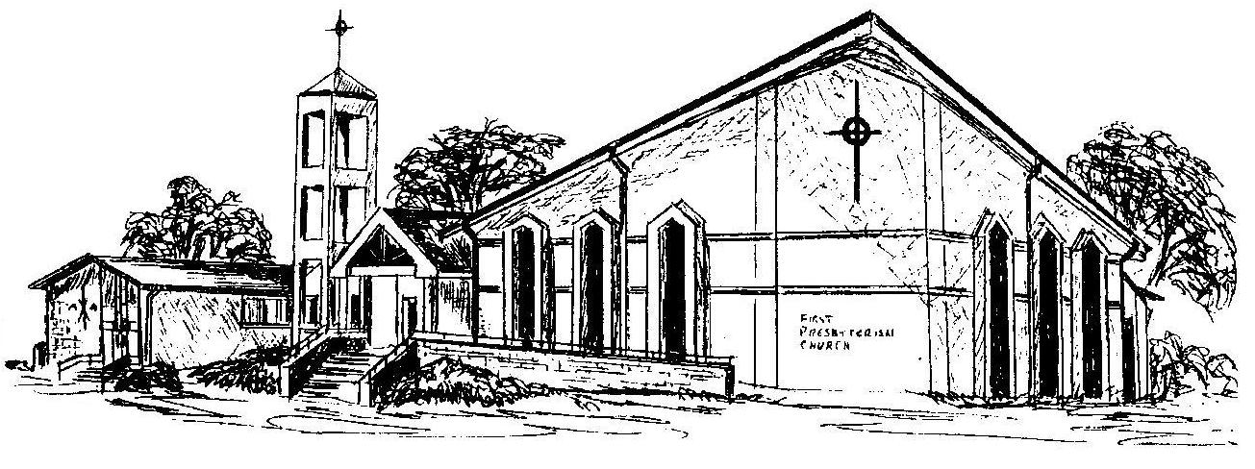

First Presbyterian Church
In the heart of Gardner since 1866 ~ Serving from the heart of God

Welcome - Thank you for joining us for worship today. Please fill out a visitor information card found in the pew racks and place those in the offering plate so that we may follow up with you in the future. Your presence with us today has been a blessing to us, we hope that you have felt the presence of God and the welcome of this congregation.

