Welcome & Announcements, Friendship Information, & Sharing Christ’s Peace
Prelude: “Little Prelude in G Minor” J.S. Bach / arr. Porter
Let us prepare our hearts and minds for worship.

Call to Worship
Leader: Come, praise the God who spoke of old to patriarchs, prophets and apostles.
People: Come, praise the God who has spoken through our mothers and fathers in faith, from generation to generation.
Leader: Come, praise the God who speaks to each of us and through each of us today.
People: We come to worship this great and glorious God of grace.

*Opening Hymn: “Holy, Holy, Holy” Red Hymnal, #262

*Prayer of Confession (Unison)
God of Grace, at every age and every stage of life, we know your presence and your love. And yet, God of Mercy, along each step of the journey of life, temptation follows us and pulls us away from your calling. So often we don’t value even what is right before us. Forgive us. Inspire us to receive and to recognize your gifts all around us. Help us to appreciate one another. Empower us to share your good news and to be generous with your gifts. In Jesus name we pray. Amen.

*Silent Reflection

*Assurance of Pardon
Leader: Every generation shall hear the good news of God’s gracious love.
People: Every generation has received the gift of God’s mercy and redemption.
Leader: Hear and receive the good news of God’s forgiveness.
People: In Jesus Christ we know God’s gift of new life.

*Gloria Patri (Glory Be to the Father…) Red Hymnal, #623

Scripture Psalm 78:1-7 (page 914)
2 Timothy 1:1-10 (page 1852)
Leader: The word of the Lord.
People: Thanks be to God.

Children's Time
Please join in singing one verse of Jesus Loves Me as the children come forward.

Special Music: “Gospelfest” Arranged by Philip Kern
Sermon: “Generation to Generation” Rev. Kimby Young

*Profession of Faith The Apostle's Creed Red Hymnal, inside back cover

*Hymn “O God Our Help in Ages Past” Red Hymnal, #52

Recognition of Senior Adults & First Presbyterian Church Members 50 years or longer

Pastoral Prayer & Lord’s Prayer: Please Pray for Vespersia Pennington, Chuck Motter, Marie Maddox, Bell and Bettge Families, Erma Knight, Mark Bowman, Nicole Clifton, Leo Pickell, Larry Hancock, Corky Scarlett, Debi Crowell Crist, Jane McGuire, Hudson Inglehart, John Freund, Glenn Schulz, Boston DeWald, Beth Ekdohl, Lanny John Turner, Larry Bartl, Byron McManus, Margaret Davidson, Ann Ferguson, Keith W. Smith, Roland Jack, Rob Kuhauz, Denny Harris, Richard Hatfield, Jackson Tijerina

Offertory: “I Would Be True” Hughes
*Doxology Red Hymnal, #625

Prayer of Dedication

*Closing Hymn: “Faith of Our Fathers” Red Hymnal, #279

Benediction

Postlude: “Strong in the Faith” Johnston
*Those who are comfortably able will please stand

Kimby Young, Pastor; Robyn Forkner, Worship Assistant & Pianist; Chancel Choir
Alice Rollf, Organist; Dean Faulk, Music Ministries; Heather Rutler, Worship Transcription

Ushers September 2017
Debbie Pickell; Kim & Karen Liu; Ron & Connie Crabbs; Wayne Rollf

The flowers are given today to the Glory of God in honor of our members and friends 65+

Bible Reading for Sunday, September 24 is Exodus 16: 2-15; 1Corinthians 12: 4-13

Substitute Teachers are needed for our Sunday School classes occasionally, including September 24 (next Sunday). To volunteer contact Nancy Falkner or Pastor Kimby.
Monday, September 18, PW Business Meeting 7:00 PM
Tuesday, September 19, Presbytery Heartland Center 8:00 AM
Wednesday, September 20, Bells 6:00 PM; Choir 7:00 PM
Thursday, September 21, Women’s Bible Study 7:00 PM

Loose Offering collected $227.84 for Hally Yust Team for Bibles through Mission Pillar.

65+ Seniors dedication today Sun., Sept. 17, at the 9:00 AM Worship Service, having cake, cookies, water and coffee in Fellowship Hall after the service.

Presbyterians 101starts today at 10:15 AM with Pastor Kimby. This will be a 10 week overview comparing PC USA to other denominations. The class will cover history, core beliefs, polity, changes thru the years and possible future directions, as well as any questions you bring.

Seekers & Servants Sunday School Class we will have a new study “Just Like Jesus” by Max Lucado. They will start in late Sept. the class meets in the Library at 10:15 AM.

Church Family Day at Worlds of Fun! On Sun., Oct. 1, you are invited to join us at Worlds of Fun. We will leave church at noon and return at 7 pm. Cost is $35. Friends and family are welcome. Please RSVP with payment of $36 per person by today September 17. Contact Connie at church 913-856-4099 or connie@fpcgardner.org.
The Mission Pillar is having a Fair Trade Sale on Sunday, September 24. They will have a table set up with coffee, tea, chocolate before and after church. Fair Trade products create trading partnerships that are based on respect and seek greater equity.

Sunday School items needed White cardstock; Bright colored foam sheets (1 pkg 1/2 sheets, 1pkg full sheets); magnetic buttons (52pack); Washable paint

Volunteering at the Joy Closet we are in desperate need of help anytime Thursdays and Saturdays. We could also use any groups such as prayer group, bible study group, youth group etc., could come 1 Saturday a month or every other month anything would be great. Please let me know if you or anyone has any interested. Thank you, Ginger Crist; Joy Closet Manager
Disciple Groups have started. It is not too late to join a group. Contact Pastor Kimby immediately if you are interested. We have four groups who will meet monthly for 90 minutes beginning in October. Two groups are looking for more members. They meet on the
1st Monday 10 a.m. and the 1st Tuesday 6:30 p.m.

Financial Report Close of August Income - $16,440.08, Expense - $17,905.13. Again this month our receipts were lower than expenses, please consider additional giving to help us balance our budget. A full report is available upon request from the treasurer or the Congregational Life Pillar.

Sunday, September 17, 2017
Super Senior Sunday
9:00 AM

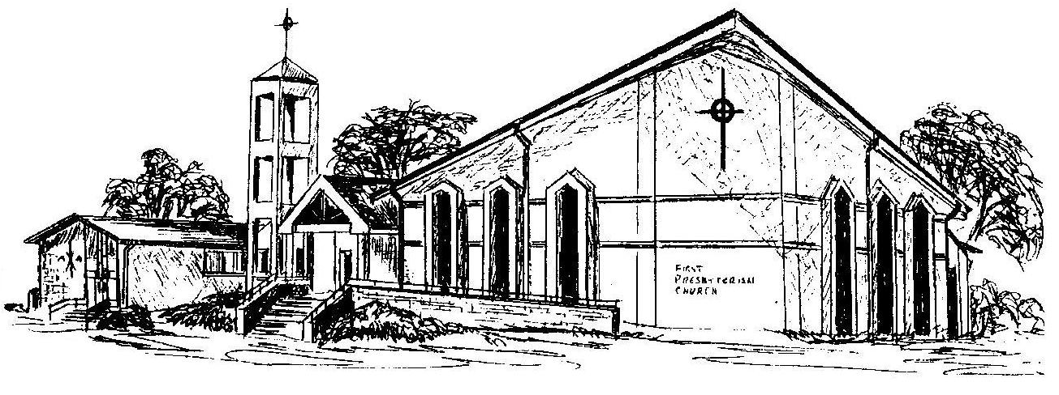

First Presbyterian Church
In the heart of Gardner since 1866 ~ Serving from the heart of God

Welcome - Thank you for joining us for worship today. Please fill out a visitor information card found in the pew racks and place those in the offering plate so that we may follow up with you in the future. Your presence with us today has been a blessing to us, we hope that you have felt the presence of God and the welcome of this congregation.

