Welcome & Announcements, Friendship Information, & Sharing Christ’s Peace
Prelude: “Jesus, Name Above All Names” Hearn
“There's Something About That Name” Gaither
Let us prepare our hearts and minds for worship.

Call to Worship
Leader: God of wonder, we celebrate you.
People: God of love, we come together as a community of faith.
Leader: God of wisdom, we feel your presence.
People: God of truth and knowledge, help us to grow in faith as we worship you.

*Opening Hymn: “Be Thou My Vision” Blue Hymnal, #339

*Prayer of Confession (Unison)
(adapted from Nancy McSpadden of Cumberland Presbyterian Church, Ministry Council)
God of wonder, love and wisdom. The world around us is a confusing and chaotic place. Our time is claimed by the everyday hustle that distracts our focus. The noise and the constant activity often keep us from hearing you call us to follow you, to learn about you, to live in your ways. As your church, we offer our hurts and wounds, our short-comings and fears, to you. As people of faith we ask for wisdom to learn and grow. Open our hearts and minds to your redeeming love. Forgive us and remake us anew. We believe in your promises. Hear our prayers. Amen.

*Silent Reflection

*Assurance of Pardon

*Gloria Patri (Glory Be to the Father…) Blue Hymnal, #579

Scripture “Psalm 1:1-3” (page 843)
“Proverbs 3:5-6” (page 987)
“Ephesians 3:14-21” (page 1820)
Leader: The word of the Lord.
People: Thanks be to God.

Children's Time – Noisy Offering
Please join in singing one verse of Jesus Loves Me as the children come forward.

Special Music: “He Never Failed Me Yet”

Sermon: “Deep and Wide” Rev. Kimby Young

*Profession of Faith The Apostle's Creed Blue Hymnal, top page 14

*Hymn “There’s A Wideness in God’s Mercy” Blue Hymnal, #298

Teacher’s Recognition

Pastoral Prayer & Lord’s Prayer: Please Pray for Chuck Motter, Marie Maddox, Bell and Bettge Families, Sandlin Family, Erma Knight, Mark Bowman, Nicole Clifton, Leo Pickell, Larry Hancock, Corky Scarlett, Debi Crowell Crist, Jane McGuire, Hudson Inglehart, John Freund, Glenn Schulz, Boston DeWald, Beth Ekdohl, Lanny John Turner, Larry Bartl, Byron McManus, Margaret Davidson, Ann Ferguson, Keith W. Smith, Roland Jack, Rob Kuhauz, Denny Harris, Richard Hatfield, Jackson Tijerina

Offertory: “My Faith Has Found a Resting Place” Norwegian Melody
*Doxology Blue Hymnal, #592

Prayer of Dedication

*Closing Hymn: “Take Thou Our Minds, Dear Lord” Blue Hymnal, #392

Benediction

Postlude: “We Walk by Faith and Not by Sight” McFarland
*Those who are comfortably able will please stand

Kimby Young, Pastor; EPIC, Worship Assistant; Robyn Forkner, Pianist
Chancel Choir; Alice Rollf, Organist
Heather Rutler, Worship Transcription; Dean Faulk, Music Ministries

Ushers September 2017
Debbie Pickell; Kim & Karen Liu; Ron & Connie Crabbs; Wayne Rollf

Monday, September 11, Session 6:30 PM
Tuesday, September 12, Men’s Breakfast Smokey’s Wellsville 7:00 AM
Wednesday, September 13, Bells 6:00 PM; Choir 7:00 PM; Nominating Committee 6:30 PM
Thursday, September 14, Women’s Bible Study 7:00 PM
Sunday, September 17, Sr Dedication Worship Service 9:00 AM

New Disciple Groups Kick off for all groups will be a potluck tonight on Sun., Sept. 10 at 6 pm in fellowship hall. You may still sign up for a group by contacting Pastor Kimby.

Men's breakfast will be at Smokey's BBQ Restaurant in Wellsville at 7:00 A.M. on Tues, Sept. 12. Dr. Tina, the speaker is a veterinarian discussing horse health and care. Hope you can make it.

Women’s Bible Study starts on Sept., 14 at 7:00 PM. Bible Study “More Than Enough”.

65+ Seniors dedication on Sun., Sept. 17, at the 9:00 AM Worship Service, having cake, cookies, water and coffee in Fellowship Hall after the service.

Rev. Kimby will teach Presbyterians 101 at 10:15 AM on Sun, mornings. This will be a 10 week overview comparing PC USA to other denominations. The class will cover history, core beliefs, polity, changes thru the years and possible future directions, as well as any questions you bring.

Divine Mercy Catholic Church has invited the ladies of the churches of the community. A luncheon on Sat., Sept. 23, at 11:30 – 1:30 PM. They will be furnishing all the dishes so just plan to attend and enjoy fellowship from other churches. Please, RSVP by Friday, Sept. 15 to Judy Hadle: 913-220-1343; Barbara Keiter: 913-237-4962.

Seekers & Servants Sunday School Class we will have a new study “Just Like Jesus” by Max Lucado. They will start in late Sept. the class meets in the Library at 10:15 AM.

Church Family Day at Worlds of Fun! On Sun., Oct. 1, which is Worldwide Communion Sunday, you are invited to join us for a worldwide adventure at Worlds of Fun. We will leave church at noon and return at 7 pm. Cost is $36. Friends and family are welcome. Please RSVP with payment of $36 per person by September 17. Contact Connie at church 913-856-4099 or connie@fpcgardner.org.
The Mission Pillar is having a Fair Trade Sale on Sunday, September 24. They will have a table set up with coffee, tea, chocolate before and after church. Fair Trade products create trading partnerships that are based on respect and seek greater equity.

Sunday, September 10, 2017
9:00 AM

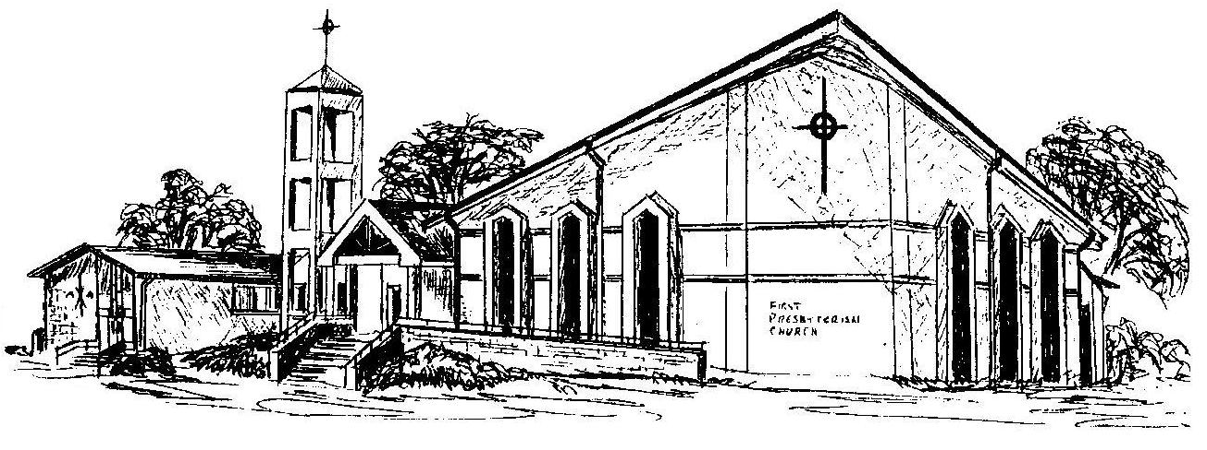

First Presbyterian Church
In the heart of Gardner since 1866 ~ Serving from the heart of God

Welcome - Thank you for joining us for worship today. Please fill out a visitor information card found in the pew racks and place those in the offering plate so that we may follow up with you in the future. Your presence with us today has been a blessing to us, we hope that you have felt the presence of God and the welcome of this congregation.

