Welcome & Announcements, Friendship Information, & Sharing Christ’s Peace
Prelude: “Come Unto Me” Overholt
Let us prepare our hearts and minds for worship.

Call to Worship
Leader: Come, all who hunger and thirst. Come all who labor and are weary. Come at God’s invitation. Come, eat and drink, and live!
People: Come, for everyone is welcome – even those whom others turn away.
Leader: Come, there is room enough for all of us.
People: Come! Worship! Celebrate! Welcome others!

*Opening Hymn: “Earth and All Stars” Blue Hymnal, #458

*Prayer of Confession (Unison)
Waterfall God, Fount of Living Water, God of bright sparkling Spirit, Creator of All. We confess that Your Word sometimes seems to have dried up in our hearts. We let ourselves become spiritually thirsty. We confess that love and hope do not pour out from us into the lives of friends and strangers. Open the floodgates of your Spirit – wash out our lives with your streams of healing. Quench our thirst that we may nurture others. Revive us again in the name of Jesus Christ. Amen.

*Silent Reflection

*Assurance of Pardon
Leader: The river of life flows from God through Jesus Christ to all who would receive God’s blessing.
People: We have received grace upon grace, life in abundance.
Leader: God’s grace is given freely and fully to all, that we may start anew in Jesus Christ.
People: May God’s love flow through us to all who are in need.

*Gloria Patri (Glory Be to the Father…) Blue Hymnal, #579

Scripture “Isaiah 55:1-2” (page 1148)
“John 4:5-30” (page 1651)
Leader: The word of the Lord.
People: Thanks be to God.

Children's Time
Please join in singing one verse of Jesus Loves Me as the children come forward.

Sermon “Room at the Table” Rev. Kimby Young

*Profession of Faith “The Apostle's Creed” Blue Hymnal, top page 14

*Hymn “We Come As Guests Invited” Blue Hymnal, #517

Offertory: “Just As I Am” Bradbury / Rasley

*Doxology Blue Hymnal, #592

*Prayer of Dedication & Pastoral Prayer Please Pray for Bell and Bettge Families, Sandlin Family, Erma Knight, Mark Bowman, Nicole Clifton, Leo Pickell, Larry Hancock, Corky Scarlett, Debi Crowell Crist, Jane McGuire, Hudson Inglehart, John Freund, Glenn Schulz, Boston DeWald, Beth Ekdohl, Lanny John Turner, Larry Bartl, Byron McManus, Margaret Davidson, Ann Ferguson, Keith W. Smith, Roland Jack, Rob Kuhauz, Denny Harris, Richard Hatfield, Jackson Tijerina

Communion & Celebration of the Lord’s Supper
Invitation
Great Thanksgiving
The Lord’s Prayer
Breaking of Bread
Communion of the People
Prayer of Thanksgiving

*Closing Hymn: “In Christ There Is No East or West” Blue Hymnal, #439

*Benediction

Postlude: “Grace to You” Blankenship
*Those who are comfortably able will please stand

Sunday, September 3, Communion Worship Service 9:00 AM
Monday, September 4, Office Closed Labor Day
Monday, September 4, Congregational Life Meeting 7:00 PM
Wednesday, September 6, Women’s Group 10:00 AM; Music Ministry 6:00 PM
Sunday, September 10, Worship Service 9:00 AM Noisy Offering; Rally Day 10:15 AM
Sunday, September 10, Mission Pillar Meeting 11:15 AM
Sunday, September 10, Kick off for all groups will be a potluck 6:00 PM

Women’s Fellowship Group will meet Wed., Sept. 6, at 10:00 AM. Donalie Zimmerman will have the devotions, Sharon Frahme will provide refreshments. Our project this month will be organizing the storage cabinet in fellowship hall. The meeting is open to all women of our congregation.

Music Ministry we are going to kick off the season on Wed., Sept. 6 at 6:00 p.m. in the Fellowship Hall with a potluck dinner. Meat will be provided. Please bring your favorite side dish to share. A brief meeting and a short rehearsal will follow. I will enjoy seeing everyone again and hopefully will see some new faces. If you love to sing and want to find out what is going to be transpiring over the next several months please come and join us. We would love to have you.
Blessings To All, Dean Faulk

RALLY DAY is September 10 when Sunday School classes for the year will begin.

New Disciple Groups Kick off for all groups will be a potluck on Sun., Sept. 10 at 6 pm in fellowship hall. You may still sign up for a group by contacting Pastor Kimby.

Men's breakfast will be at Smokey's BBQ Restaurant in Wellsville at 7:00 A.M. on Tues, Sept. 12. Dr. Tina, the speaker is a veterinarian discussing horse health and care. Hope you can make it.

Nominating Committee meeting on Wednesday, Sept. 13, at 6:30 PM.

Women’s Bible Study starts on Sept., 14 at 7:00 PM. Bible Study “More Than Enough”.

65+ Seniors dedication on Sun., Sept. 17, at the 9:00 AM Worship Service, having cake, cookies, water and coffee in Fellowship Hall after the service.

Rev. Kimby will teach Presbyterians 101 at 10:15 AM on Sun, mornings. This will be a 10 week overview comparing PC USA to other denominations. The class will cover history, core beliefs, polity, changes thru the years and possible future directions, as well as any questions you bring.

Fair Trade Sales will sell coffee, tea and chocolate on Sun., Sept. 24 before and after worship.

Divine Mercy Catholic Church has invited the ladies of the churches of the community. A luncheon on Sat., Sept. 23, at 11:30 – 1:30 PM. They will be furnishing all the dishes so just plan to attend and enjoy fellowship from other churches. Please, RSVP by Friday, Sept. 15 to Judy Hadle: 913-220-1343; Barbara Keiter: 913-237-4962.

Seekers & Servants Sunday School Class we will have a new study “Just Like Jesus” by Max Lucado. They will start in late Sept. the class meets in the Library at 10:15 AM.

Church Family Day at Worlds of Fun! On Sun., Oct. 1, which is Worldwide Communion Sunday, you are invited to join us for a worldwide adventure at Worlds of Fun. We will leave church at noon and return at 7 pm. Cost is $36. Friends and family are welcome. Please RSVP with payment of $36 per person by September 17. Contact Connie at church 913-856-4099 or connie@fpcgardner.org.

Sunday
September 3, 2017
9:00 AM
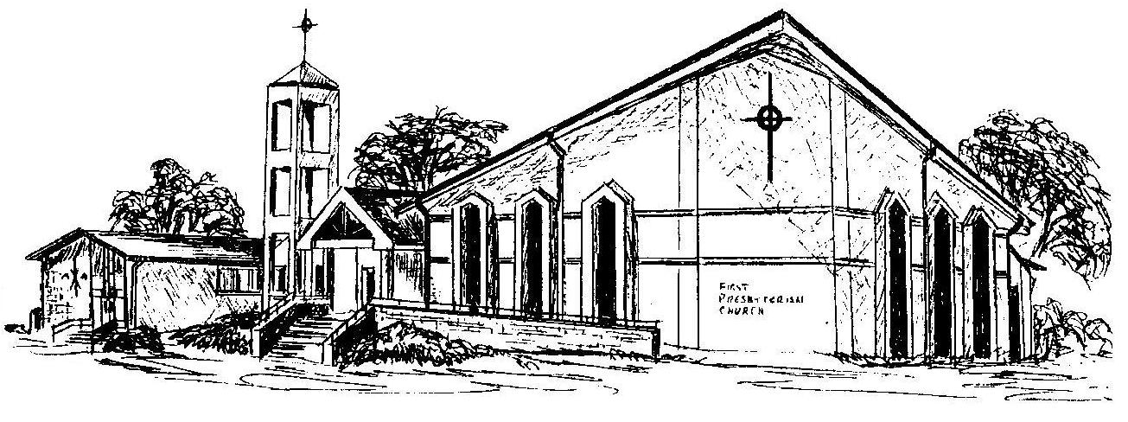

First Presbyterian Church
In the heart of Gardner since 1866 ~ Serving from the heart of God

Welcome - Thank you for joining us for worship today. Please fill out a visitor information card found in the pew racks and place those in the offering plate so that we may follow up with you in the future. Your presence with us today has been a blessing to us, we hope that you have felt the presence of God and the welcome of this congregation.

Kimby Young, Pastor; Rhonda Atwater, Worship Assistant;
Robyn Forkner, Pianist; Alice Rollf, Organist
Heather Rutler, Worship Transcription; Dean Faulk, Music Ministries

Ushers September 2017
Debbie Pickell; Kim & Karen Liu; Ron & Connie Crabbs; Wayne Rollf

Bible Reading for September 10 – Psalm 1:1-3 Ephesians 3:14-21

