Welcome & Announcements, Friendship Information, & Sharing Christ’s Peace
Prelude: “Medley--Praise the Lord” R. Gay and J. Ellor
Let us prepare our hearts and minds for worship.

Call to Worship
Leader: Jesus said, “I am the vine, you are the branches.”
People: We are connected to God and connected to one another.
Leader: We love because God first loved us.
People: Let us love one another.
Leader: Let us share God’s love in the world.
People: Let us love our God as we worship and serve together.

*Opening Hymn: “God You Spin the Whirling Planets” Blue Hymnal, # 285

*Prayer of Confession (Unison)
God of Unity and Community, you remind us again of our need for you. You affirm again for us our need for one another. Yet, so often we fail to connect. We fail to offer our true selves. We fail to recognize the nature of others around us. Open our eyes and our hearts to your grace all around us. Inspire us to see and to know those whom we encounter. Empower us to share your love, and thereby to share ourselves, in the name of Jesus Christ our Savior. Amen.

*Silent Reflection

*Assurance of Pardon (from 2 Corinthians 5)
Leader: Remember, if anyone is in Christ, that person is part of the new creation. The old things have gone away, behold, the new has come!
People: God reconciled us through Christ and gave us this ministry of reconciliation.
Leader: We are forgiven by God and recreated each new day. We are called by God to do this for others.
People: Thanks to God who gives us the power to forgive and to offer life to others in Jesus’ name.

*Gloria Patri (Glory Be to the Father…) Blue Hymnal, #579

Scripture “John15:1-17” (page 1676)
“2 Corinthians 5:16-21” (page 1799)
Leader: The word of the Lord.
People: Thanks be to God.

Children's Time
Please join in singing one verse of Jesus Loves Me as the children come forward.

Special Music: “Your Grace Still Amazes Me” by Phillips, Craig & Dean

Sermon: “Faith Connections” Rev. Kimby Young

*Profession of Faith The Apostle's Creed Blue Hymnal, top page 14

*Hymn “Amazing Grace” Blue Hymnal, #280

Pastoral Prayer & Lord’s Prayer: Please Pray for Erma Knight, Mark Bowman, Nicole Clifton, Leo Pickell, Larry Hancock, Corky Scarlett, Debi Crowell Crist, Lucy, Karen Elliott, Jane McGuire, Hudson Inglehart, John Freund, Stan Knoche, Glenn Schulz, Boston DeWald, Beth Ekdohl, Lanny John Turner, Larry Bartl, Byron McManus, Margaret Davidson, Ann Ferguson, Keith W. Smith, Roland Jack, Rob Kuhauz, Denny Harris, Richard Hatfield, Jackson Tijerina

Offertory: “Greater Love” Barbour
*Doxology Blue Hymnal, #592

Prayer of Dedication

*Closing Hymn: “Blest Be the Tie that Binds” Blue Hymnal, #438

Benediction

Postlude: “Bind Us Together” B. Gillman
*Those who are comfortably able will please stand

Kimby Young, Pastor; Larry Schick, Worship Assistant; Robyn Forkner, Pianist
Chesley Jones, Special Music; Alice Rollf, Organist
Heather Rutler, Worship Transcription; Dean Faulk, Music Ministries

Ushers for August 2017
Tracy & Colby McCabe; Harvey Seim; Carl Frahme; John Kunkel; Tom Corwin

Sunday, August 27: Worship Pillar 11:15 AM
Monday, August 28: Deacons 6:30 PM
New Disciple Groups - Sign up today using the Discipleship Survey or talk to Pastor Kimby for more information. Groups will meet once a month for 9 months at a time convenient for group members. (Sundays, weekdays, daytime or evening). Kick off for all groups will be a potluck on Sunday, September 10 at 6 pm in fellowship hall. If you have to miss that day you can still be in a group.

New Women's Fall Bible Study “More Than Enough” How Jesus Meets Our Deepest Needs It is a six week study beginning, September 14, 2017 through October 19, 2017. It begins at 7:00 p.m. in the Calvin Room. The cost of the book is $7.50. Sign up and order a book beginning August 27, 2017- September 10, 2017 in the narthex.

Discipleship Survey – Discipleship Pillar is seeking input as they plan for fall programming.
Please complete the survey and return it to the church office, by today, August 27.

Financial Report - The monthly income and expenses of the congregation are printed in the newsletter for the previous month. Newsletters are available in the narthex. A full report is available upon request from the treasurer or the Congregational Life Pillar.

Bible Reading for Sunday, September 3 Isaiah 55:1-13; John 4:5-30

Worship Assistants - Join us today Sunday, August 27, 2017 immediately following worship in the chapel. We encourage those that are currently serving as worship assistants to attend this meeting. Those of you who have not served as worship assistants but would be willing to serve in this capacity are encouraged to attend also. Everyone is welcome!

Music Ministry Kick Off Potluck, September 6 at 6, Time for new members to join!
Chancel Choir and Bell Choir members are invited to gather on September 6 at 6 pm in Fellowship Hall for a potluck dinner and brief meeting. A short vocal rehearsal will follow. Friends and guests interested in joining our music ministry are invited to join us for food and fellowship. Meat will be provided. Please bring a salad, side or dessert to share. Contact Dean Faulk or Robyn Forkner with questions.

Discipleship has a wish list for our classrooms this year.
-Colorful construction paper
-White cardstock
-Bright colored foam sheets (1 pkg 1/2 sheets, 1pkg full sheets)
-Colorful pipe cleaners (2 pkgs)
-magnetic buttons (52pack)
- Colorful dry erase markers
- DVD player
- Extension cord with electrical strip.

Sunday, August 27, 2017
9:00 AM

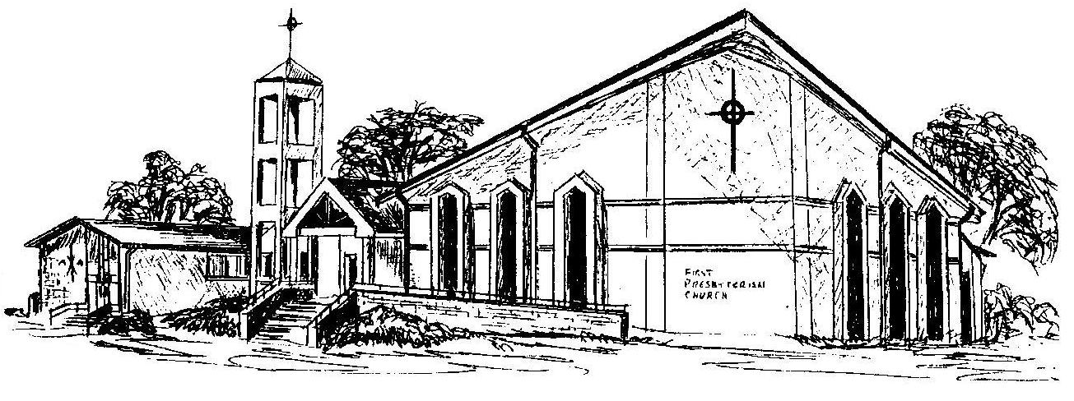

First Presbyterian Church
In the heart of Gardner since 1866 ~ Serving from the heart of God

Welcome - Thank you for joining us for worship today. Please fill out a visitor information card found in the pew racks and place those in the offering plate so that we may follow up with you in the future. Your presence with us today has been a blessing to us, we hope that you have felt the presence of God and the welcome of this congregation.

