Welcome & Announcements, Friendship Information, & Sharing Christ’s Peace
Prelude: “God, the Almighty” G. Davidson
Let us prepare our hearts and minds for worship.

Call to Worship
Leader: Fan into flame the gift of God that is in you.
People: The Spirit God gave us, gives us power and love and purpose.
Leader: God has called us to share the good news of God’s grace through Jesus Christ.
People: By the power of God’s Spirit, we will live God’s love with compassion and joy.

*Opening Hymn: “Praise to the Lord, the Almighty” Red Hymnal, #8

*Prayer of Confession (Unison)
God of Grace, we hear Your call to share Your good news of love and power. But then we get distracted and forget to open ourselves to others to offer Your Word. We doubt our own abilities to offer anything of worth, forgetting that You are the One who gives in abundance. We fear failure or rejection, so we hold back when we should let go. Inspire us again to reach out in Your name. Empower us to give as freely as You have given, to live as fully as You have created us to live, to love as extravagantly as You love us, in the name of Jesus Christ. Amen.

*Silent Reflection

*Assurance of Pardon

*Gloria Patri (Glory Be to the Father…) Red Hymnal, #623

Scripture “Deuteronomy 6:4-9” (page 284)
“2 Timothy 1:3-14” (page 1852)
“2 Timothy 3:14-17” (page 1855)
Leader: The word of the Lord.
People: Thanks be to God.

Children's Time
Please join in singing one verse of Jesus Loves Me as the children come forward.

Special Music: "This Is The Stuff" by Francesca Battestelli

Sermon: “Make a Difference” Rev. Kimby Young

*Profession of Faith The Apostle's Creed Red Hymnal, inside back cover

*Hymn “Pass It On” Red Hymnal, #309

Pastoral Prayer & Lord’s Prayer: Please Pray for Mark Bowman, Nicole Clifton, Leo Pickell, Larry Hancock, Corky Scarlett, Debi Crowell Crist, Lucy, Karen Elliott, Jane McGuire, Hudson Inglehart, John Freund, Stan Knoche, Glenn Schulz, Boston DeWald, Beth Ekdohl, Lanny John Turner, Larry Bartl, Byron McManus, Margaret Davidson, Ann Ferguson, Keith W. Smith, Roland Jack, Rob Kuhauz, Denny Harris, Richard Hatfield, Jackson Tijerina

Offertory: “I Will Walk Before the Lord” L. Groom
*Doxology Red Hymnal, #625

Prayer of Dedication

*Closing Hymn: “I Love to Tell the Story” Red Hymnal, #297

Benediction

Postlude: “Song for the Nations” C. Christensen
*Those who are comfortably able will please stand

Kimby Young, Pastor; Eric Gourley, Worship Assistant; Robyn Forkner, Pianist
Sydney Wetherington, Special Music; Kelli Baker, accompanist; Alice Rollf, Organist
Heather Rutler, Worship Transcription; Dean Faulk, Music Ministries

Ushers for August 2017
Tracy & Colby McCabe; Harvey Seim; Carl Frahme; John Kunkel; Tom Corwin

Monday, August 21: PW Meeting 7:00 PM
Wednesday, August 23: Prayer Circle 12:00 PM
Wednesday, August 23: Nominating Committee 6:30 PM
Sunday, August 27: Worship Pillar 11:15 AM

Scripture for Sunday, August 27: John 15:1-17; 2 Corinthians 5: 16-21

Our thanks for all the cards and greetings in recognition of our 60th anniversary. We feel greatly blessed by a wonderful church family.
Donnie & LeMoyne Zimmerman
Operation Christmas Child Monthly collections for August are composition notebooks, crayons, pencils/sharpeners, school scissors they have a basket under the table in front of the office.

New Women's Fall Bible Study “More Than Enough” How Jesus Meets Our Deepest Needs It is a six week study beginning, September 14, 2017 through October 19, 2017. It begins at 7:00 p.m. in the Calvin Room. The cost of the book is $7.50. Sign up and order a book beginning August 27, 2017- September 10, 2017 in the narthex.

Discipleship Survey Today we are distributing a one page survey. This is a general questionnaire about classes, groups, and studies you might be interested in. The Discipleship Pillar is seeking input as they plan for fall programming. Please complete the survey and return it to the church office, by Sunday, August 27.

Worship Assistants Changes are coming! Join us on Sunday, August 27, 2017 immediately following worship in the chapel. We encourage those that are currently serving as worship assistants to attend this meeting. Those of you who have not served as worship assistants but would be willing to serve in this capacity are encouraged to attend also. Everyone is welcome!

Financial Report The monthly income and expenses of the congregation are printed in the newsletter for the previous month. Newsletters are available in the narthex. A full report is available upon request from the treasurer or the Congregational Life Pillar.

Music Ministry Kick Off Potluck, September 6 at 6, Time for new members to join!
Chancel Choir and Bell Choir members are invited to gather on September 6 at 6 pm in Fellowship Hall for a potluck dinner and brief meeting. A short vocal rehearsal will follow. Friends and guests interested in joining our music ministry are invited to join us for food and fellowship. Meat will be provided. Please bring a salad, side or dessert to share. Contact Dean Faulk or Robyn Forkner with questions.

MARK YOUR CALENDARS – RALLY DAY – is September 10 when Sunday School classes for the year will begin.

Worlds of Fun sponsored by EPIC, Sunday, October 1, 12:00 – 7:00 PM, cost $36.00 per person. All families and friends invited! RSVP with payment by September 17, contact
Connie.

Sunday, August 20, 2017
9:00 AM

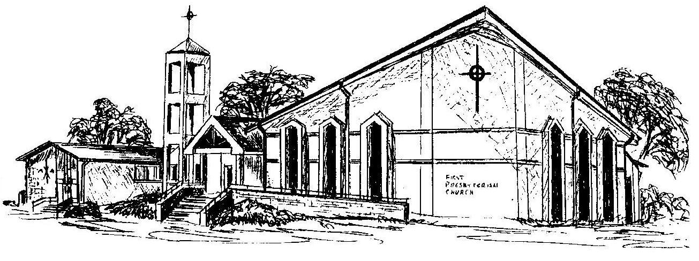

First Presbyterian Church
In the heart of Gardner since 1866 ~ Serving from the heart of God

Welcome - Thank you for joining us for worship today. Please fill out a visitor information card found in the pew racks and place those in the offering plate so that we may follow up with you in the future. Your presence with us today has been a blessing to us, we hope that you have felt the presence of God and the welcome of this congregation.

