Welcome & Announcements, Friendship Information, & Sharing Christ’s Peace
Prelude: “The Majesty of God” Medley
Let us prepare our hearts and minds for worship.

Call to Worship
Leader: Our great God, Creator of the Universe, calls us to come into God’s presence.
People: We come aware of God’s magnificence and in awe of God’s love.
Leader: Our great God, loves each one of us and cares for all the people of the earth.
People: We respond in gratitude, seeking to share God’s love and light.

*Opening Hymn: “For the Beauty of the Earth” Blue Hymnal, #473

*Prayer of Confession (Unison) (from Thom Shuman, Lectionary Liturgies)
Everlasting God, we know how easy it is to forget your presence and power in our lives. Focused on our daily planners, we do not pay attention to the night sky and the stars that glitter. Surrounded by the sounds of anger, violence, and hate, we have trouble listening to your whispers of hope and grace. Thinking that Scripture is filled only with stories, we cannot understand your truth which can change lives. Forgive us. Lift us to our feet so we may walk with you; fill us with your strength so we may serve your people; touch us with your healing so we may proclaim to everyone the Good News that has come in Jesus Christ, our Lord and Savior. Amen.

*Silent Reflection

*Assurance of Pardon

*Gloria Patri (Glory Be to the Father…) Blue Hymnal, #579

Special Music “Fairest, Lord Jesus" Jon Rollf

Scripture “Genesis 1:26-28; Genesis 2:4-7” (page 3)
“Psalm 8” (page 848)
“Psalm 19:1-6” (page 858)
Leader: The word of the Lord.
People: Thanks be to God.

Children's Time - Blessing of the Backpacks
Please join in singing one verse of Jesus Loves Me as the children come forward.
Special Music: "Fur Elise" Nalleli Rollf

Sermon: “Grounded and Unbounded” Rev. Kimby Young

*Profession of Faith The Apostle's Creed Blue Hymnal, top page 14

*Hymn “God Who Stretched the Spangled Heavens” Blue Hymnal, #268

Pastoral Prayer & Lord’s Prayer: Please Pray for Leo Pickell, Larry Hancock, Corky Scarlett, Debi Crowell Crist, Lucy, Karen Elliott, Jane McGuire, Hudson Inglehart, John Freund, Stan Knoche, Glenn Schulz, Boston DeWald, Beth Ekdohl, Lanny John Turner, Larry Bartl, Byron McManus, Margaret Davidson, Ann Ferguson, Keith W. Smith, Roland Jack, Rob Kuhauz, Denny Harris, Richard Hatfield, Jackson Tijerina

Offertory: “Psalm 8” Traditional American Melody
*Doxology Blue Hymnal, #592

Prayer of Dedication

*Closing Hymn: “O God of Earth and Space” Blue Hymnal, #274

Benediction

Postlude: “He's Got the Whole World in His Hands” Trad. Spiritual / arr. E. Bush
*Those who are comfortably able will please stand

Kimby Young, Pastor; Harvey Seim, Worship Assistant; Robyn Forkner, Pianist
Nalleli & Jon Rollf, Special Music; Alice Rollf, Organist
Heather Rutler, Worship Transcription; Dean Faulk, Music Ministries

Ushers for August 2017
Tracy & Colby McCabe; Harvey Seim; Carl Frahme; John Kunkel; Tom Corwin

Sunday, August 13: Mission Pillar 11:15AM
Monday, August 14: Session 6:30 PM
Wednesday, August 16: Prayer Circle 12:00 & 5:30 PM
Friday, August 18: EPIC Lockin starts 6:00 PM
Saturday, August 19: EPIC Lockin ends 10:00 AM
Saturday, August 19: Fellowship Hall reserved All Day
Bible reading for Sunday, August 20, Deuteronomy 6:4-9; Timothy 1:3-14; 3:14-17

PW Meeting Monday, August 21, 7:00 PM

Nominating Committee Wednesday, August 23, 6:30 PM

Operation Christmas Child Monthly collections for August are composition notebooks, crayons, pencils/sharpeners, school scissors they have a basket under the table in front of the office.

New Women's Fall Bible Study “More Than Enough” How Jesus Meets Our Deepest Needs It is a six week study beginning, September 14, 2017 through October 19, 2017. It begins at 7:00 p.m. in the Calvin Room. The cost of the book is $7.50. Sign up and order a book beginning August 27, 2017- September 10, 2017 in the narthex.

Discipleship Survey This is a general questionnaire about classes, groups, and studies you might be interested in. The Discipleship Pillar is seeking input as they plan for fall programming. Please complete the survey and return it to the church office, by Sunday, August 27.

Worship Assistants Changes are coming! Join us on Sunday, August 27, 2017 immediately following worship in the chapel. We encourage those that are currently serving as worship assistants to attend this meeting. Those of you who have not served as worship assistants but would be willing to serve in this capacity are encouraged to attend also. Everyone is welcome!

Financial Report The monthly income and expenses of the congregation are printed in the newsletter for the previous month. Newsletters are available in the narthex. A full report is available upon request from the treasurer or the Congregational Life Pillar.

MARK YOUR CALENDARS – RALLY DAY – is September 10 when Sunday School classes for the year will begin.

Worlds of Fun sponsored by EPIC, Sunday, October 1, 12:00 – 7:00 PM, cost $36.00 per person. All families and friends invited! RSVP with payment by September 17, contact
Connie.

Sunday, August 13, 2017
9:00 AM

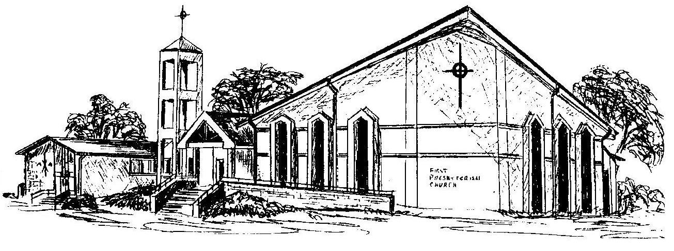

First Presbyterian Church
In the heart of Gardner since 1866 ~ Serving from the heart of God

Welcome - Thank you for joining us for worship today. Please fill out a visitor information card found in the pew racks and place those in the offering plate so that we may follow up with you in the future. Your presence with us today has been a blessing to us, we hope that you have felt the presence of God and the welcome of this congregation.

