Welcome & Announcements, Friendship Information, & Sharing Christ’s Peace
Minute for Mission Tracy McCabe
Prelude: “The Holy City” S. Adams
Let us prepare our hearts and mind’s for worship.

Call to Worship
Leader: Blessed is the One who comes in the name of our God!
People: Blessed is Christ who came in the power of God’s name and the nature of God’s love!
Leader: Blessed is Jesus who lived in courage that we might learn to live in peace!
People: Hosanna in the Highest! Blessed is our King and our God!

*Opening Hymn: “Hosanna, Loud Hosanna” Blue Hymnal, #89

*Prayer of Confession (Unison) (from An Improbable Gift of Blessing by Tirabassi and Grant)
Holy and gentle God, we confess that we want you to meet our expectations rather than changing our lives to meet yours. We confess that we are often changeable and self-centered like the Jerusalem crowd, shouting “Hosanna” one day and “Crucify” the next. We confess that we prefer the festivity of Palm Sunday to the quiet sadness of Holy Week. Forgive our sins and help us take up our own crosses to follow you. Amen.

*Silent Confession

*Assurance of Pardon
Leader: When we cry “Hosanna” we are shouting “Lord, Save Us!”
People: Hosanna in the Highest!
Leader: When we cry “Hosanna” God enters our lives with forgiveness!
People: Hosanna in the Highest!
Leader: When we cry “Hosanna” God hears our cries and answers our pleas!
People: Hosanna in the Highest! Blessed be the name of the Lord!

*Gloria Patri (Glory Be to the Father…) Blue Hymnal, #567

Scripture “Matthew 21:1-11” (page1531)
Leader: The word of the Lord.
People: Thanks be to God.

Children's Time
Please join in singing one verse of Jesus Loves Me as the children come forward.
Responses: Hosanna in the highest!; Praise to the Son of David!; Blessed is Jesus the Messiah!; Thank God for Jesus!; Save Us Now!; Glory to God in the Highest!; Come, King of Israel!; Long live Jesus!; Hallelujah!; Blessed is He who comes in the name of the Lord!

Special Music: “Ride On, King Jesus” by Jean Anne Shafferman

Sermon: “The Way of the Cross: Palm and Passion” Rev. Kimby Young

*Profession of Faith The Apostle's Creed Blue Hymnal, top page 14

*Hymn “Ride on, Ride on in Majesty” Blue Hymnal, #91

Pastoral Prayer & Lord’s Prayer: Please Pray for Brooke Miller, Roy Barnett, Larry Bartel, Byron McManus, Margaret Davidson, Brenda Polsen, Pam Wilson, Vespersia Pennington, Naomi Salser, Ann Ferguson, Miah, Nancy Jenkins, Glenn Schulz, Cynthia Miller, Arlene Thompson, Keith W. Smith, Roland Jack, Rob Kuhauz, Denny Harris, Delphine Brawner, Kyle Campbell, Clay Simmons, Jano Smoor, John Kuhns, Richard Hatfield, Jackson Tijerina, The DeWald Family
Offertory: “God So Loved the World” Stainer

*Doxology Blue Hymnal, #592

Prayer of Dedication

*Closing Hymn: “All Glory Laud and Honor” Blue Hymnal, #88

Benediction

Postlude: “The Palms” J. Faure
*Those who are comfortably able will please stand

Kimby Young, Pastor; Tina Fraser, Worship Assistant; Robyn Forkner, Pianist
Dean Faulk, Director of Chancel Choir; Chancel Choir; Alice Rollf, Organist
Heather Rutler, Worship Transcription; Todd Burd, Music Ministries

Ushers for April 2017
Harvey Seim; Larry Schick; Debbie Pickell; Mike & Pat Clark; Delores Guilinger
Sunday, April 9, Mission Pillar Meeting 11:15AM
Sunday, April 9, Kimby’s Bible Study 4:30 PM
Monday, April 10, NO Session Meeting
Tuesday, April 11, Men’s Breakfast Perkins 7:00 AM
Wednesday, April 12, Bells 6:00 PM; Choir 7:00 PM

Holy Week:
Thursday, April 13, Maundy Thursday Service 7:00 PM
Friday, April 14, Good Friday Service 7:00 PM
Sunday, April 16, Easter Sunday Worship Service 9:00 AM

Revelation Bible Study - Today only - 4:30-6 p.m. - Everyone welcome. Pastor Kimby Young is finishing the New Testament Overview today with a one session review of the Book of Revelation. If you have always wanted to know more about this mysterious book, join us today for this very fast overview. No prior study is required.

One Great Hour of Sharing If you would like to give a donation, please earmark on your check OGHS offering.

Men’s Breakfast will be held at 7:00 AM on Tuesday, April 11, at Perkins Restaurant. We
hope you can make it.

Sermon Series for Lent: “The Way of the Cross”
April 16 – EASTER – Resurrection - John 20:1-18

Flowering the cross – On Easter Sunday, bring a fresh flower from your garden to flower the cross in memory of a loved one. We will have flowers available for any who do not bring one from home.

Ladies You’re Invited to the Annual Spring Brunch, Saturday, April 22 at 9:30 AM. There will be music, devotions, and great fellowship and food! Our speaker will be Carl Frahme and the theme is: "God and Nature". Call church office to make your reservation. There is a sign-up sheet in the Narthex to help bring food, serve, set-up and various other ways. Promises to be a fun day! Nursery is provided by contacting the church office.

New Member Inquiry - A new class will be forming after Easter for any interested in learning more about First Presbyterian Church of Gardner. Please indicate your interest on a visitor card found in the pew rack, or tell Connie Crabbs or Pastor Kimby Young.

Sunday, April 9, 2017
Palm Sunday
9:00 AM

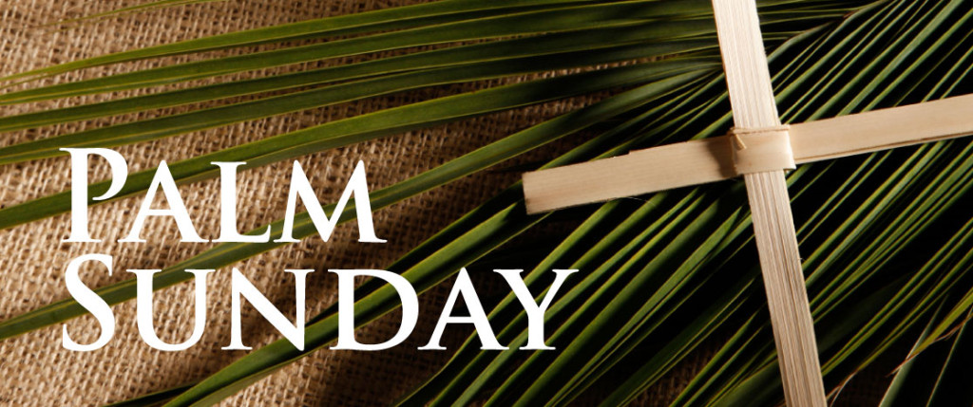

First Presbyterian Church
In the heart of Gardner since 1866 ~ Serving from the heart of God

Welcome - Thank you for joining us for worship today. Please fill out a visitor information card found in the pew racks and place those in the offering plate so that we may follow up with you in the future. Your presence with us today has been a blessing to us, we hope that you have felt the presence of God and the welcome of this congregation.

