Christmas Eve

(Please note: stand only for the 3 hymns indicated with * and sing only the verses listed.)

Prelude: “O Holy Night” Adam

Welcome and Call to Worship
Leader: Do not be afraid; for behold – I bring you good news of great joy.
People: To us is born this day in the city of David a Savior, who is Christ, the Lord.
Leader: This will be a sign for you: you will find a babe wrapped in swaddling cloth and lying in a manger.
People: Glory to God in the highest, and on earth, peace!

Lighting the Four Advent Candles & the Christ Candle Dave, Cindy, Nalleli & Jon Rollf
Tonight, we relight the candles of hope, peace, joy and love. And now, this evening, we light the Christ Candle, reminding us of the birth of Jesus Christ Light of the World. “Glory to God in the highest, and on earth peace, good will toward all!”

Special Music “Heirlooms” Nancy Falkner, Linda Wolf Amy Grant

Opening Prayer for Christmas Eve (Unison)
Good and gracious God, on this holy night you gave us your Son, the Lord of the universe, wrapped in swaddling clothes, the Savior of all, lying in a manger. On this holy night draw us into the mystery of your love. Join our voices with the heavenly host that we may sing your glory on high. Illumine our paths with the light of Christ’s presence, that we may clearly see the way before us, the truth to speak, and the life to live for him, our Lord Jesus Christ, who lives and reigns with you in the unity of the Holy Spirit, one God, now and forever. Amen.

*Carol “O Come, All Ye Faithful” verses 1 & 2 Red #145

The First Lesson Isaiah 9:2, 6-7 Davis Tropansky (page 1072)

Carol “First Noel” verses 1 & 4 Red #136

The Second Lesson Luke 1:26-38 Peggy Beach (page 1588)

Carol “It Came Upon the Midnight Clear” verses 1 & 4 Red #128

The Third Lesson Matthew 1:18-24 Bill Danner (page 1497)

Carol “O Little Town of Bethlehem” verses 1 & 2 Red #141

The Fourth Lesson Luke 2:1-7 Heather Culbertson (page 1590)

Carol “Away in a Manger” verses 1 & 2 Red #157

The Fifth Lesson Luke 2:8-14 Larry Flakus (page 1591)

Carol “Angels We Have Heard on High” verses 1 & 3 Red #132

The Sixth Lesson Luke 2:15-20 Jillian Fretz (page 1591)

Carol “Hark! The Herald Angels Sing” verses 1 & 2 Red #133

The Seventh Lesson Matthew 2:1-12 Randy Rieger (page 1497)

Carol “We Three Kings of Orient Are” verses 1 & 5 Red #166

Offering and Offertory “Sheep May Safely Graze” J. S. Bach

Prayer of Thanksgiving

The Eighth Lesson Isaiah 11:1-4a Jo Lynn Clark (page 1076)

*Carol “Joy to the World” verses 1 & 4 Red #125

Celebration of The Lord’s Supper
All are welcome at Christ’s table in the Presbyterian tradition.

Special Music “O Holy Night” Cooper McGuire

The Ninth Lesson John 1:1-5, 9-14 Cameron McGuire (page 1645)

The Distribution of the Candles
(As the light is passed from person to person, hold the lit candle straight, tip the unlit candle into the flame to receive the light of Christ.)

*Carol “Silent Night, Holy Night!” Red #147

*Benediction

Postlude: “Angels From the Realms of Glory” Smart
Kimby Young, Pastor; The Dave Rollf Family, Worship Assistants;
Robyn Forkner, Pianist; Todd Burd, Music Ministries; Alice Rollf, Organist;
Heather Rutler, Worship Transcription

Christmas Day, Sunday, December 25, 10 a.m. – Casual Celebration of the birth of Jesus Christ; combined with First Light
New Year’s Day, Sunday, January 1, 10 a.m. – New Year’s Day Communion and Worship; combined with First Light

Christmas Eve Readers:
Davis Tropansky
Peggy Beach
Bill Danner
Heather Culbertson
Larry Flakus
Jillian Fretz
Randy Rieger
Jo Lynn Clark
Cameron McGuire

Communion Servers:
Paula Waters
Lois Barber
Phil Lenahan
Kim Allen
Wayne Rollf
Mary Barbara Allen
Ron Crabbs
Mike McGuire

The Christmas Joy Offering of the PCUSA which is being received tonight is used for two purposes. Half of the offering is distributed through the Board of Pensions for the assistance programs that provide support to church workers facing difficult or unusual circumstances. The other fifty percent supports Presbyterian-related racial ethnic schools and colleges through the Racial Ethnic and Women's Ministries of the Presbyterian Mission Agency.

Sunday, December 24th, 2016
Christmas Eve Service
4:30 PM
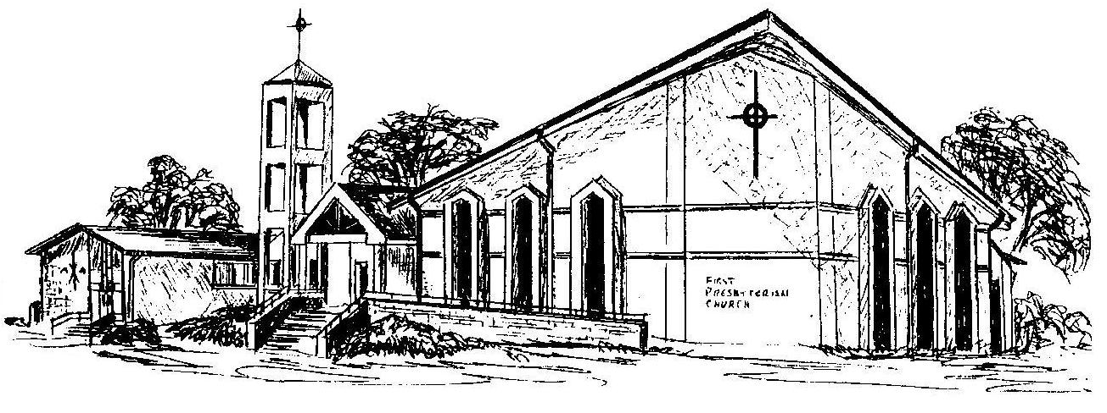

First Presbyterian Church
In the heart of Gardner since 1866 ~ Serving from the heart of God

Welcome - Thank you for joining us for worship today. Please fill out a visitor information card found in the pew racks and place those in the offering plate so that we may follow up with you in the future. Your presence with us today has been a blessing to us, we hope that you have felt the presence of God and the welcome of this congregation.

