Welcome & Announcements, Friendship Information, & Sharing Christ’s Peace

Prelude: In the Morning D. Meece
Let us prepare our hearts and minds for worship.

Call to Worship
Leader: Jesus says, “Come, Follow Me.”
People: We will follow where God leads; we will seek to understand.
Leader: Jesus says, “I will make you fishers of men; I will show you how to gather people.”
People: We will live faithfully so that others may come to know God.

*Opening Hymn: Blessed Assurance Red Hymnal, # 345

*Prayer of Confession (Unison)
Great God, Revealer and Revelation, we come seeking life and blessing and truth. We shy away when sometimes you reveal challenge and transformation and suffering. Open our hearts to whatever you would reveal. Help us to grow as you would have us grow. Teach us to seek even when we think we know it all. Inspire us to share with others all that you have shown us. Empower us to live your love and grace, that all may come to know you, through Jesus Christ our Lord. Amen.

*Assurance of Pardon

*Gloria Patri (Glory Be to the Father…) Red Hymnal, #623

Scripture Psalm 139:1-18, 23-24 (page 974)
Mark 1:14-20 (page 1552)
Leader: The word of the Lord.
People: Thanks be to God.

Children's Time
Please join in singing one verse of Jesus Loves Me as the children come forward.

Special Music: “Voice of Truth” Casting Crowns
Sermon: "Called to Grow - Seeking God” Rev. Dr. Kimby Young

*Profession of Faith The Apostle's Creed Red Hymnal, inside back cover

*Hymn In the Garden Red Hymnal, # 425
Offertory: All I Know T. English

*Doxology Red Hymnal, #625

*Prayer of Dedication & Pastoral Prayer Please Pray for Amanda Allen Smith, Sharon Frahme, Vern Thomas, Charles Barnett, Steve McGill, Norma Boone, Gladys Lane, Mark Howard, Mr. & Mrs. Brad Hadel, Scott Miller, Clay Simmons, Jano Smoor, John Kuhns, Richard Hatfield, Lee Edwards, Mark Freund, Jackson Tijerina, DeWald Family, Tara Miller-Palmer, Shirley Wilson, Austin W. Pennington

Communion
Invitation
Great Thanksgiving
The Lord’s Prayer
Breaking of Bread
Communion of the People
Prayer of Thanksgiving

*Closing Hymn: Just a Closer Walk With Thee Red Hymnal, # 380

*Benediction

Postlude: Here Am I, Send Me Purifoy

Kimby Young, Pastor; Alice Rollf, Worship Assistant;
Todd Burd, Soloist & Music Ministries; Robyn Forkner, Pianist;
Alice Rollf, Organist; Heather Rutler, Worship Transcription

Ushers September 2016
Lynn Moldrup, Cindy Rollf, Nalleli Rollf, Wayne Rollf, Wetheringtons

Monday, September 5, Office Closed Labor Day
Wednesday, September 7, Women’s Fellowship Group 10:00 AM
Wednesday, September 7, Nominating Committee 6:30 PM
Wednesday, September 7, Chancel Bell 6:00 – 7:00 PM
Wednesday, September 7, Chancel Choir 7:00 – 8:00 PM
Thursday, September 8, Congregational Life Pillar Meeting 7:00 PM
Sunday, September 11, Rally Day Children’s Sunday School 10:15 AM
Monday, September 12, Session 6:30 PM
Tuesday, September 13, Men’s Breakfast at Perkins 7:30 AM
Welcome Guests - Thank you for joining us for worship today. Please fill out a visitor information card found in the pew racks and place those in the offering plate so that we may follow up with you in the future. Your presence with us today has been a blessing to us, we hope that you have felt the presence of God and the welcome of this congregation. If you have questions or would like to speak to the pastor, talk to her after the service, call 913-856-4099 or email kimby@fpcgardner.org. Our website is www.fpcgardner.church.

Women’s Fellowship Group - will meet on Wednesday, September 7, at 10:00 AM for Devotions and Fellowship.

Sermon series – Next Week September 11 – Called to Care (wholeness) - I Corinthians 5:14-21 - healing, reconciliation, forgiveness

Sunday School Rally Day – September 11, 2016 – 10:15 AM Children’s Classes Resume.
Sugar Cookie Bars will be for sale in the Narthex after the service next week. The cookies will be $4.00 for a half dozen. Funds will go to Operation Christmas Child. If you have questions please contact Pam Wilson at 913-449-8135 or pamela_sue61@hotmail.com.
Men’s Breakfast – will meet at Perkin’s Restaurant on Tuesday, September 13 at 7:30 AM.

Nominating Committee – is creating a slate of officers for 2017. If you have a name to submit for consideration as Elder, Deacon or Nominating Committee member, please contact Bob Bergene or the church office. If you are asked, please prayerfully consider this call to serve.

Mission Auction – October 22 – Mark your calendars now for the annual Outreach Mission Auction. The Mission Pillar is starting to collect items for the auction. If you have a business or a connection to a business who might donate, please speak to a member of the Mission Pillar or moderator Eldonna Chesnut. Also, begin thinking about something you might donate for the auction either as an individual or as a group.

Operation Christmas Child - for September Crayons/Markers, Writing Paper, Scissors, Pencils/Sharpeners/Cases, Erasers, Bar Soap/Wash cloths, Boys/Girls underwear and socks.

Ladies Fall Bible Study starts on Thursday, September 15 at 7:00 PM - in September we will start a new Bible Study. “Fully Devoted: Living Each Day in Jesus’ Name”. The question is do we live each day in Jesus’ name? How do we accomplish this and what steps do we need to take to live a spiritual life? Are you up to the challenge? Hope to see you.

Sunday, September 4th, 2016
9:00 AM
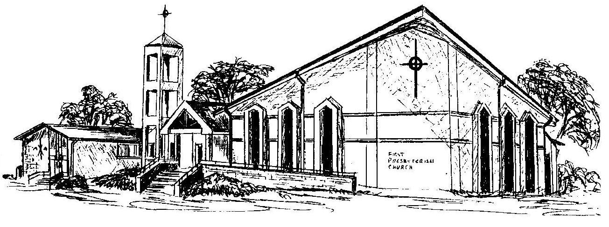

First Presbyterian Church
In the heart of Gardner since 1866 ~ Serving from the heart of God

