Welcome & Announcements, Friendship Information, & Sharing Christ’s Peace

Prelude: Largo Bargiel
Let us prepare our hearts and minds for worship.

Call to Worship (from Psalm 103)
Leader: Bless the Lord, O my soul,
People: All that is within me, bless God’s holy name.
Leader: Bless the Lord, O my soul,
People: Do not forget all God’s benefits.

*Opening Hymn: All Creatures of Our God and King Red Hymnal, #64

*Prayer of Confession (Unison)
Generous and Loving God, we know that you love and care for us. We know that you provide for us always. We confess that sometimes we are still afraid to trust. We are timid about reaching out and taking risks. We are cautious about giving of our time, talent and property because we want to be sure of tomorrow. Give us confidence to respond to your grace with generosity and joy. Help us to trust your promises and to recognize your gifts for us at all times and in all places. In the name of Jesus our Savior we pray. Amen.

*Silent Reflection

*Assurance of Pardon

*Gloria Patri (Glory Be to the Father…) Red Hymnal, #623
Scripture Psalm 112:1-9 (page 952)
2 Corinthians 9:6-15 (page 1803)
Leader: The word of the Lord.
People: Thanks be to God.

Children's Time
Please join in singing one verse of Jesus Loves Me as the children come forward.

Special Music: He Never Failed Me Yet Robert Ray

Sermon “Called to Give – Joyful Living” Rev. Kimby Young

*Profession of Faith The Apostle's Creed Red Hymnal, inside back cover

*Hymn: Take My Life and Let It Be Red Hymnal, #379

Pastoral Prayer & Lord’s Prayer: Please Pray for Ralph Corwin, Gladys Lane, Minnie Ashmore, Don Speer, Norma Boone, Mark Howard, Mr. & Mrs. Brad Hadel, Scott Miller, Clay Simmons, Jano Smoor, John Kuhns, Richard Hatfield, Mark Freund, Jackson Tijerina, DeWald Family, Tara Miller-Palmer, Shirley Wilson, Austin W. Pennington

Offertory: I Surrender All Weeden
*Doxology Red Hymnal, #625
*Prayer of Dedication

*Closing Hymn: We Praise Thee O God Our Redeemer Red Hymnal, #16

*Benediction

Postlude: My Heart Shall Rejoice Nordman

*Those who are comfortably able will please stand

Flowers are given today to the Glory of God in Memory of Bud Sweetwood and Ida Sands by Melva and Barbara Sue Sweetwood.

Kimby Young, Pastor; Bob Bergene, Worship Assistant; Chancel Choir; Alice Rollf, Organist; Todd Burd, Music Ministries; Robyn Forkner, Pianist; Heather Rutler, Worship Transcription

Ushers for September 2016
Lynn Moldrup, Cindy Rollf, Nalleli Rollf, Wayne Rollf, Wetheringtons

Sunday, September 25, Worship Pillar Meeting 11:15 AM
Monday, September 26, Memorial Committee 6:00 PM; Deacons 6:30 PM
Wednesday, September 28, Chancel Bells 6:00 PM; Chancel Choir 7:00 PM
Thursday, September 29, Ladies Bible Study 7:00 PM
Saturday, October 1, Blessing of the Animals 4:00 PM Open to the Community
Sunday, October 2, Worship World Wide Communion Service 9:00 AM
Sunday, October 2, Bible Study Class 4:30 PM

Open House at Pastor Kimby’s – Saturday, October 15 from 4-6 p.m.
Boy Scout Jacob Hoffman Creating a Memorial Garden for Eagle Project Buy a brick.
Personalized paving bricks will be sold to memorialize loved ones. Who have passed away that were important to you, i.e. parents, sibling, etc. Please consider the purchase of one or more of these bricks to make a permanent remembrance in the Memorial Garden. More information on this project will be coming soon, including the cost of each brick. If you are interested in a brick, please contact Brett Wilson at brett.wilson@jocogov.org or call him at 913-208-8190.

Nominating Committee – is creating a slate of officers for 2017. If you have a name to submit for consideration as Elder, Deacon or Nominating Committee member, please contact Bob Bergene or the church office. If you are asked, please prayerfully consider this call to serve.

Operation Christmas Child collection for this month is socks, (boys/girls) underwear, school supplies, bar soap and wash cloths.

Joy Closet T-shirts - New t-shirts are being ordered for Joy Closet workers and anyone else who wants to advertise for the closet. The shirts will be a Heather Grey color with Joy Closet Logo on the front and bible verse on the Back, the shirts are available in Short Sleeve and Long Sleeve. There is no cost for these shirts but donations are welcome to cover the cost. Sign up in the narthex or at Joy Closet. Matthew 25:36 "I needed clothes and you clothed me."

Blessing of Animals – Saturday, October 1, 4:00 PM. Open to the community. Bring animals contained or on a leash. After a short communal service & blessing. Individual families may pray with Pastor Kimby or enjoy ice cream and fellowship. Bring a lawn chair. Invite friends!

New Short-term Basic Bible Study - Pastor Kimby leading - October 2 - November 13, Sundays, 4:30-6 p.m. - The course is aimed at beginners. More advanced students, are welcome to come share expertise. Anyone is welcome – member or friend. No advance registration is required. Contact Pastor Kimby with questions.

Tree Dedication is in honor of Albert (Al) on Saturday, October 8 at 2:00 PM, at Vespersia Pennington house 621 N Locust. The Congregation is invited. Light refreshments will be served. Bring your own lawn chairs.

Mission Auction – October 22 – The mission pillar is asking everyone to consider donating something for the auction. Packed baskets and baked goods are fine but hoping to have additional items this year also. There will be a spaghetti dinner before the auction. We will be selling tickets to the dinner. Proceeds will go to one local and one international location. We will be looking for volunteers to help with set up, serving, and clean up. If you are interested in helping please email Eldonna.

Sunday
September 25th, 2016
9:00 AM

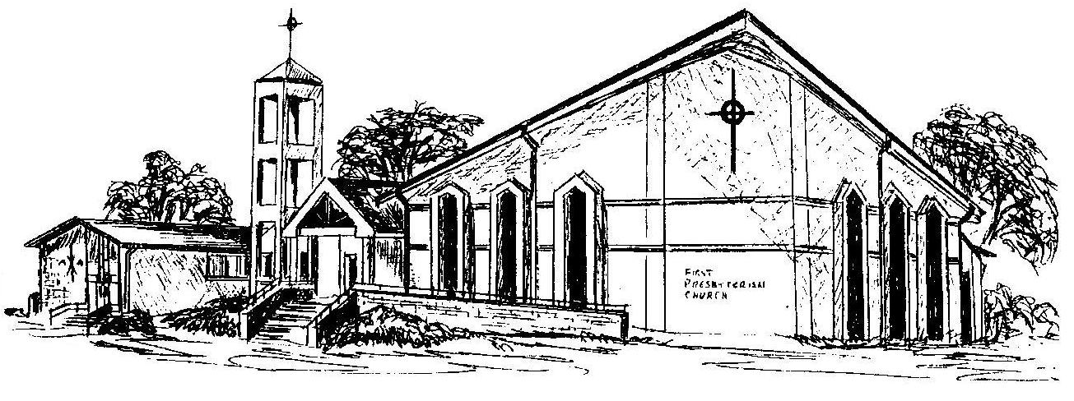

First Presbyterian Church
In the heart of Gardner since 1866 ~ Serving from the heart of God

Welcome - Thank you for joining us for worship today. Please fill out a visitor information card found in the pew racks and place those in the offering plate so that we may follow up with you in the future. Your presence with us today has been a blessing to us, we hope that you have felt the presence of God and the welcome of this congregation.

