Welcome & Announcements, Friendship Information, & Sharing Christ’s Peace

Prelude: Sing Praise to God Medley
Let us prepare our hearts and minds for worship.

Call to Worship
Leader: God is Creator of the universe and Maker of each new day.
People: We gather to worship and to sing of God’s grace.
Leader: Whatever happens for good or for ill, we know that God is with us.
People: We remember God’s presence with us and God’s promises for us, and we respond in praise.

*Opening Hymn: How Great Thou Art Red Hymnal, #4

*Prayer of Confession (Unison)
God of Mercy and Redemption, we sometimes question You when we see suffering in the world. We do not understand why bad things happen and we beg you for intervention. We have trouble letting go of our own pain and anger. We hold on to resentment. We lick our wounds. We hesitate to change. Give us courage to move forward. Bring healing and hope. Inspire us to restore trust. Encourage us to be Your people of justice and mercy. We pray in the name of Jesus Christ who saves us. Amen

*Silent Reflection

*Assurance of Pardon
Leader: Because of God’s love for us in Jesus Christ, anything is possible.
People: God sets aside our past mistakes and our old ways of doing things.
Leader: God makes everything new and empowers us to begin again.
People: In Christ we are forgiven and set free to start over.
Leader: By God’s grace we respond with new life.
People: We thank God and we live to glorify God.

*Gloria Patri (Glory Be to the Father…) Red Hymnal, #623
Scripture Psalm 13 (page 852)
2 Corinthians 5:14-21 (page 1799)
Leader: The word of the Lord.
People: Thanks be to God.

Children's Time
Please join in singing one verse of Jesus Loves Me as the children come forward.

Special Music: Jesus Loves Me Arr. Hassell

Sermon Called to Care – Living Wholeness Rev. Kimby Young

*Profession of Faith The Apostle's Creed Red Hymnal, inside back cover

*Hymn: Precious Lord, Take My Hand Red Hymnal, #463

Pastoral Prayer & Lord’s Prayer: Please Pray for Don Speer, Sharon Frahme, Steve McGill, Norma Boone, Gladys Lane, Mark Howard, Mr. & Mrs. Brad Hadel, Scott Miller, Clay Simmons, Jano Smoor, John Kuhns, Richard Hatfield, Lee Edwards, Mark Freund, Jackson Tijerina, DeWald Family, Tara Miller-Palmer, Shirley Wilson, Austin W. Pennington

Offertory: Change My Heart, O God Espinosa
*Doxology Red Hymnal, #625
*Prayer of Dedication

*Closing Hymn: Amazing Grace Red Hymnal, # 202

*Benediction

Postlude: Instruments of Your Peace Dearman
*Those who are comfortably able will please stand
Kimby Young, Pastor; Kim Allen, Worship Assistant;
Todd Burd, Music Ministries; Chancel Choir;
Robyn Forkner, Pianist; Alice Rollf, Organist; Heather Rutler, Worship Transcription

Ushers for September 2016
Lynn Moldrup, Cindy Rollf, Nalleli Rollf, Wayne Rollf, Wetheringtons

Sunday, September 11, Rally Day Children’s Classes Resume 10:15 AM
Monday, September 12, Session 6:30 PM
Tuesday, September 13, Men’s Breakfast at Perkins 7:30 AM
Wednesday, September 14, Chancel Bells 6:00 – 7:00 PM
Wednesday, September 14, Chancel Choir 7:00 – 8:00 PM
Thursday, September 15, Ladies Bible Study 7:00 PM

Sugar Cookie Bars will be for sale in the Narthex after the service on September 11, Rally Day. The cookies will be $4.00 for a half dozen. Funds will go to Operation Christmas Child. If you have questions please contact Pam Wilson at 913-449-8135 or pamela_sue61@hotmail.com.

Anniversary Picture - an extra large print of the congregation on the morning of the anniversary is on display in the hallway to fellowship hall. Copies of the print may be ordered for $20. Place your orders on the sign up sheet in the narthex.

Sermon series – Next Week September 18 – Called to Welcome (share the Good News) – Hebrews 13:2; John 1:43-51; Psalm 46 - authenticity, integrity, openness

Local Boy Scout Jacob Hoffman Memorial Garden for Eagle Project.
The Session has approved a work project that involves turning the mulched area on the north side of the Church (along the handicapped ramp) into a Memorial Garden. The garden will have an array of perennials that can live in a low water, high sunlight area and a monument stone dedicating the garden will sit in the middle. A major portion of the garden will be set aside for personalized paving bricks to memorialize loved ones that have gone to Church here and have passed or perhaps those that have passed away that were important to you, i.e. parents, sibling, etc.
Please consider the purchase of one or more of these bricks to make a permanent remembrance in the Memorial Garden. More information on this project will be coming soon, including the cost of each brick. The scout does need a good estimate of how many bricks will be purchased, but you can always add a brick later, this is not a one-time only offer.
If you are interested in a brick, please contact Brett Wilson at brett.wilson@jocogov.org or call him at 913-208-8190

Nominating Committee – is creating a slate of officers for 2017. If you have a name to submit for consideration as Elder, Deacon or Nominating Committee member, please contact Bob Bergene or the church office. If you are asked, please prayerfully consider this call to serve.

Operation Christmas Child collection for this month is socks, (boys/girls) underwear, school supplies, bar soap and wash cloths.

Joy Closet T-shirts - New t-shirts are being ordered for Joy Closet workers and anyone else who wants to advertise for the closet. The shirts will be a Heather Grey color with Joy Closet Logo on the front and bible verse on the Back, the shirts are available in Short Sleeve and Long Sleeve. There is no cost for these shirts but donations are welcome to cover the cost. Sign up in the narthex or at Joy Closet. Matthew 25:36 "I needed clothes and you clothed me."

Blessing of Animals – Saturday, October 1, 4:00 PM. Open to community - more details to come.

Mission Auction – October 22 – The mission pillar is asking everyone to consider donating something for the auction. Packed baskets and baked goods are fine but hoping to have additional items this year also. There will be a spaghetti dinner before the auction. We will be selling tickets to the dinner so watch for more information to come soon. Proceeds will go to one local and one international location. We will be looking for volunteers to help with set up, serving, and clean up. If you are interested in helping please email Eldonna.

Sunday,
September 11th, 2016
9:00 AM

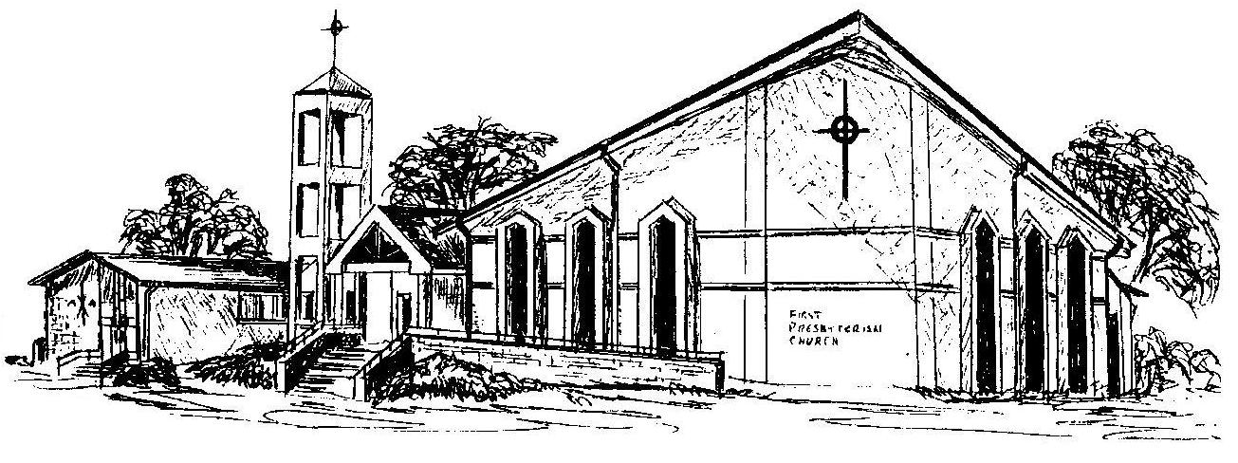

First Presbyterian Church
In the heart of Gardner since 1866 ~ Serving from the heart of God

Welcome - Thank you for joining us for worship today. Please fill out a visitor information card found in the pew racks and place those in the offering plate so that we may follow up with you in the future. Your presence with us today has been a blessing to us, we hope that you have felt the presence of God and the welcome of this congregation.

