Welcome & Announcements, Friendship Information, & Sharing Christ’s Peace

Prelude: Brethren, We Have Met to Worship Moore / Ritter
Let us prepare our hearts and minds for worship.

Call to Worship
Leader: Let us worship our eternal God, the Source of Love and Life.
People: Let us worship Jesus Christ, the Risen One, who lives among us and calls us to new life.
Leader: Let us worship the Spirit, Holy Fire of inspiration, who renews us and empowers us to serve.
People: We worship the one true God, who challenges us to live a life worthy of Christ’s calling.

*Opening Hymn: This is My Father’s World The Hymnal, #58

*Prayer of Confession (Unison)
Holy God, we acknowledge to you, to ourselves, and to one another that we are not what you have called us to be. We have not always made every effort to live as you have called us to live. We have failed to speak and act in ways that could have made a difference in the lives of others. Have mercy on us. Forgive our sin. Change our lives. Help us to grow into the fullness of Christ you have set before us. We pray in Jesus name. Amen.

*Assurance of Pardon

*Gloria Patri (Glory Be to the Father…) The Hymnal, #623

Scripture Ephesians 4:1-6, 11-16 (page 1821)
Leader: The word of the Lord.
People: Thanks be to God.

Children's Time
Please join in singing one verse of Jesus Loves Me as the children come forward.

Special Music: God Bless the Broken Road by Rascal Flatts

Sermon: “Grow Up Into Christ” Rev. Kimby Young

*Profession of Faith The Apostle's Creed The Hymnal, inside back cover
*Hymn Our God Has Made Us One The Hymnal, #287
Offertory: Let Us Pray Hildebrand
*Doxology The Hymnal, #625

*Prayer of Dedication & Pastoral Prayer Please Pray for Steve McGill, Norma Boone, Gladys Lane, Mark Howard, Mr. & Mrs. Brad Hadel, Scott Miller, Clay Simmons, Lora Beth Knoche Clark, Jano Smoor, John Kuhns, Richard Hatfield, Lee Edwards, Mark Freund, Jackson Tijerina, DeWald Family, Tara Miller-Palmer, Shirley Wilson, Austin W. Pennington

Communion
Invitation
Great Thanksgiving
The Lord’s Prayer
Breaking of Bread
Communion of the People
Prayer of Thanksgiving

*Closing Hymn: They’ll Know We Are Christians By Our Love The Hymnal, #284

*Benediction

Postlude: Face to Face Owens / Batstone

Todd Burd, Music Ministries; Paula Waters, Worship Assistant;
Robyn Forkner, Pianist; Sydney Wetherington, Special Music;
Alice Rollf, Organist

Communion Servers, Sunday, August 7
Linda Wolf, Nancy Falkner, Paula Waters, Lois Barber, Janet & Larry Flakus

Ushers August 2016
George Frame; John Forkner; Tracy McCabe; Colby McCabe; Jerry & Paula Waters

Sunday, August 7, Mission Pillar Meeting 10:15 AM
Monday, August 8, Session 6:30 PM
Tuesday, August 9, Men’s Breakfast Perkins 7:30 AM
Wednesday, August 10, Nominating Committee 6:30 PM
Monday, August 15, PW Meeting 7:00 PM
Wednesday, August 17, Joy Closet Cashiers Meeting 6:30 PM
150th Anniversary Celebration

Friday Evening, August 12 – 6:00 p.m. – Actual date of the Charter
Potluck dinner – In Fellowship Hall
150th Anniversary Gathering - In the Sanctuary
Sing-a-long with your favorite hymns
Reminisce with stories from our past – shared by members and guests

Saturday Evening, August 13 – 6:00 p.m.
Ice Cream Social & Games from 1866
Square Dancing – On Shawnee Street

Sunday Morning, August 14 – 9:00 a.m. – Worship with Homecoming
Worship Service – In the Sanctuary
Participation by former pastors and members who followed in the ministry
Introduction of special guests
Special memories and stories from guests
Inspirational music - Provided by the Chancel Choir
Brunch – In Fellowship Hall
Meat and drinks provided
Bring a salad or dessert to share

New Website - We are launching a new website in August and encourage you to check it out at fpcgardner.church. This format will be more user friendly and will allow us to make faster updates. The website is still under construction, but is taking shape. If you have any questions or suggestions, please speak to Mike McGuire or Pastor Kimby Young.

Nominating Committee – has started to work on creating a slate of officers for 2017. If you have a name to submit for consideration as Elder, Deacon or Nominating Committee member, please contact Bob Bergene or the church office. If you are asked, please prayerfully consider this call to serve.

Strengthening Families Program Outreach - First Presbyterian Church is the host site for the 14 week SF program in Gardner beginning August 18. We have agreed also to provide the first meal for about 75 people. Mission Pillar through Pam Wilson will provide sloppy joes and macaroni and cheese. Donations for parts of the meal are being accepted on the signup sheet in the narthex. Volunteers are also welcome to help serve and clean up the meal on August 18.

Sunday, August 7th, 2016
9:00 AM
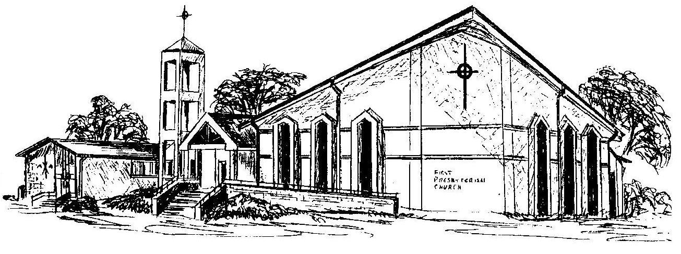

First Presbyterian Church
In the heart of Gardner since 1866 ~ Serving from the heart of God

