Welcome & Announcements, Friendship Information, & Sharing Christ’s Peace

Prelude: Aria Cantabile M. Schaeffer
Let us prepare our hearts and minds for worship.

Call to Worship (adapted from Isaiah 55)
Leader: Come, all who are thirsty; Come to the waters of life.
People: Come, you who have no money; Come, enjoy and eat.
Leader: Come to the table of grace and salvation; Come to God’s loving community.
People: Come to the Savior of all the world; Come, listen that you may live.

*Opening Hymn: Today We All Are Called To Be Blue Hymnal #434, v 1, 3, 4

*Prayer of Confession (Unison)
God of care and comfort, healing and love, we confess that we hear your call to serve others, but sometimes we do not respond. Fear paralyses us. Apathy overtakes us. Selfishness consumes us. Sometimes we let others suffer when we could make a difference. Forgive us. Help us to hear your call again. Inspire us to be our better selves. Empower us to offer your love wherever we are able. Nurture us that we may nurture others in the name of Jesus Christ. Amen.

*Silent Reflection

*Assurance of Pardon

*Gloria Patri (Glory Be to the Father…) Blue Hymnal, #579
Scripture James 2:14-18 - Message (page 1882)
Matthew 25:31-40 (page 1542)
Leader: The word of the Lord.
People: Thanks be to God.

Children's Time
Please join in singing one verse of Jesus Loves Me as the children come forward.

Special Music: He Is Exalted Arr. Larson

Sermon “Called to Serve- Compassionate Action” Rev. Kimby Young
And whatever you do, whether in word or deed, do it all in the name of the Lord Jesus, giving thanks to God the Father through him. (Colossians 3:17)
*Profession of Faith The Apostle's Creed Blue Hymnal, top page 14

*Hymn: We Give Thee But Thine Own Blue Hymnal #428, v 1, 3, 4

Pastoral Prayer & Lord’s Prayer: Please Pray for Amanda Allen Smith, Sharon Frahme, Vern Thomas, Charles Barnett, Steve McGill, Norma Boone, Gladys Lane, Mark Howard, Mr. & Mrs. Brad Hadel, Scott Miller, Clay Simmons, Jano Smoor, John Kuhns, Richard Hatfield, Lee Edwards, Mark Freund, Jackson Tijerina, DeWald Family, Tara Miller-Palmer, Shirley Wilson, Austin W. Pennington
Offertory: The Servant Song Gillard
*Doxology Blue Hymnal, #592

*Prayer of Dedication

*Closing Hymn: Live Into Hope Blue Hymnal # 332

*Benediction

Postlude: Take My Life and Let it be Consecrated Malan
*Those who are comfortably able will please stand
Kimby Young, Pastor; Jerry Beach, Worship Assistant;
Todd Burd, Music Ministries; Chancel Choir;
Robyn Forkner, Pianist; Alice Rollf, Organist; Heather Rutler, Worship Transcription

Ushers for August 2016
George Frame, John Forkner, Tracy & Colby McCabe, Jerry & Paula Waters

Sunday, August 26, Discipleship Pillar Meeting 10:15 AM
Sunday, August 26, Worship Pillar Meeting 11:15AM
Wednesday, August 31, Joy Closet Board Meeting 6:30 PM
Wednesday, August 31, Chancel Bell 6:00 – 7:00 PM; Chancel Choir 7:00 – 8:00 PM

Welcome - Thank you for joining us for worship today. Please fill out a visitor information card found in the pew racks and place those in the offering plate so that we may follow up with you in the future. Your presence with us today has been a blessing to us, we hope that you have felt the presence of God and the welcome of this congregation.
Sermon series – Next Week September 4 – Called to Grow (personally and communally) – Mark 1:14-20; Psalm 139 - discipleship, growth.

Women’s Fellowship Group will meet on Wednesday, September 7, at 10:00 AM for Devotions and Fellowship.

Sunday School Rally Day – September 11, 2016 – 10:15 AM Children’s Classes Resume.
Sugar Cookie Bars will be for sale in the Narthex after the service on September 11, Rally Day. The cookies will be $4.00 for a half dozen. Funds will go to Operation Christmas Child. If you have questions please contact Pam Wilson at 913-449-8135 or pamela_sue61@hotmail.com.
Thank you Note
I would like to thank the congregation, friends and various medical staff, during my hip surgery and recovery. I appreciate the calls, cards, visits and prayers.
Thank you,
Charles Barnett

Nominating Committee – has started to work on creating a slate of officers for 2017. If you have a name to submit for consideration as Elder, Deacon or Nominating Committee member, please contact Bob Bergene or the church office. If you are asked, please prayerfully consider this call to serve.

Mission Auction – October 22 – The mission pillar is asking everyone to consider donating something for the auction. Packed baskets and baked goods are fine but hoping to have additional items this year also. There will be a spaghetti dinner before the auction. We will be selling tickets to the dinner so watch for more information to come soon. Proceeds will go to one local and one international location. We will be looking for volunteers to help with set up, serving, and clean up. If you are interested in helping please email Eldonna.

Operation Christmas Child collection for this month is socks, (boys/girls) underwear, school supplies, bar soap and wash cloths.

Ladies Fall Bible Study starts on Thursday, September 15 at 7:00 PM
Ladies of the church in September we will start a new Bible Study. “Fully Devoted: Living Each Day in Jesus’ Name”. The question is do we live each day in Jesus’ name? How do we accomplish this and what steps do we need to take to live a spiritual life? Are you up to the challenge? There will be a table in the Narthex to order the book. The price will be $8.00; we hope to see you.

Sunday, August 28th, 2016
9:00 AM

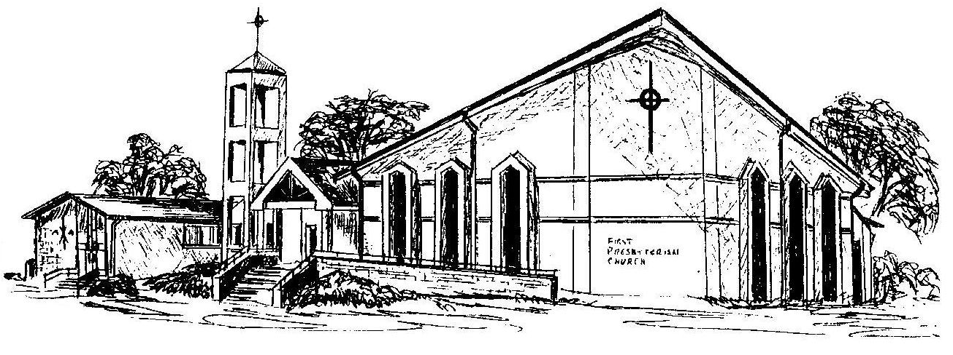

First Presbyterian Church
In the heart of Gardner since 1866 ~ Serving from the heart of God

