Welcome & Announcements, Friendship Information, & Sharing Christ’s Peace

Prelude: Praise to the Lord, the Almighty Gesanbuch
Let us prepare our hearts and minds for worship.

Call to Worship
Leader: In the name of Jesus Christ we are gathered to worship.
People: By the grace of God we are called together to serve.
Leader: Filled with the Spirit of God, we offer the gifts we have been given.
People: Blessed by our Triune God, we seek to respond in love.

*Opening Hymn: In Christ There is No East or West Blue Hymnal, #439

*Prayer of Confession (Unison)
Gracious God of unity and community, we confess that we divide more than we connect. We find competition more compelling than cooperation. We compare ourselves to others and try to call one better than another. Forgive our failure to see the wondrous diversity you have created. Forgive us when we do not appreciate the gifts you have given either to ourselves or to others. Help us to build up one another in love, to speak words of encouragement, and to share our own gifts freely and fully to your glory in Jesus Christ our Lord. Amen.

*Silent Reflection

*Assurance of Pardon
Leader: God’s gifts are bountiful and beautiful.
People: We have received grace upon grace.
Leader: God offers us forgiveness and new life in Christ.
People: Thanks be to God who makes all things possible.

*Gloria Patri (Glory Be to the Father…) Red Hymnal, #623
Scripture Romans 12:1-18 (page 1763)
Leader: The word of the Lord.
People: Thanks be to God.

Children's Time
Please join in singing one verse of Jesus Loves Me as the children come forward.

Special Music: Sun of My Soul & How Gentle God's Commands
Sermon “Called to Appreciate – Sharing Gifts” Rev. Kimby Young

Special Music: City on a Hill Casting Crowns

*Profession of Faith The Apostle's Creed Red Hymnal, inside back cover

*Hymn: Called as Partners in Christ’s Service Blue Hymnal, #343

Pastoral Prayer & Lord’s Prayer: Please Pray for Sharon Frahme, Charles Barnett, Steve McGill, Norma Boone, Gladys Lane, Mark Howard, Mr. & Mrs. Brad Hadel, Scott Miller, Clay Simmons, Jano Smoor, John Kuhns, Richard Hatfield, Lee Edwards, Mark Freund, Jackson Tijerina, DeWald Family, Tara Miller-Palmer, Shirley Wilson, Austin W. Pennington
Offertory: Make Us One Cymbala
*Doxology Red Hymnal, #625

*Prayer of Dedication

*Closing Hymn: Blest Be the Tie That Binds Blue Hymnal, #438

*Benediction
(adapted from Book of Common Worship liturgy for ordination; I Corinthians 12)
Leader: Now there are varieties of gifts, but the same Spirit;
People: And there are varieties of service, but the same Lord;
Leader: To each is given the manifestation of the Spirit for the common good.
People: Indeed, the body does not consist of one member but of many.
Leader: You are the body of Christ today. Go out to follow Jesus Christ in service to others.
People: Connected to one another and to Jesus, we will share God’s love in the world.

Postlude: People of God Watson

*Those who are comfortably able will please stand

Kimby Young, Pastor; Mike McGuire, Worship Assistant;
Todd Burd, Soloist & Music Ministries; Nalleli Rollf, Special Music;
Robyn Forkner, Pianist; Alice Rollf, Organist; Heather Rutler, Worship Transcription

Ushers for August 2016
George Frame, John Forkner, Tracy & Colby McCabe, Jerry & Paula Waters
Welcome - Thank you for joining us for worship today. Please fill out a visitor information card found in the pew racks and place those in the offering plate so that we may follow up with you in the future. Your presence with us today has been a blessing to us, we hope that you have felt the presence of God and the welcome of this congregation.

Monday, August 22, Memorial Committee 6:00 PM; Deacons 6:30 PM
Tuesday, August 23, Nominating Committee 6:30 PM
Sunday, August 28, Discipleship Pillar Meeting 10:15 AM; Worship Pillar Meeting 11:15AM

Membership Inquiry - If you would like to know more about the church or if you are interested in joining First Presbyterian, meet with pastor Kimby today after the service. All questions are welcome.

Sermon series – Next Week August 28 – Called to Serve – (whatever you do) – James 2:14-18, Matthew 25:31-40 – compassionate action

Nominating Committee – has started to work on creating a slate of officers for 2017. If you have a name to submit for consideration as Elder, Deacon or Nominating Committee member, please contact Bob Bergene or the church office. If you are asked, please prayerfully consider this call to serve.

Sunday School Rally Day – September 11, 2016 – 10:15 AM Children’s Classes Resume.

Mission Auction – October 22 – The mission pillar is asking everyone to consider donating something for the auction. Packed baskets and baked goods are fine but hoping to have additional items this year also. There will be a spaghetti dinner before the auction. We will be selling tickets to the dinner so watch for more information to come soon. Proceeds will go to one local and one international location. We will be looking for volunteers to help with set up, serving, and clean up. If you are interested in helping please email Eldonna.

Operation Christmas Child collection for this month is socks, (boys/girls) underwear, school supplies, bar soap and wash cloths.

Ladies Fall Bible Study starts Thursday, September 15 at 7:00 PM
Ladies of the church in September we will start a new Bible Study. “Fully Devoted: Living Each Day in Jesus’ Name”. The question is do we live each day in Jesus’ name? How do we accomplish this and what steps do we need to take to live a spiritual life? Are you up to the challenge? There will be a table in the Narthex to order the book. The price will be $8.00; we hope to see you.

Sunday, August 21st, 2016
9:00 AM

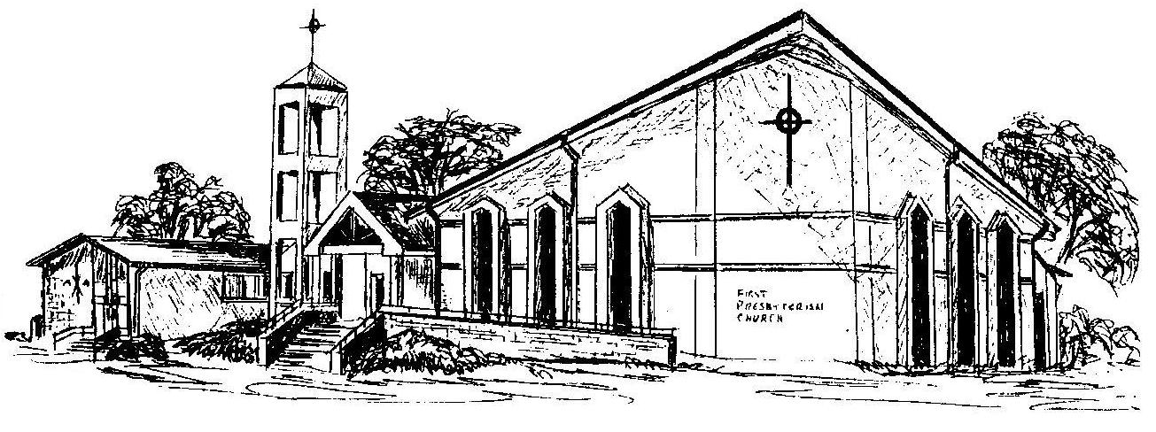

First Presbyterian Church
In the heart of Gardner since 1866 ~ Serving from the heart of God

