Welcome & Announcements, Friendship Information, & Sharing Christ’s Peace

Prelude: Oh, How He Loves You and Me Arr. by Hayes
Let us prepare our hearts and minds for worship.

Call to Worship (Psalm 95)
Leader: O come, let us sing to the Lord; let us make a joyful noise to the rock of our salvation!
People: Let us come into God’s presence with thanksgiving; let us make a joyful noise to God with songs of praise!
Leader: O come, let us worship and bow down, let us kneel before the Lord, our Maker!
People: For the Lord is our God, and we are the people of God’s pasture, and the sheep of God’s hand.

*Opening Hymn: For the Beauty of the Earth The Hymnal, #560

*Prayer of Confession (from Touch Holiness by Duck and Tirabassi) (Unison)
Merciful God, whose care never ceases, we come to you as we are. We are tired from trying to do more than we can manage. We are anxious about problems which go unresolved. We are worried about events beyond our control. We do not easily let go. For mistakes we cannot redeem, for tasks left undone, for uncertain goals, we need your forgiveness and ask for your understanding. For recovery of strength and enthusiasm, we pray for your Spirit. For fullness of life, generous hearts, and contented souls, we pray to be followers of Christ Jesus. In your mercy, restore us and lead us. Amen.

*Silent Reflection

*Assurance of Pardon

*Gloria Patri (Glory Be to the Father…) The Hymnal, #623
Scripture Isaiah 42:1-9 (page 1124)
Colossians 3:12-17 (page 1834)
Leader: The word of the Lord.
People: Thanks be to God.

Children's Time – Blessing of the Backpacks
Please join in singing one verse of Jesus Loves Me as the children come forward.

Special Music:

Sermon Put On Christ Rev. Kimby Young

*Profession of Faith The Apostle's Creed The Hymnal, inside back cover

*Hymn: May Jesus Christ Be Praised The Hymnal, #87 verses 1, 4 & 6

Pastoral Prayer & Lord’s Prayer: Please Pray for Norma Boone, Gladys Lane, Mark Howard, Mr. & Mrs. Brad Hadel, Scott Miller, Clay Simmons, Lora Beth Knoche Clark, Jano Smoor, John Kuhns, Richard Hatfield, Lee Edwards, Mark Freund, Jackson Tijerina, DeWald Family, Tara Miller-Palmer, Shirley Wilson, Austin W. Pennington
Offertory: This Is My Father's World Arr. by Rice
*Doxology The Hymnal, #625

*Prayer of Dedication

*Closing Hymn: Christ is Made the Sure Foundation The Hymnal, # 276

*Benediction
Postlude: Think About His Love with The Love of God Arr. Tornquist
*Those who are comfortably able will please stand
Todd Burd, Music Ministries; Connie Thomas, Worship Assistant;
Megan Wetherington, Playing a Irish Whistle, Special Music;
Robyn Forkner, Pianist; Heather Rutler, Worship Transcription

Ushers for July 2016
Larry & Janet Flakus, Carl & Sharon Frahme, Mike & Tina Fraser

Monday, August 1, Congregation Life Pillar Meeting 7 PM
Wednesday, August 3, Women’s Fellowship Group 10 AM
Sunday, August 7, Mission Pillar Meeting 10:15 AM

Women’s Fellowship Group
We will again meet on Wednesday, August 3, at 10:00 AM for Devotions and tie lap quilts made by Janet Flakus, for local nursing facilities.
We will continue to collect personal items for Safehome.

Parade Entry for Johnson County Fair – August 6
Join us to represent First Presbyterian Church in the Johnson County Fair Parade on Saturday morning, August 6. We can use riders on our float and walkers to hand out our gifts and goodies. Our handouts will include an invitation to the anniversary celebration the following week. We are also accepting donations of individually wrapped, non-melting candy at any time in the office. Plans are currently being made for a float with photos of our various church buildings through the years. If you would be willing to help with the creation, contact Kimby Young or Nancy Falkner. If you would be willing to walk or ride, let us know, so we can give you details about when and where to gather.

New Website - We are launching a new website in August and encourage you to check it out at fpcgardner.church. This format will be more user friendly and will allow us to make faster updates. The website is still under construction, but is taking shape. If you have any questions or suggestions, please speak to Mike McGuire or Pastor Kimby Young.

Nominating Committee – has started to work on creating a slate of officers for 2017. If you have a name to submit for consideration as Elder, Deacon or Nominating Committee member, please contact Bob Bergene or the church office. If you are asked, please prayerfully consider this call to serve.

150 Anniversary Weekend
Photos – Weddings, Baptisms, Confirmation, Youth Events, etc. Please submit photos of your family or of church events or people for a slideshow. Send to Carl Frahme at cfrahme@prodigy.net.

Calendar of Events Insert
Note the dates and times for events and invite a friend to join us.

Favorite Hymn Requests Insert
Use the form to submit your favorite faith songs for use during our anniversary weekend celebration. Place completed form in offering plate or give to Pastor Kimby Young.

Sunday, July 31st, 2016
9:00 AM

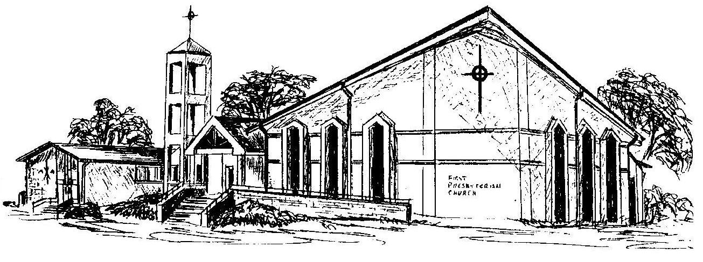

First Presbyterian Church
In the heart of Gardner since 1866 ~ Serving from the heart of God

