Welcome & Announcements, Friendship Information, & Sharing Christ’s Peace

Prelude: Come! Live in the Light! D. Haas
Let us prepare our hearts and minds for worship.

Call to Worship (from Psalm 150)
Leader: Praise God in the sanctuary; praise God in the mighty heavens.
People: Praise God for God’s acts of power; Praise God for surpassing greatness.
Leader: Praise God with the sounding of the trumpet; praise God with tambourine and dancing.
People: Let everything that breathes praise the Lord. Praise the Lord!

*Opening Hymn: God of Grace and God of Glory The Hymnal, #292

*Prayer of Confession (Unison)
God of Power and Might, we confess our failure to understand your power and glory. The world aches for peace, and yet our actions reveal our priority for power. We confess our sin in the ways we use and abuse the power you have given us. We stand passively when we should act. We act aggressively when we should show compassion. We are confused by our own fears. We fail to be the people of grace you have empowered us to be. Shine your light on us again that we may be your light in the world in the name of Jesus Christ. Amen.

*Silent Reflection

*Assurance of Pardon

*Gloria Patri (Glory Be to the Father…) The Hymnal, #623

Special Music: Wonderful Words of Life

Scripture Psalm 8 (page 848)
Colossians 1:9-20NRSV (page 1832)
Leader: The word of the Lord.
People: Thanks be to God.

Children's Time
Please join in singing one verse of Jesus Loves Me as the children come forward.

Special Music: This New Jerusalem
Sermon: “Inheritance” Rev. Kimby Young
*Profession of Faith The Apostle's Creed The Hymnal, inside back cover

*Hymn: Come Live in the Light (We Are Called) Insert

Pastoral Prayer & Lord’s Prayer: Please Pray for Norma Boone, Mark Howard, Mr. & Mrs. Brad Hadel, Scott Miller, Clay Simmons, Lora Beth Knoche Clark, Jano Smoor, John Kuhns, Richard Hatfield, Lee Edwards, Mark Freund, Jackson Tijerina, DeWald Family, Tara Miller-Palmer, Shirley Wilson, Austin W. Pennington

Offertory: Psalm 8 Trad. American Melody

*Doxology The Hymnal, #625

*Prayer of Dedication

*Closing Hymn: How Great Thou Art The Hymnal, #4

*Benediction

Postlude: Here I Am, Lord Schutte

*Those who are comfortably able will please stand

Todd Burd, Music Ministries; Nancy Schulz, Worship Assistant;
Special Music, Emily Worth, Guy Cauthon, Cooper McGuire;
Alice Rollf, Organist; Robyn Forkner, Pianist;
Heather Rutler, Worship Transcription

Ushers for July 2016
Larry & Janet Flakus, Carl & Sharon Frahme, Mike & Tina Fraser

Sunday, July 24, Worship Pillar Meeting 11:15 AM
Monday, July 25, Deacons Meeting 6:30 PM
Monday, July 25, Memorial Committee Meeting 7 PM
Wednesday, July 27, Nominating Committee 6:30 PM

Nominating Committee – has started to work on creating a slate of officers for 2017. If you have a name to submit for consideration as Elder, Deacons or Nominating Committee member, please contact Bob Bergene or the church office.

Blessing of the Back Packs, Back to School Blessing
Students of all ages, and teachers or school workers at all levels, are invited to bring a "symbol" of their school year (a backpack, notebook, calendar, planner, even a pencil) to worship with you on Sunday, July 31. For a time of recognition and prayer for the coming year.

Parade
Walk or ride with us to represent First Presbyterian Church in the Johnson County Fair Parade on Saturday morning, August 6. Bring candy now or any time to pass out.

150 Anniversary Weekend
Photos – Weddings, Baptisms, Confirmation, Youth Events, etc. Please submit photos of your family or of church events or people for a slideshow. Send to Carl Frahme at cfrahme@prodigy.net.

Calendar of Events Insert
Note the dates and times for events and invite a friend to join us.

Favorite Hymn Requests Insert
Use the form to submit your favorite faith songs for use during our anniversary weekend celebration.

Sunday, July 24th, 2016
9:00 AM

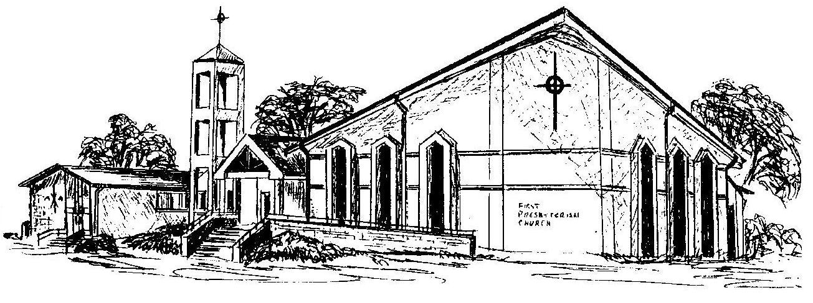

First Presbyterian Church
In the heart of Gardner since 1866 ~ Serving from the heart of God

