Welcome & Announcements, Friendship Information
Window Dedication and Eagle Scout project recognition Grant Fairchild;
Ivan Crane; Scott Miller; Sharing Christ’s Peace

Prelude: Rejoice in the Lord Medley
Let us prepare our hearts and minds for worship.

Call to Worship
Leader: Rejoice in the Lord always!
People: Again I will say, “Rejoice!”
Leader: At all times and in all circumstances, we know that God is with us and God loves us.
People: We respond to God’s grace in worship and praise.

*Opening Hymn: Joyful, Joyful We Adore Thee The Hymnal, #1

*Prayer of Confession (Unison)
Great God of goodness and peace, we come aware of our failures as well as your love for us. We worry when we should trust. We fear when we should have courage. We do not stand or speak when we should demonstrate love or care. Yet at other times, we do or say things that should not be said, without thinking of your will for us. Forgive us. Help us to focus on you, to respond to your faithfulness and to be your witnesses of mercy and joy in the world by your grace and to your glory. Amen.

*Silent Reflection

*Assurance of Pardon
Leader: In Jesus Christ we are forgiven and set free.
People: Thanks be to God!
Leader: We are made new and all things are possible through our Lord Jesus Christ.
People: With gratitude and joy we respond to God’s love.

*Gloria Patri (Glory Be to the Father…) The Hymnal, #623

Scripture Psalm 100 in NRSV (page 937)
Philippians 4:4-13 (page 1830)
Leader: The word of the Lord.
People: Thanks be to God.

Children's Time - Noisy Offering
Please join in singing one verse of Jesus Loves Me as the children come forward.
Special Music: Pastorale Leybach
Sermon: “Can Do” Rev. Kimby Young
*Profession of Faith The Apostle's Creed The Hymnal, inside back cover

*Hymn: Open My Eyes, That I May See The Hymnal, #381

Pastoral Prayer & Lord’s Prayer: Please Pray for Scott Miller, Randy Rieger, Clay Simmons, Ron Crabbs, Lora Beth Knoche Clark, Jano Smoor, John Kuhns, Richard Hatfield, Lee Edwards, Mark Freund, Jackson Tijerina, Eric Gourley, DeWald Family, Tara Miller-Palmer, Shirley Wilson, Austin W. Pennington, Doris Ann Case

Offertory: Sweet Hour of Prayer Bradbury / Clarke

*Doxology The Hymnal, #625

*Prayer of Dedication

*Closing Hymn: Now Thank We All Our God The Hymnal, #556

*Dismissal and Benediction
Leader: Rejoice in the Lord always! Again I will say “Rejoice!”
People: I can do all things through Christ who gives me strength.
Leader: May the peace of God that passes all understanding keep your hearts and minds in Christ Jesus.
People: We go out to serve in the power and presence of our God of grace – Father, Son and Holy Spirit. Amen.

Postlude: Peace Like a River Traditional

*Those who are comfortably able will please stand

Todd Burd, Music Ministries;
Larry Schick, Worship Assistant; Alice Rollf, Organist;
Robyn Forkner, Pianist; Heather Rutler, Worship Transcription

Ushers for July 2016
Larry & Janet Flakus, Carl & Sharon Frahme, Mike & Tina Fraser

Sunday, July 17, Discipleship Pillar Meeting 10:45 AM
Monday, July 18, Presbyterian Women Meeting 7:00 PM
Wednesday, July 20, Lion’s Club 6:00 PM
Sunday, July 24, Worship Pillar Meeting 11:15 AM

School Supply Drive
The deacons would like to invite the congregation to participate in our school supply drive. We will be collecting items starting July 1st through the 20th. If you have any questions, please contact any of the deacons or call Jessica Brunker at 913-238-7601. Our goal is to divide up the supplies collected amongst the schools in our community.

FirstLight Vacation Bible School July 18-21 6:00 – 8:00 PM
“Cave Quest Following Jesus the Light of the World” will be in the Fellowship Hall July 18-21 6:00 – 8:00 PM. Children ages 3 through completed fourth grade.

Nominating Committee – has started to work on creating a slate of officers for 2017. If you have a name to submit for consideration as Elder, Deacons or Nominating Committee member, please contact Bob Bergene or the church office.

Blessing of the Back Packs, Back to School Blessing
Students of all ages, and teachers or school workers at all levels, are invited to bring a "symbol" of their school year (a backpack, notebook, calendar, planner, even a pencil) to worship with you on Sunday, July 31. For a time of recognition and prayer for the coming year.

Parade
Walk or ride with us to represent First Presbyterian Church in the Johnson County Fair Parade on Saturday morning, August 6. Bring candy now or any time to pass out.

150 Anniversary Weekend
Photos – Weddings, Baptisms, Confirmation, Youth Events, etc. Please submit photos of your family or of church events or people for a slideshow. Send to Carl Frahme at cfrahme@prodigy.net.

Calendar of Events Insert
Note the dates and times for events and invite a friend to join us.

Favorite Hymn Requests Insert
Use the form to submit your favorite faith songs for use during our anniversary weekend celebration.

Sunday, July 17th, 2016
9:00 AM

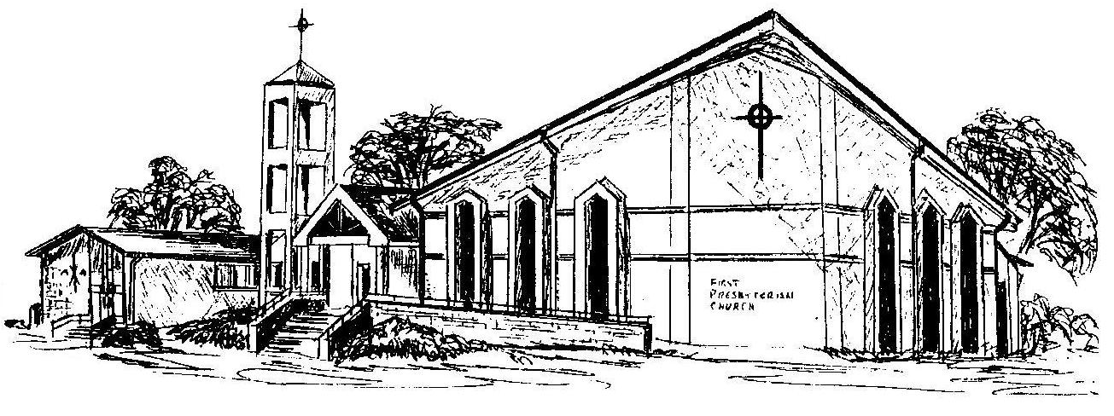

First Presbyterian Church
In the heart of Gardner since 1866 ~ Serving from the heart of God

