Welcome & Announcements, Friendship Information, & Sharing Christ’s Peace

Prelude: Medley on Christian Love
Let us prepare our hearts and minds for worship.

Call to Worship
Leader: We gather together to praise God in scripture and song, in prayer and praise.
People: We come together to worship God as a community created by Christ.
Leader: We remember who we are and who God calls us to be.
People: We give thanks for all that has been and all that is yet to come.

*Opening Hymn: In Thanksgiving Let Us Praise Him The Hymnal, #557

*Prayer of Confession (Unison)
Gracious God, we open our hearts and confess our sins – against you, against our neighbor, against even ourselves. For the wrongs of our minds, our hearts, our hands, our spirits – forgive us. For all the times we do not carry to completion that work which you have started in us – forgive us. For all the ways we fail to allow your love to abound more and more – forgive us. Fill us with the good fruit of right living which you have promised in Jesus Christ our Savior and Lord. Amen.

*Silent Reflection

*Assurance of Pardon
Leader: Anyone who is in Christ is a new creation.
People: A new life has begun in Jesus Christ.
Leader: God calls us to new miracles of grace every day.
People: We respond to God’s mercy in gratitude and joy.

*Gloria Patri (Glory Be to the Father…) The Hymnal, #623

Scripture Philippians 1:3-11 (page 1825)
Leader: The word of the Lord.
People: Thanks be to God.

Children's Time
Please join in singing one verse of Jesus Loves Me as the children come forward.

Special Music: "At Your Feet" by Hall & Ingram
Sermon: “Well Begun, Not Done” Rev. Kimby Young
*Profession of Faith The Apostle's Creed The Hymnal, inside back cover

*Hymn: More Love to Thee O Christ The Hymnal, #363

Pastoral Prayer & Lord’s Prayer: Please Pray for Ron Crabbs, Family of Gary Helt, Lora Beth Knoche Clark, Jano Smoor, Warren & Erma Knight, John Kuhns, Richard Hatfield, Robyn McGuire, Lee Edwards, Pam Wilson, Mark Freund, Jackson Tijerina, Eric Gourley, DeWald Family, Tara Miller-Palmer, Shirley Wilson, Austin W. Pennington, Doris Ann Case

Offertory: He Who Began a Good Work in You Mohr

*Doxology The Hymnal, #625

*Prayer of Dedication

*Closing Hymn: We Are God’s People The Hymnal, #283

*Benediction

Postlude: Tell the World Skidmore

*Those who are comfortably able will please stand

Todd Burd, Music Ministries & Soloist;
Linda Wolf, Worship Assistant; Alice Rollf, Organist;
Robyn Forkner, Pianist; Heather Rutler, Worship Transcription

Ushers for July 2016
Larry & Janet Flakus, Carl & Sharon Frahme, Mike & Tina Fraser

Sunday, July 10, Mission Pillar Meeting 10:15 AM
Monday, July 11, Congregational Life Pillar Meeting 7:00 PM
Tuesday, July 12, Men’s Breakfast Perkins at 7:30 AM
Wednesday, July 13, Lion’s Club 6:00 PM
Sunday, July 17, Discipleship Pillar Meeting 10:45 AM

School Supply Drive
The deacons would like to invite the congregation to participate in our school supply drive. We will be collecting items starting July 1st through the 20th. If you have any questions, please contact any of the deacons or call Jessica Brunker at 913-238-7601. Our goal is to divide up the supplies collected amongst the schools in our community.

Gardner Community Theater presents “Broadway Review” July 15-16 at 7:00 PM.
Concert at First Presbyterian Church, the tickets are $7.00 at the door.

FirstLight Vacation Bible School July 18-21 6:00 – 8:00 PM
“Cave Quest Following Jesus the Light of the World” will be in the Fellowship Hall July 18-21 6:00 – 8:00 PM. Children ages 3 through completed fourth grade.

Women’s Community Lunch at New Life, Saturday, July 23, 11:30 AM – Brave in Christ. Join a small group of First Presbyterian women as we join other Christian women for lunch.

Blessing of the Back Packs, Students and Teachers
Students of all ages, and teachers or school workers at all levels, are invited to bring a "symbol" of their school year (a backpack, notebook, calendar, planner, even a pencil) to worship with you on Sunday, July 31. You will be invited to come forward for a time of recognition and prayer for the coming year. The blessing is actually for the people, not for the items, as you enter this next important phase, with prayers for another successful year of learning and growing. The recognition is early this year so we will catch teachers as they begin planning and college students before they head off to school. Plan to join us on July 31 for this Back to School Blessing.

Parade
Join us to represent First Presbyterian Church in the Johnson County Fair Parade on Saturday morning, August 6. We can use walkers and candy to pass out.

150 Anniversary Weekend
Photos - Please submit photos of your family or of church events or people for a slideshow. Mark your calendar for a potluck Friday night, August 12. We will welcome home some former members and staff or families of former staff members and Presbytery representatives. Following dinner we will share stories enjoy hymns and perhaps a few other surprises. On Saturday evening we will share an ice cream social and games with the Gardner community. Sunday we will celebrate our regular worship with more memories and inspirations from homecoming guests followed by a pot brunch. If you would like to help organize and implement these plans, contact Kimby Young to volunteer.

Sunday, July 10th, 2016
9:00 AM

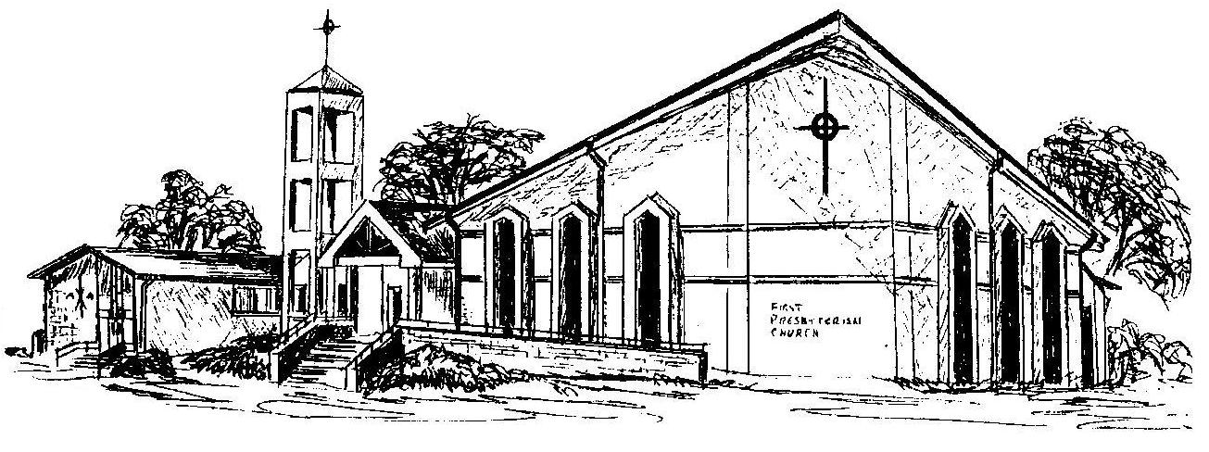

First Presbyterian Church
In the heart of Gardner since 1866 ~ Serving from the heart of God

