Welcome & Announcements, Friendship Information, & Sharing Christ’s Peace
Prelude Christmas Echoes arr. Hodson & Others
Let us prepare our hearts and minds for worship.

Call to Worship & Lighting of the Advent Candles: Advent Readers: The Cornell Family
Leader: Jesus said, “I am the Light of the World, whoever follows me will not walk in darkness, but will have the light of life.”
People: As we light the first candle again in our Advent wreath, we remember the prophet’s hope based on God’s promise: To send a Messiah who would bring peace and love to the world.
Leader: As we light the second candle, we remember the peace of Christ that calms our fears and inspires us to reach out to others,
People: The light reminds us that Christ has come to set our hearts on fire. Get up and make ready, for Jesus Christ comes.
Leader: Let us prepare for the coming of the Lord.

*Opening Hymn: O Come All Ye Faithful Red Hymnal, #145

*Prayer of Confession (Unison)
God of Peace, we come this morning with our hearts far from peaceful. We are distracted and disturbed by our worries, our world, our responsibilities and our inadequacies, even by our sinful choices and behaviors. You call us to prepare for Christ’s coming and yet we are not ready. We do not make room for Christ’s presence in each of our days. Interrupt our busy-ness and pull us into your presence. Open our eyes and ears to your call for us. Fill us with your Spirit that we may see and serve you this season and always. We pray in the name of Jesus Christ, Prince of Peace. Amen.

*Silent Reflection

*Assurance of Pardon

*Gloria Patri (Glory Be to the Father…) Red Hymnal, #623

Scripture Isaiah 11:1-10 (page 1076)
Matthew 3:1-6 (page 1499)
Leader: The word of the Lord.
People: Thanks be to God.

Children's Time- Please join in singing one verse of Jesus Loves Me as children come forward.
Special Music: Celebration for Advent Martin

Sermon “Tasting Peace” Rev. Kimby Young

*Profession of Faith The Apostle's Creed Red Hymnal, inside back cover

*Hymn Come Thou Long Expected Jesus Red Hymnal, #124

Offertory: The Peace Carol Beers

*Doxology Red Hymnal, #625

*Prayer of Dedication & Pastoral Prayer Please Pray for Keith W. Smith, The Family of Ray Brunker Jr., Glenn Schulz, Roland Jack, Rob Kuhauz, Mary Harris, Denny Harris, Delphine Brawner, Carla Betik, Cynthia Miller, Kyle Campbell, Minnie Ashmore, Norma Boone, Mark Howard, Mr. & Mrs. Brad Hadel, Scott Miller, Clay Simmons, Jano Smoor, John Kuhns, Richard Hatfield, Mark Freund, Jackson Tijerina, The DeWald Family, Austin W. Pennington

Communion
Invitation
Great Thanksgiving
The Lord’s Prayer
Breaking of Bread
Communion of the People
Prayer of Thanksgiving

*Closing Hymn: O Little Town of Bethlehem Red Hymnal, #141

*Benediction

Postlude: O Sanctissima Traditional

Kimby Young, Pastor; The Cornell Family, Worship Assistants; Robyn Forkner, Pianist;
Todd Burd, Music Ministries; Alice Rollf, Organist; Donna Douglas, Guest Conductor; Heather Rutler, Worship Transcription

Ushers December 2016
Vern & Leone Knabe; Bob & Char Bergene; Randy & Sandy Rieger

Flowers are given to the Glory of God in Memory of Ray Brunker Jr. by his family.

Monday, December 5, Congregational Life Pillar Meeting 7:00 PM
Wednesday, December 7, Chancel Bell 6:00 – 7:00 PM & Chancel Choir 7:00 – 8:00 PM
Friday, December 9, Court of Honor 7:00 PM
Saturday, December 10, Fellowship Hall set up for Cantata

Welcome Donna Butler Douglas as guest conductor for 3 weeks. Donna is a composer, artist, church consultant and church musician who lives in Olathe with her husband, Gary. Donna has a master's degree in music theory and composition, and has worked for many years in many different churches (including an overlap with Kimby for a few years). Thank you, Donna, for agreeing to join us in ministry through this season.

Confection Sale to raise money for Operation Christmas Child – Pam will be creating wonderful goodies for us. She will be making cream cheese mints and peppermint stir spoons. She will be taking orders on Dec. 4th before and after church. Don’t miss out!

CHRISTMAS POINSETTIAS FOR SANCTUARY COST $11.00 If you would like to purchase one (or more) poinsettias for the sanctuary in memory of or in honor of someone, please let the Church office know by Monday, December 5th. The poinsettias are $11.00 each.

Christmas Cantata entitled “Appalachian Winter” by Joseph Martin. On Sunday, December 11, at 9:00 AM & 11:00 AM, First Presbyterian Church.

Mayors Christmas Tree. The Christmas tree holding the items the children want is located in the foyer. Please consider choosing one or more tags for items to purchase. Do not wrap the gifts but do provide the wrapping paper, bows, etc. for the parents to wrap the presents for the children. Please have all presents returned to church by Dec 11th, so the “elves” can verify that we have everything ready for delivery.

Men’s Breakfast at Perkins
The First Presbyterian Men’s Breakfast will be held at 7:30 AM on Tuesday, December 13, at Perkins Restaurant. Hope to see you!

Christmas Eve, Saturday, December 24, 4:30 p.m. – Candlelight Communion Worship
Christmas Day, Sunday, December 25, 10 a.m. – Casual Celebration of the birth of Jesus Christ; combined with First Light
New Year’s Day, Sunday, January 1, 10 a.m. – New Year’s Day Communion and Worship; combined with First Light

Christmas Joy Offering
During December we receive contributions for the Christmas Joy Offering. This is a PCUSA special offering which is used to provide assistance to current and retired church workers in times of need, and to assist future leaders in Presbyterian-related racial ethnic schools and colleges. You may bring your offering on Christmas Eve, Christmas Day, or any time before those services

Sunday
December 4th, 2016
2nd Sunday Advent
9:00 AM
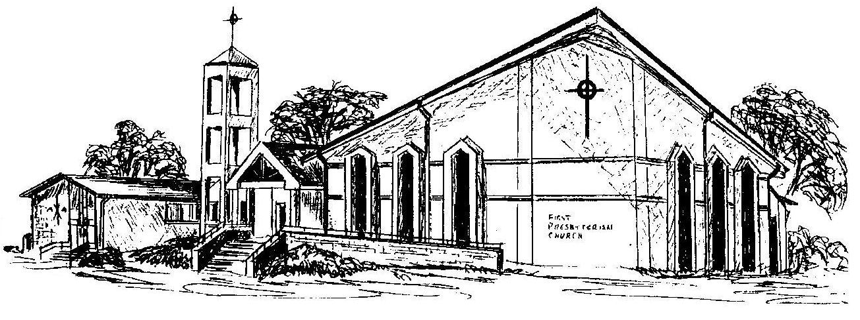

First Presbyterian Church
In the heart of Gardner since 1866 ~ Serving from the heart of God

Welcome - Thank you for joining us for worship today. Please fill out a visitor information card found in the pew racks and place those in the offering plate so that we may follow up with you in the future. Your presence with us today has been a blessing to us, we hope that you have felt the presence of God and the welcome of this congregation.

