Welcome & Announcements, Friendship Information, & Sharing Christ’s Peace
Prelude: Christians, Awake, Salute This Happy Morn Wainwright
Let us prepare our hearts and minds for worship.

Call to Worship
Leader: Jesus Christ is born today! Rejoice and give thanks!
People: Emmanuel has come! God is with us!
Leader: Wonder of wonders, the Word became flesh and has come to dwell among us.
People: And we have seen Christ’s glory, full of grace and truth!
Leader: Glory to God in the highest,
People: And on Earth peace among all whom God favors!

Lighting of the Christ Candle – Today, we light the candles of hope, peace, joy and love. And now, we light the Christ Candle, reminding us of the birth of Jesus Christ Light of the World.
People: “Glory to God in the highest, and on earth peace, good will toward all!”

*Opening Carol: Angels We Have Heard on High Red Hymnal, #132

*Prayer for Christmas Day (Unison) (from Bread for the Journey by Ruth Duck)
Amazing God, you have confounded the wisdom of the world by coming to us in the form of a human baby, frail and vulnerable. Help us to comprehend the great love with which you open yourself to our world, that we in turn may risk to open ourselves in love toward all your children, and that we may find the source of our lives in Jesus Christ and the folly of the cross. Amen.

*Carol: Away in a Manger Red Hymnal, #157

Narration of the Christmas Story
Angels: “Hallelujah!”
Shepherds: “Children of God!
Magi: “Amazing!”

*Carol: The First Noel verse 1 Red Hymnal, #136

Pastoral Prayer:

*Carol: Hark the Herald Angels Sing Red Hymnal, #133

Giving & Receiving:

Offertory: A Child is Born Parks

Prayer of Dedication

*Closing Carol: Joy to the World Red Hymnal, #125

Benediction

Postlude: Ring Christmas Bells Parks
*Those who are comfortably able will please stand

Sunday, December 25th, 2016
Christmas Day
10:00 AM

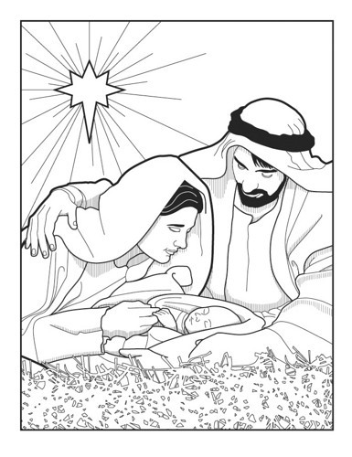

First Presbyterian Church
FirstLight United Methodist Church

Kimby Young, Pastor
Nancy Pauls, Pastor
Alice Rollf, Organist

