Welcome & Announcements, Friendship Information, & Sharing Christ’s Peace
Prelude: O Come, Emmanuel Piano/Organ Duet
Let us prepare our hearts and minds for worship.

Call to Worship and Lightening of the Advent Candles: The Brunker & Allen Family
Leader: Jesus said, “I am the Light of the World, whoever follows me will not walk in darkness, but will have the light of life.”
People: As we light the advent candles again today, we remember the hope, the peace and the joy of all those who have gone before us, all those who have called us and all those who have helped us to prepare for the coming of Christ.
Leader: Today as we light the fourth candle, we remember the love of God as shown most clearly in Jesus Christ our Lord.
People: These candles remind us that this hope, this peace, this joy, and this love are offered to us today.
Leader: Behold, the Light of the World has come!

*Opening Hymn: Joy to the World Red Hymnal, #125
* Prayer of Confession (Unison)
God of Light and Love, as Christmas draws closer, we confess that we are distracted by so many trappings of the season. Remind us again today to focus on Christ and to share your love in the world. We pray in the name of Jesus Christ, Emmanuel, God with us, now and always. Amen.

*Silent Confession

*Assurance of Pardon (Isaiah 9:2)
Leader: The people who walked in darkness have seen a great light.
People: On all living in the land of deep shadows, a light has dawned.
Leader: Friends, hear and believe the Good News of God’s grace.
People: The Light of the world has come! Jesus Christ was born for all!

*Gloria Patri (Glory Be to the Father…) Red Hymnal, #623

Bells Angels We Have Heard On High Arr. B. Wayne Bisbee

Scripture Isaiah 7:14-15 (page 1070)
Isaiah 35:3-10 (page 1111)
Matthew 1:18-25 (page 1497)
Leader: The word of the Lord.
People: Thanks be to God.
Children's Time
Please join in singing one verse of Jesus Loves Me as the children come forward.

Special Music: Say He Will Come Robert Lau

Sermon: “God With Us!” Rev. Kimby Young

*Profession of Faith The Apostle's Creed The Hymnal, inside back cover

*Hymn What Child is This? Red Hymnal, # 137

Pastoral Prayer & Lord’s Prayer: Please Pray for The Family of Julie Page, The Family of Norma Boone, Keith W. Smith, Glenn Schulz, Roland Jack, Rob Kuhauz, Mary Harris, Denny Harris, Delphine Brawner, Carla Betik, Cynthia Miller, Kyle Campbell, Minnie Ashmore, Mark Howard, Mr. & Mrs. Brad Hadel, Scott Miller, Clay Simmons, Jano Smoor, John Kuhns, Richard Hatfield, Mark Freund, Jackson Tijerina, The DeWald Family, Austin W. Pennington

Offertory: Joseph, O Dear Joseph German Melody

*Doxology Red Hymnal, # 625

*Prayer of Dedication

*Closing Hymn: Angels We Have Heard on High Red Hymnal, #132

*Benediction

Postlude: O Come, All Ye Faithful J. Reading
*Those who are comfortably able will please stand

Kimby Young, Pastor; The Brunker & Allen Family, Worship Assistants;
Robyn Forkner, Pianist; Todd Burd, Music Ministries; Alice Rollf, Organist;
Donna Douglas, Guest Conductor; Chancel Choir; Chancel Bells;
Heather Rutler, Worship Transcription

Ushers:
Vern & Leone Knabe; Bob & Char Bergene; Randy & Sandy Rieger

Sunday, December 18, PYF Parent Meeting about the Mission Trip 4:00 PM

Christmas Eve, Saturday, December 24, 4:30 p.m. – Candlelight Communion Worship
Christmas Day, Sunday, December 25, 10 a.m. – Celebration of the birth of Jesus Christ; combined with First Light. Come dressed casually.
New Year’s Day, Sunday, January 1, 10 a.m. – New Year’s Day Communion and Worship; combined with First Light

Sunday School
Seekers & Servants, will meet in the Library. All are invited.

Pastor's Bible Study Class Today Kimby will lead a session on the scripture about Jesus’ birth, as told by different gospel writers. Everyone is welcome to join us. The class will not meet on Sunday, December 25 or Sunday, January 1.

Welcome Donna Butler Douglas as guest conductor for 3 weeks. Donna is a composer, artist, church consultant and church musician who lives in Olathe with her husband, Gary. Donna has a master's degree in music theory and composition, and has worked for many years in many different churches (including an overlap with Kimby for a few years). Thank you, Donna, for agreeing to join us in ministry through this season.

Christmas Joy Offering
During December we receive contributions for the Christmas Joy Offering. This is a PCUSA special offering which is used to provide assistance to current and retired church workers in times of need, and to assist future leaders in Presbyterian-related racial ethnic schools and colleges. You may bring your offering on Christmas Eve, Christmas Day, or any time before those services.

New Member Inquiry - If you would like to know more about membership or would like to join, please contact Pastor Kimby Young. We will set a gathering time in January based on the schedules of those who have expressed interest.

Save the Date - Cooper McGuire Free Fundraising Concert - Sunday, January 8, 2:30 p.m. - to raise money for the Kansas State University tour of Ireland in May. Thank you to Cooper for directing the handbell choir today.

The New Nativity Set in the Shawnee side entryway is a Memorial Gift given to the glory of God and in memory of Richard “Dick” Murrow by Juanita Murrow, Mike & Robyn McGuire and family, and Rod Murrow.

Sunday, December 18th, 2016
Third Sunday of Advent
9:00 AM
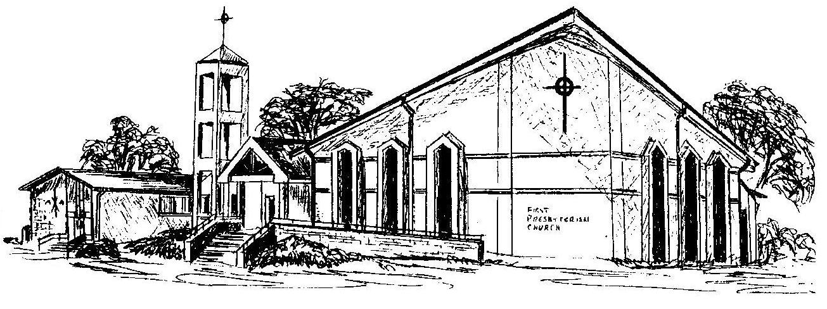

First Presbyterian Church
In the heart of Gardner since 1866 ~ Serving from the heart of God

Welcome - Thank you for joining us for worship today. Please fill out a visitor information card found in the pew racks and place those in the offering plate so that we may follow up with you in the future. Your presence with us today has been a blessing to us, we hope that you have felt the presence of God and the welcome of this congregation.

