Welcome & Announcements, Friendship Information, & Sharing Christ’s Peace
Seconds for Stewardship –Deacons

Prelude: I Sing Praises MacAlmon
Lift Every Voice and Sing Johnson
Let us prepare our hearts and minds for worship.

Call to Worship
Leader: For all the saints who went before us, who have spoken to our hearts and touched us with your fire,
People: We praise you, O God!
Leader: For all the saints who live beside us, whose weaknesses and strengths are woven with our own,
People: We praise you, O God!
Leader: For all the saints who live beyond us, who challenge us to change the world with them,
People: We praise you, O God!

*Opening Hymn: For All The Saints Blue Hymnal, #526

*Prayer of Confession (Unison) (Book of Common Worship, PCUSA)
Eternal God, in every age you have raised up men and women to live and die in faith. We confess that we are often indifferent to your will. You call us to proclaim your name, but we are silent. You call us to do what is just, but we remain idle. You call us to live faithfully, but we are afraid. In your mercy, forgive us. Give us courage to follow in your way, that joined with those from ages past, who have served you with faith, hope, and love, we may inherit the kingdom you promised in Jesus Christ. Amen.

*Silent Reflection

*Assurance of Pardon
Leader: In life and in death, we belong to God.
People: By God’s grace we are renewed each day. By God’s grace we receive new life.
Leader: Hear the good news of God’s grace and forgiveness.
People: In Jesus Christ, we are set free to live as God’s people in the world.

*Gloria Patri (Glory Be to the Father…) Blue Hymnal, #579

Scripture John 14:1-3, 11-21; 25-31 (page 1675)
Hebrews 12:1-3 (page 1877)
Leader: The word of the Lord.
People: Thanks be to God.
Children's Time
Please join in singing one verse of Jesus Loves Me as the children come forward.

Special Music: Come to the Table of the Lord Althouse

Sermon “We Belong to God” Rev. Kimby Young

*Profession of Faith The Apostle's Creed Blue Hymnal, top page 14

*Hymn We Belong to God Blue Hymnal, #400

Offertory: It is Well with My Soul Bliss

*Doxology Blue Hymnal, #592

*Prayer of Dedication & Pastoral Prayer Please Pray for Pam Wilson, Jerrine Reed, Rob Kuhauz, Amanda (Allen) Smith, Mary Harris, Denny Harris, Delphine Brawner, Carla Betik, Corky Scarlett, Cynthia Miller, Kyle Campbell, Minnie Ashmore, Norma Boone, Mark Howard, Mr. & Mrs. Brad Hadel, Scott Miller, Clay Simmons, Jano Smoor, John Kuhns, Richard Hatfield, Mark Freund, Jackson Tijerina, DeWald Family, Tara Miller-Palmer

Communion & Celebration of all Saints
Invitation
Great Thanksgiving
The Lord’s Prayer
Breaking of Bread
Communion of the People
Prayer of Thanksgiving

*Closing Hymn: Lift Every Voice and Sing Blue Hymnal, #563

*Benediction

Postlude: Song of the Faithful Hughes

Kimby Young, Pastor; Carl Frahme, Worship Assistant; Robyn Forkner, Pianist;
Todd Burd, Music Ministries; Alice Rollf, Organist; Annette Pascarelli, Worship Transcription

Ushers November 2016
Karl & Kim Allen; Joni Meyer; Ron & Connie Crabbs; Sandy Nellor
Congratulations to John & Sarah Hutchison who have a new baby boy, John Henry Hutchison, born October 31st. His grandparents are Phil & Judy Lenahan.

Monday, November 7, Congregational Life Pillar Meeting 7:00 PM
Tuesday, November 8, Breakfast on the farm, Bob Bergene’s 7:30 AM
Saturday, November 12, Operation Christmas Child Packing Party 9:00 – 11:00 AM
November 14-20, Operation Christmas Child packed boxes due Nov 20, by 12:00 PM

Advent Devotions - We are still accepting submissions for daily Advent Devotionals from the congregation. They are due this week so that we can compile them to distribute at the end of the month. Sign up or speak to Kimby if you have an idea or an article to submit.

Mitten Tree – PW and Mission pillar are combining resources to promote and fill the mitten tree. Please start gathering hats and mittens to fill our tree. School/schools to receive the donations will be announced as soon as confirmed with the GE schools.

Breakfast on the Farm
The First Presbyterian Men’s Breakfast will be held at 7:30 AM on Tuesday, November 8, at Bob Bergene’s farm, Bob’s address is 30165 W 154th Street. Hope you can make it.

Nursing Home Worship Service at Meadowbrook 3:30 PM & Medicalodge 4:00 PM
Nov. 6th- PW
Nov. 13th – Discipleship Pillar
Nov. 20th – Mission Pillar
Nov. 27th – Pastor Kimby & Friends

Ladies Fall Gathering on Thursday, November 17 at 6:30 PM
Program will be a slide show by Hannah Culbertson about her mission trip to Africa. Special music will be provided by Megan Wetherington. Both young ladies are from our church family. Please bring your favorite salad to share, your own table service, and a friend.

Stewardship Pledge Dedication will be Sunday, November 20 at the 9 a.m. service. If you did not receive a letter this week with a pledge card in it, and would like to receive one, please let Connie or Kimby know.

Thank offering will be received on Sunday, Nov. 20th. This PW collection will fund 22 projects internationally for health ministries and self-development. It is an offering used to express gratitude to God intangible ways.

Advent begins on Sunday, November 27 - Thanksgiving weekend. If you or your family would be willing to read scripture or liturgy during Advent, on Christmas Eve, or on Christmas Day, please contact Paula Waters to be put on a list. Some dates are already taken.

Sunday
November 6th, 2016
All Saints’ Day
9:00 AM
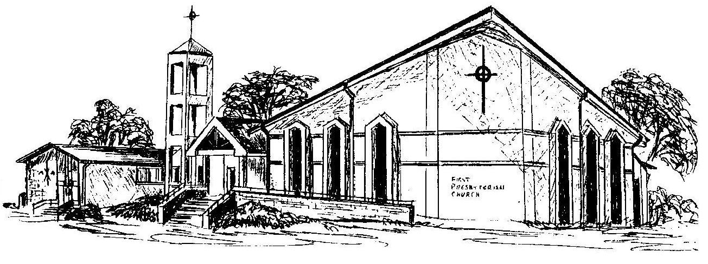

First Presbyterian Church
In the heart of Gardner since 1866 ~ Serving from the heart of God

Welcome - Thank you for joining us for worship today. Please fill out a visitor information card found in the pew racks and place those in the offering plate so that we may follow up with you in the future. Your presence with us today has been a blessing to us, we hope that you have felt the presence of God and the welcome of this congregation.

