Welcome & Announcements, Friendship Information, & Sharing Christ’s Peace

Prelude: Jesu, Joy of Man's Desiring Bach

Call to Worship : Advent Readers: Larry & Rhonda Atwater
Leader: Jesus said, “I am the Light of the World, whoever follows me will not walk in darkness, but will have the light of life.”
People: Today, we light the first candle on our Advent wreath.
Leader: We remember the prophets’ hope based on God’s promise to send a Messiah, one who would bring peace and love to the world.
People: The first light reminds us that God’s promises are still true for us today.
Leader: Wait and hope, for Jesus Christ is coming.

*Opening Hymn Come Ye Thankful People Come Red Hymnal, # 559

*Call to Confession
Leader: Thanksgiving Day has passed, but the season of giving thanks continues.
People: We remember with gratitude all the ways God has blessed us.
Leader: Our Creator comes to dwell among us, to live love for us and through us.
People: With expectation and hope, we turn to God in prayer, seeking God’s presence and guidance.
Leader: Let us pray together.

*Confession (Unison)
Holy God of hope and promise, we come today seeking your grace. We have heard your promises down through the ages. We have experienced your presence walking beside us. And yet we are reluctant to live with the confidence that you are with us here and now. We fear what tomorrow might bring, instead of rejoicing in the abundance you offer. Help us to live into the hope you have given in the name of Jesus Christ, Emmanuel, God with us. Amen.

*Silent Reflection

*Assurance of Pardon
Leader: Hebrews 11 says “Faith is the assurance of things hoped for, the conviction of things not seen.”
People: Hope means believing when there is no proof.
Leader: Friends, we have more than hope in the promises of Jesus Christ. Though there is no proof for what we believe, we daily experience that grace of God that goes beyond understanding.
People: We receive the promises of God and know God’s love to be true. In Jesus Christ we are redeemed.
*Gloria Patri (Glory Be to the Father…) Red Hymnal, # 623
Scripture Isaiah 2:2-5 (page 1062)
John 1:1-5 (page 1645)
Leader: The word of the Lord.
People: Thanks be to God.

Children's Time
Please join in singing one verse of Jesus Loves Me as the children come forward.

Special Music: Alleluia for Advent Liebergen

Sermon “Walking in the Light” Rev. Kimby Young

*Profession of Faith The Apostle's Creed Red Hymnal, inside back cover

*Hymn: O Come, O Come, Emmanuel Red Hymnal, #123

Pastoral Prayer & Lord’s Prayer: Please Pray for Keith W. Smith, The Family of Jerrine Reed, Glenn Schulz, Roland Jack, Rob Kuhauz, Mary Harris, Denny Harris, Delphine Brawner, Carla Betik, Cynthia Miller, Kyle Campbell, Minnie Ashmore, Norma Boone, Mark Howard, Mr. & Mrs. Brad Hadel, Scott Miller, Clay Simmons, Jano Smoor, John Kuhns, Richard Hatfield, Mark Freund, Jackson Tijerina, The DeWald Family

Offertory: O Come, O Come, Immanuel arr. Wilson
*Doxology Red Hymnal, #625
*Prayer of Dedication

*Closing Hymn: Rejoice Ye Pure in Heart Red Hymnal, #562

*Benediction

Postlude: Ode to Thanksgiving Beethoven
*Those who are comfortably able will please stand

Kimby Young, Pastor; Larry & Rhonda Atwater, Worship Assistant; Alice Rollf, Organist;
Todd Burd, Music Ministries; Robyn Forkner, Pianist; Chancel Choir;
Heather Rutler, Worship Transcription

Ushers for November 2016
Kim & Karl Allen; Joni Meyer; Ron & Connie Crabbs; Sandy Nellor
Sunday, November 27, No SS, Kimby’s class, Pre K – 8th.
Sunday, November 27, Worship Pillar Meeting 11:15 AM
Monday, November 28, PW Meeting 7:00 PM
Friday, December 2, Joy Closet Volunteer Dinner 6:30 PM
Saturday, December 3, Women’s Christmas Luncheon 12:00 PM
Sunday, December 4, Worship Communion Service 9:00 AM
Monday, December 5, Congregational Life Pillar Meeting 7:00 PM

Nursing Home Worship Service at Meadowbrook 3:15 PM & Medicalodge 4:00 PM
Nov. 27th – Pastor Kimby & Friends & Volunteers Welcome!

Mitten Tree – PW and Mission pillar are combining resources to promote and fill the mitten tree. Please start gathering hats and mittens to fill our tree. School/schools to receive the donations will be announced as soon as confirmed with the GE schools.

Joy Closet Volunteer Dinner - Friday, December 2, 6:30 PM. Meat and Drink provided. Please bring a side dish to share. We look forward to saying “Thank You” to our volunteers for their hard work and dedication to this ministry.

Women’s Christmas Luncheon – Saturday, December 3, noon. Bring a dish to share, and a “white elephant” gift (less than $5). Guests are welcome. Invite a friend.

Mayor’s Christmas Project – We have adopted three local children to receive gifts from our congregation. You may contribute money to purchase a larger item or you may choose a gift tag with a description of a specific gift to purchase and return by December 11. Tree tags are available in the narthex on the small Christmas tree. Follow the instructions on the gift tag.

Christmas Joy Offering – a PCUSA special offering will be received any time in December and on Christmas Eve or Christmas Day. This offering is used to provide assistance to current and retired church workers in times of need, and to assist future leaders in Presbyterian-related racial ethnic schools and colleges.

Christmas Eve worship service will be held on December 24 at 4:30 P.M. with candlelight, communion, and carols. Come for our traditional service and invite a friend.

Christmas Day worship will be held on Sunday, December 25 at 10:00 A.M. We will combine with FirstLight United Methodist Church for one service in celebration of the birth of our Lord Jesus Christ. This will be a casual come-as-you-are service of scripture, carols and prayer. We will remember the greatest gift ever given as we praise God together.

New Year’s Day worship will also be held on Sunday, January 1 at 10:00 A.M. combining with FirstLight United Methodist Church. Mark your calendars and plan to attend.

Sunday
1st Sunday of Advent
November 27th, 2016
9:00 AM

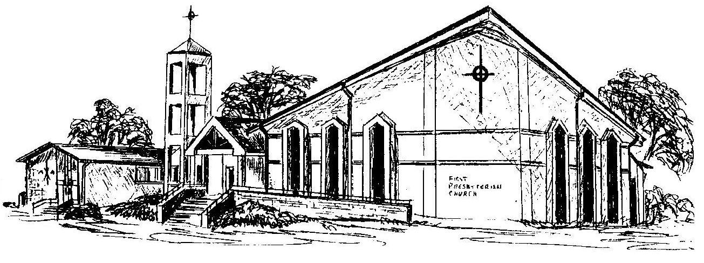

First Presbyterian Church
In the heart of Gardner since 1866 ~ Serving from the heart of God

Welcome - Thank you for joining us for worship today. Please fill out a visitor information card found in the pew racks and place those in the offering plate so that we may follow up with you in the future. Your presence with us today has been a blessing to us, we hope that you have felt the presence of God and the welcome of this congregation.

