Welcome & Announcements, Friendship Information, & Sharing Christ’s Peace

Prelude: Christ is King! Medley

Call to Worship
Leader: Look around you and be grateful for all that God has given.
People: An abundance of gifts surround us, material and spiritual – even too many to be named or counted.
Leader: Look within you and be grateful for all that God has given.
People: Gifts, talents, abilities, interests, experiences and opportunities overflow from the hand of a loving God.

*Opening Hymn We Gather Together Red Hymnal, #561

*Prayer of Confession (Unison)
God of giving and grace, so often we forget to thank you for your abundant generosity. So often we take for granted the gifts you have given us, as if they are for our use alone, rather than for the common good. Forgive us, and inspire us, to use our gifts generously for others, to share our resources well, and to affirm the gifts of all we see around us by the grace of Jesus Christ. Amen.

*Silent Reflection

*Assurance of Pardon
*Gloria Patri (Glory Be to the Father…) Red Hymnal, # 623
PW Thank Offering & Mitten Tree Dedication
Chancel Bells Seek Ye First Arr. Wagner
Scripture Psalm 100 (page 937)
Mark 12: 28-31 (page 1575)
1 Corinthians 12:4-7 (page 1785)
Leader: The word of the Lord.
People: Thanks be to God.

Children's Time - Operation Christmas Child Box Dedication
Please join in singing one verse of Jesus Loves Me as the children come forward.

Special Music: Praise His Holy Name Keith Hampton

Sermon “Dedication” Rev. Kimby Young

*Profession of Faith The Apostle's Creed Red Hymnal, inside back cover

*Hymn: Now Thank We All Our God Red Hymnal, #556

Installation of Elders and Deacons:
Elders: Vera Beach, Eldonna Chesnut, Sandy Rieger, Delores Guilinger, Joyce Scarlett
Deacons: Denise Bockus, Linda Wolf, Marilyn Huffman. Jessica Brunker,
Vern Knabe, Joyce Pattrick

Pastoral Prayer & Lord’s Prayer: Please Pray for Glenn Schulz, Roland Jack, Jerrine Reed, Rob Kuhauz, Mary Harris, Denny Harris, Delphine Brawner, Carla Betik, Cynthia Miller, Kyle Campbell, Minnie Ashmore, Norma Boone, Mark Howard, Mr. & Mrs. Brad Hadel, Scott Miller, Clay Simmons, Jano Smoor, John Kuhns, Richard Hatfield, Mark Freund, Jackson Tijerina, The DeWald Family

Presentation of Stewardship Pledge Cards

Offertory: Savior, Source of Every Blessing Mozart
*Doxology Red Hymnal, #625
*Prayer of Dedication

*Closing Hymn: In Thanksgiving Let Us Praise Him Red Hymnal, #557

*Benediction

Postlude: A Psalm of Thanksgiving Wilson
*Those who are comfortably able will please stand

Kimby Young, Pastor; Robyn Forkner, Worship Assistant; Alice Rollf, Organist;
Todd Burd, Music Ministries; Robyn Forkner, Pianist; Chancel Bells;
Chancel Choir; Heather Rutler, Worship Transcription

Ushers for November 2016
Kim & Karl Allen; Joni Meyer
Ron & Connie Crabbs; Sandy Nellor
Sunday, November 20, PYF Breakfast 9:45 – 11:15 AM
Monday, November 21, PW Meeting 7:00 PM
Thursday, November 24, Thanksgiving Day Office Closed
Friday, November 25, Office Closed
Sunday, November 27, 1st Sunday of Advent 9:00 AM

Nursing Home Worship Service at Meadowbrook 3:30 PM & Medicalodge 4:00 PM
Nov. 20th – Mission Pillar
Nov. 27th – Pastor Kimby & Friends & Volunteers Welcome!

Mitten Tree – PW and Mission pillar are combining resources to promote and fill the mitten tree. Please start gathering hats and mittens to fill our tree. Schools to receive the donations will be announced as soon as confirmed with the GE schools.

Operation Christmas Child Boxes Due Today - Boxes will be delivered this week to the Gardner collection site for shipping. Today we dedicate all of the boxes and pray they are a blessing to children world wide who receive these gifts. Thank you to everyone who showed up for our packing party last week. Thank you to Pam Wilson and the entire Mission Pillar for another job well done.

The PYF will be hosting their annual fall brunch today. Delicious hot breakfast items will be available from 9:45-11:15. Donations will be accepted to support the 2017 youth mission trip. Come enjoy good food and great fellowship!

Stewardship Pledge Dedication is today. Pledge cards are available in the narthex.

Thank offering is received today. This PW collection will fund 22 projects internationally for health ministries and self-development. It is an offering used to express gratitude to God in tangible ways.

Advent begins next Sunday, November 27 - Thanksgiving weekend. If you or your family would be willing to read scripture or liturgy during Advent, on Christmas Eve, or on Christmas Day, please contact Paula Waters to be put on a list. Some dates are already taken.

Mayors Christmas Tree Project - Again this year we have adopted some children from the city to provide Christmas gifts. Our gift tag tree will be out in the narthex next Sunday.

Women’s Christmas Luncheon on Saturday, December 3 at Noon in the Fellowship Hall.

Sunday
November 20th, 2016
9:00 AM

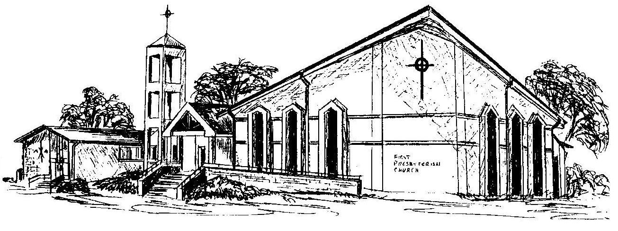

First Presbyterian Church
In the heart of Gardner since 1866 ~ Serving from the heart of God

Welcome - Thank you for joining us for worship today. Please fill out a visitor information card found in the pew racks and place those in the offering plate so that we may follow up with you in the future. Your presence with us today has been a blessing to us, we hope that you have felt the presence of God and the welcome of this congregation.

