Welcome & Announcements, Friendship Information, & Sharing Christ’s Peace
Seconds from Stewardship Congregation Life Pillar

Prelude: In Harvest Time Clarke

Call to Worship
Leader: All around us God has blessed us with abundance.
People: We thank God for the gifts of this day, and for each new day.
Leader: We turn our eyes and our hearts to see God’s grace around us.
People: We worship God with grateful hearts and open hands.

*Opening Hymn Come Thou Fount of Every Blessing Red Hymnal, #2

*Prayer of Confession (Unison) (by Joanna Harader, Spacious Faith)
Holy One, We long to be faithful stewards of your abundant grace. We long to serve each other in love and humility, to serve your world with wisdom and energy. Forgive us when we stumble over pride, when our words and actions are not guided by love. Forgive us when fear overtakes us, when we are not bold enough to recognize your gifts all around us. Turn our hearts when we act in folly. Restore our energy when it is gone. Sometimes, many times, O God, our efforts fail. But your abundant grace is strong and eternal. We are grateful that forgiveness is ours through Jesus Christ our Lord. Amen.

*Silent Reflection

*Assurance of Pardon
*Gloria Patri (Glory Be to the Father…) Red Hymnal, # 623
Scripture Exodus 16:11-21 (page 112)
Matthew 6:25-34 (page 1505)
Leader: The word of the Lord.
People: Thanks be to God.

Children's Time
Please join in singing one verse of Jesus Loves Me as the children come forward.

Special Music: Give Thanks Smith

Sermon “Abundance vs. Scarcity” Rev. Kimby Young

*Profession of Faith The Apostle's Creed Red Hymnal, inside back cover

*Hymn: Open My Eyes, That I May See Red Hymnal, #381

Pastoral Prayer & Lord’s Prayer: Please Pray for Connie Turner, Dennis Chambers, Shelley Broas, Jerrine Reed, Rob Kuhauz, Mary Harris, Denny Harris, Delphine Brawner, Carla Betik, Corky Scarlett, Cynthia Miller, Kyle Campbell, Minnie Ashmore, Norma Boone, Mark Howard, Mr. & Mrs. Brad Hadel, Scott Miller, Clay Simmons, Jano Smoor, John Kuhns, Richard Hatfield, Mark Freund, Jackson Tijerina, DeWald Family

Offertory: My Shepherd Will Supply My Need Broughton
*Doxology Red Hymnal, # 625
*Prayer of Dedication

*Closing Hymn: For the Beauty of the Earth Red Hymnal, #560

*Benediction

Postlude: Our Hymn of Grateful Praise Kocher / arr. Rasley

*Those who are comfortably able will please stand

Kimby Young, Pastor; Keely McCabe, Worship Assistant; Alice Rollf, Organist;
Todd Burd, Music Ministries; Robyn Forkner, Pianist;
Chancel Choir; Heather Rutler, Worship Transcription

Ushers for November 2016
Kim & Karl Allen; Joni Meyer
Ron & Connie Crabbs; Sandy Nellor

Sunday, November 13, Mission Pillar Meeting 11:15 AM
Sunday, November 13, Discipleship Pillar Meeting 11:15 AM
Monday, November 14, Session 6:30 PM
Monday, November 14, Deacons 6:30 PM
Wednesday, November 16, Chancel Bells 6:00 – 7:00 PM; Chancel Choir 7:00 – 8:00 PM
Thursday, November 17, Ladies Night Salad Supper 6:30 PM
Sunday, November 20, PYF Breakfast 9:45 – 11:15 AM
Nursing Home Worship Service at Meadowbrook 3:30 PM & Medicalodge 4:00 PM
Nov. 13th – Discipleship Pillar
Nov. 20th – Mission Pillar
Nov. 27th – Pastor Kimby & Friends & Volunteers Welcome

Mitten Tree – PW and Mission pillar are combining resources to promote and fill the mitten tree. Please start gathering hats and mittens to fill our tree. School/schools to receive the donations will be announced as soon as confirmed with the GE schools.

Ladies Fall Gathering on Thursday, November 17 at 6:30 PM
Program will be a slide show by Hannah Culbertson about her mission trip to Africa. Special music will be provided by Megan Wetherington. Both young ladies are from our church family. Please bring your favorite salad to share, your own table service, and a friend.

The Olathe Mayor’s Prayer Breakfast will be held on Friday, Nov. 18 from 6:30 - 8 a.m. in the Cook Center on the campus of MNU. This annual event brings all segments of the surrounding communities together to share in a morning of spiritual renewal and reflection on the Friday prior to Thanksgiving. The featured speaker for this year is Mr. Dayton Moore, General Manager of the Kansas City Royals. Tickets for the event are $20 and may be purchased from Robyn Forkner. Please visit www.olathempb.org/ for more information.

The PYF will be hosting their annual fall brunch on Sunday, November 20. Delicious hot breakfast items will be available from 9:45-11:15. Donations will be accepted to support the 2017 youth mission trip. Come enjoy good food and great fellowship!

Stewardship Pledge Dedication will be Sunday, November 20 at the 9 a.m. service. If you did not receive a letter with a pledge card in it, and would like to receive one, please let Connie or Kimby know.

Thank offering will be received on Sunday, November 20. This PW collection will fund 22 projects internationally for health ministries and self-development. It is an offering used to express gratitude to God in tangible ways.

Advent begins on Sunday, November 27 - Thanksgiving weekend. If you or your family would be willing to read scripture or liturgy during Advent, on Christmas Eve, or on Christmas Day, please contact Paula Waters to be put on a list. Some dates are already taken.

Sunday
November 13th, 2016
9:00 AM

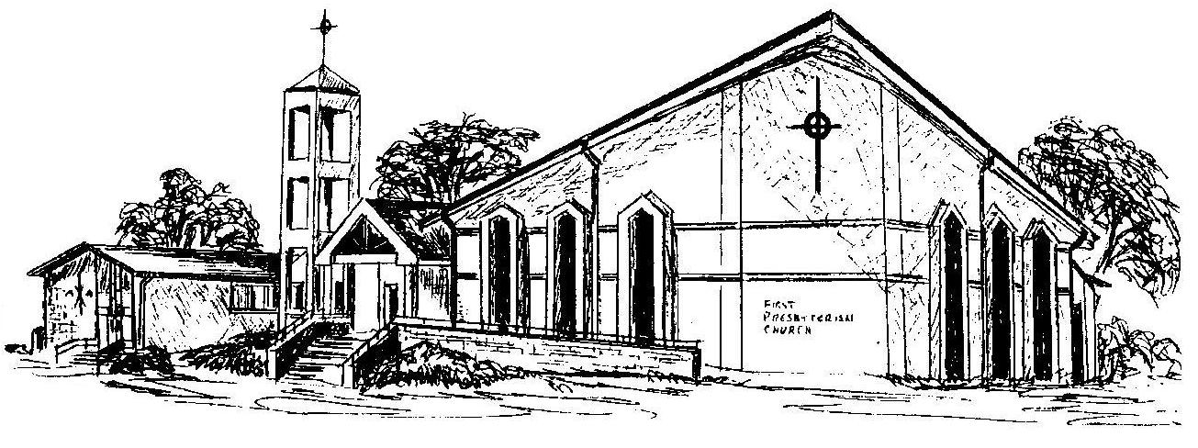

First Presbyterian Church
In the heart of Gardner since 1866 ~ Serving from the heart of God

Welcome - Thank you for joining us for worship today. Please fill out a visitor information card found in the pew racks and place those in the offering plate so that we may follow up with you in the future. Your presence with us today has been a blessing to us, we hope that you have felt the presence of God and the welcome of this congregation.

