Welcome & Announcements, Friendship Information, & Sharing Christ’s Peace

Seconds for Stewardship Mission Pillar

Prelude: Blessed Assurance /Great is Thy Faithfulness Knapp / Runyan

Call to Worship (from Psalm 46)
Leader: God is our refuge and strength, a very present help in trouble.
People: Therefore we will not fear, though the earth should change.
Leader: Come, behold the works of the Lord.
People: Be still and know that I am God.

*Opening Hymn Great is Thy Faithfulness Blue Hymnal, #276

*Prayer of Confession (Unison)
Great and Faithful God, we admit that sometimes we fail to trust you. We get distracted and lose sight of your plan. We forget your promises and look for assurance elsewhere. Forgive us. Remind us again of your unfailing grace. Strengthen us with your presence. Inspire us to hope in Jesus Christ our Lord. Amen.

*Silent Reflection

*Assurance of Pardon

*Gloria Patri (Glory Be to the Father…) Blue Hymnal, #579

Scripture Jeremiah 29:4-12 (page 1221)
Romans 8:24-28 (page 1757)
Leader: The word of the Lord.
People: Thanks be to God.

Children's Time
Please join in singing one verse of Jesus Loves Me as the children come forward.

Special Music: Come and See Michael Barrett
Sermon “A Future With Hope” Rev. Kimby Young

*Profession of Faith The Apostle's Creed Blue Hymnal, top page 14

*Hymn: God of Our Life Blue Hymnal, #275
Pastoral Prayer & Lord’s Prayer: Please Pray for the Family of Don Speer, Kyle Campbell, Ralph Corwin, Gladys Lane, Minnie Ashmore, Norma Boone, Mark Howard, Mr. & Mrs. Brad Hadel, Scott Miller, Clay Simmons, Jano Smoor, John Kuhns, Richard Hatfield, Mark Freund, Jackson Tijerina, DeWald Family, Tara Miller-Palmer, Shirley Wilson, Austin W. Pennington

Offertory: His Eye is on the Sparrow Gabriel
*Doxology Blue Hymnal, #592
*Prayer of Dedication

*Closing Hymn: Our God, Our Help in Ages Past Blue Hymnal, #210

*Benediction

Postlude: Father Welcomes Mayhew

*Those who are comfortably able will please stand

Flowers are given today to the Glory of God in Loving Memory of
Bill, Maxine and Steve Punches by Ron & Connie Crabbs & Family

Kimby Young, Pastor; Lynn Moldrup, Worship Assistant; Alice Rollf, Organist;
Todd Burd, Music Ministries; Robyn Forkner, Pianist;
Chancel Choir; Heather Rutler, Worship Transcription

Ushers for October 2016
Brian & Denise Bockus; Larry Schick
LeMoyne & Donnie Zimmerman; Brett Wilson

Sunday, October 9, Mission Pillar Meeting 11:15 AM
Monday, October 10, Session 6:30 PM
Tuesday, October 11, Men’s Breakfast Perkins 7:30 AM Gardner Police Chief
Wednesday, October 12, Chancel Bells 6:00 – 7:00 PM
Wednesday, October 12, Chancel Choir 7:00 – 8:00 PM
Thursday, October 13, Ladies Bible Study 7:00 PM
Saturday, October 15, Open House at Pastor Kimby’s, 371 N. Sumac, 4:00 – 6:00 PM
Monday, October 17, PW Meeting All Women invited 7:00 PM

Joy Closet Volunteers Needed Cashier every other Thursday morning 10:00AM – 1:00PM and two Monday evenings a month 4:00 – 7:00PM.

Boy Scout Jacob Hoffman Creating a Memorial Garden for Eagle Project Buy a brick.
Personalized paving bricks are being sold to memorialize loved ones. Please consider the purchase of one or more of these bricks to make a permanent remembrance in the Memorial Garden. Each brick costs $50.00. Supplement funds are available, if that cost is too high for you. If you are interested in a brick, see Jacob in the Narthex after service, please contact Brett Wilson at brett.wilson@jocogov.org or call him at 913-208-8190.

Operation Christmas Child collection for this month is socks, (boys/girls) underwear, school supplies, bar soap and wash cloths.

New Short-term Basic Bible Study - Pastor Kimby leading - Sundays, 4:30-6 p.m. - The course is aimed at beginners. More advanced students, are welcome to come share expertise. The class has started but it is not too late to join. Anyone is welcome – member or friend. No advance registration is required. Contact Pastor Kimby with questions.

Mission Auction – October 22 – Items needed to Auction off. 6:00 – 6:30 Spaghetti dinner served. Minimum $5.00 donations requested per person. Tickets can be purchased in the church office or call 913-856-4099 for a reservation. 7:00 Auction begins and is free to everyone to attend and bid. Proceeds will support Operation Christmas Child, Johnson County area Care Portal, and Presbyterian International Relief Fund.

Advent Devotional Booklet 2016 – Seeking Submissions - Please consider writing a short reflection to share with the congregation for daily devotionals. Contact pastor Kimby or sign up on the sheet in the narthex. Entries are due by Monday, November 7.

Wacky Dinner November 20th 4-6pm. – consider opening your home for part of the meal. Contact Nancy Falkner to volunteer.

REMEMBER OUR DEPARTED LOVED ONES
ALL SAINTS’ DAY SUNDAY, NOVEMBER 6th, 2016
We will honor the memory of our recently departed loved ones during the worship service. Please send in names of your departed loved ones by email, phone, or use the form due by Wednesday, October 19th. Tear form off and put in the offering plate.

Name of Departed ___________________________________________________

Given by___________________________________________________________

Sunday
October 9th, 2016
9:00 AM

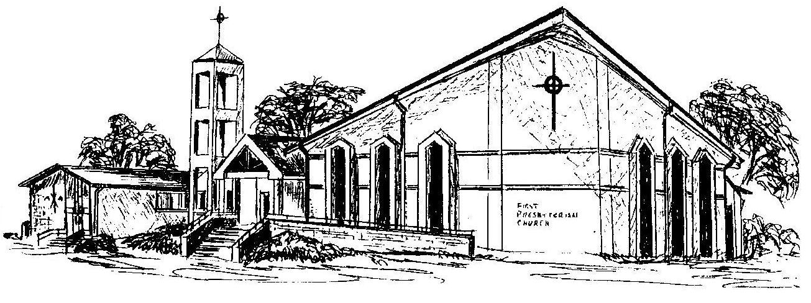

First Presbyterian Church
In the heart of Gardner since 1866 ~ Serving from the heart of God

Welcome - Thank you for joining us for worship today. Please fill out a visitor information card found in the pew racks and place those in the offering plate so that we may follow up with you in the future. Your presence with us today has been a blessing to us, we hope that you have felt the presence of God and the welcome of this congregation.

