Welcome & Announcements, Friendship Information, & Sharing Christ’s Peace

Seconds for Stewardship - PYF

Prelude: Selection of Children’s Hymns

Call to Worship
Leader: Come, people of God, for this is Children’s Sabbath.
People: Today we celebrate children, and we accept the challenge of lifting up God’s children everywhere.
Leader: Come, children of God, celebrate God’s grace.
People: We come as little children into the loving arms of Christ.

*Opening Hymn This is My Father’s World Red Hymnal, #58

*Prayer of Confession (Unison) (from Children’s Defense Fund)
Creator God, You have made each of us in Your image, and yet we fail to reflect your love and justice. You have created every child in Your image, and yet we do not treat every child as a precious reflection of You. We see some children as valued treasures, and others as lost causes. We invest our time, money and hopes in some children, while we squander the great potential of others. Open our eyes, we pray to see that every child is made in Your image and belongs to You. Help us to love, protect and nurture all children. We pray these things in the name of the One who came to us as a child wrapped in swaddling clothes and lying in a manger. Amen.

*Silent Reflection

*Assurance of Pardon

*Gloria Patri (Glory Be to the Father…) Red Hymnal, #623

Chancel Bells: Amazing Grace Sandra Eithum
Scripture Exodus 1:22-2:10 (page 88)
Mark 10:13-16 (page 1570)
Leader: The word of the Lord.
People: Thanks be to God.

Children's Time
Please join in singing one verse of Jesus Loves Me as the children come forward.
Special Music: A Little Child Will Lead Them Grier & Everson

Sermon “Every Fifth Child” Rev. Kimby Young

*Profession of Faith The Apostle's Creed Red Hymnal, inside back cover

*Hymn: Jesus Loves the Little Children Red Hymnal, #580

Pastoral Prayer & Lord’s Prayer: Please Pray for Mary Harris, Denny Harris, Delphine Brawner, Carla Betik, the family of Sylvia Bing, the family of Merle Winters, the family of Shirley Wilson, Corky Scarlett, Cynthia Miller, Kyle Campbell, Gladys Lane, Minnie Ashmore, Norma Boone, Mark Howard, Mr. & Mrs. Brad Hadel, Scott Miller, Clay Simmons, Jano Smoor, John Kuhns, Richard Hatfield, Mark Freund, Jackson Tijerina, DeWald Family, Tara Miller-Palmer

Offertory: The Blessing Song Gordon/arr. Fettke
*Doxology Red Hymnal, #625
*Prayer of Dedication

*Closing Hymn: All Things Bright and Beautiful Red Hymnal, #578

*Benediction

Postlude: I’ve Got Peace Like a River Spiritual
I’m Gonna Live so God Can Use Me Spiritual

*Those who are comfortably able will please stand

Kimby Young, Pastor; Sandy Rieger, Worship Assistant; Alice Rollf, Organist;
Todd Burd, Music Ministries; Robyn Forkner, Pianist; Chancel Bells;
Chancel Choir; Heather Rutler, Worship Transcription

Ushers for October 2016
Brian & Denise Bockus; Larry Schick
LeMoyne & Donnie Zimmerman; Brett Wilson

Sunday, October 23, Discipleship Pillar Meeting 11:15 AM
Monday, October 24, Deacons 6:30 PM
Wednesday, October 26, Chancel Bells 6:00 – 7:00 PM; Chancel Choir 7:00 – 8:00 PM
Thursday, October 27, Ladies Bible Study 7:00 PM
On Sunday, October 30, at 10:00 AM Congregational “Election” Meeting to elect Elders, Deacons and Nominating Committee 2017.

Boy Scout Jacob Hoffman Creating a Memorial Garden for Eagle Project Buy a brick.
Personalized paving bricks are being sold to memorialize loved ones. Please consider the purchase of one or more of these bricks to make a permanent remembrance in the Memorial Garden. Each brick costs $50.00. Supplement funds are available, if that cost is too high for you. If you are interested in a brick, see Jacob in the Narthex after service, please contact Brett Wilson at brett.wilson@jocogov.org or call him at 913-208-8190. Deadline is October 30th.

Operation Christmas Child collection for this month is socks, (boys/girls) underwear, school supplies, bar soap and wash cloths.

Advent Devotional Booklet 2016 – Seeking Submissions - Please consider writing a short reflection to share with the congregation for daily devotionals. Contact pastor Kimby or sign up on the sheet in the narthex. Entries are due by Monday, November 7.

Women’s Fellowship Group
We will meet on Wednesday, November 2, 2016 at 10:00 AM for Devotions and Filling beautiful bags designed and donated by Pat Rankin for SAFEHOME. We will continue to collect personal items for SAFEHOME until November 2, 2016. Items Needed for SAFEHOME include: Shampoo, Conditioners, Body Wash, Body Lotion, Hair Brushes, Combs, Hairspray, Mouthwash, Adult and Children’s Toothbrushes, Toothpaste, Women’s Deodorant, Facial Tissue, Baby Wipes, Baby Body Wash, and Diaper Rash Cream. A basket is provided in the Narthex for your items.

Breakfast on the Farm
The First Presbyterian Men’s Breakfast will be held at 7:30 AM on Tuesday, November 8, at Bob Bergene’s farm, Bob’s is address 30165 W 154th Street. Hope you can make it.

Wacky Dinner November 20th 4-6pm. – consider opening your home for part of the meal. Contact Nancy Falkner to volunteer.

Nursing Home Worship Service at Meadowbrook 3:30 PM & Medicalodge 4:00 PM
Nov. 6th- PW
Nov. 13th – Discipleship Pillar
Nov. 20th – Mission Pillar
Nov. 27th - TBA

Sunday
October 23rd, 2016
9:00 AM

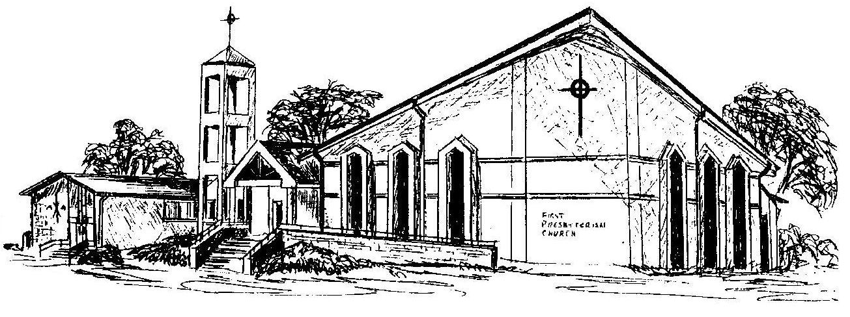

First Presbyterian Church
In the heart of Gardner since 1866 ~ Serving from the heart of God

Welcome - Thank you for joining us for worship today. Please fill out a visitor information card found in the pew racks and place those in the offering plate so that we may follow up with you in the future. Your presence with us today has been a blessing to us, we hope that you have felt the presence of God and the welcome of this congregation.

