Welcome & Announcements, Friendship Information, & Sharing Christ’s Peace

Prelude: In the Beauty of Holiness W. O'Donnell
Let us prepare our hearts and minds for worship.

Call to Worship
Leader: Jesus said, “I am the Bread of Life; those who come to me shall never be hungry; those who believe in me shall never thirst.”
People: Come, let us feast on the Bread of Life. Come, Let us drink the Cup of Salvation.
Leader: Today, all over the world, Christians gather around this table of grace to share the feast which Christ has prepared for us and for all.
People: Together we join with Christians of all times and places, to worship our God of love and life.

*Opening Hymn: In Christ There Is No East or West Blue Hymnal, #439

*Prayer of Confession (Unison)
Great God of all the world, we know that you call us to be one world community, inviting all people into your love and abundance. Sometimes fear stops us – fear of those who are different, fear of scarcity of resources, fear of change from what is familiar, fear of the unknown future. Help us on this Worldwide Communion Sunday to hear your call to unity and to conquer fear. Help us to be open to your world in all its diversity, and to share generously the gifts you have given, that all may know your mercy and grace, through Jesus Christ our Lord. Amen.

*Assurance of Pardon

*Gloria Patri (Glory Be to the Father…) Blue Hymnal, #579

Scripture I Kings 17:7-16 (page 555)
Mark 6:34-44 (page 1562)
Leader: The word of the Lord.
People: Thanks be to God.

Children's Time
Please join in singing one verse of Jesus Loves Me as the children come forward.

Special Music: Come To The Table Pote
Sermon “Baskets and Bread” Rev. Kimby Young

*Profession of Faith The Apostle's Creed Blue Hymnal, top page 14

*Hymn God is Here Blue Hymnal, #461

Offertory: Bread of the World Hodges / G.Martin

*Doxology Blue Hymnal, #592

*Prayer of Dedication & Pastoral Prayer Please Pray for the Family of Bob Shippee, Martha Hodges, Ralph Corwin, Gladys Lane, Minnie Ashmore, Don Speer, Norma Boone, Mark Howard, Mr. & Mrs. Brad Hadel, Scott Miller, Clay Simmons, Jano Smoor, John Kuhns, Richard Hatfield, Mark Freund, Jackson Tijerina, DeWald Family, Tara Miller-Palmer, Shirley Wilson, Austin W. Pennington

Communion
Invitation
Great Thanksgiving
The Lord’s Prayer
Breaking of Bread
Communion of the People
Prayer of Thanksgiving

*Closing Hymn: I Come With Joy Blue Hymnal, #507

*Benediction

Postlude: Hymn of Joy R. Grosvenor

Kimby Young, Pastor; Nancy Schulz, Worship Assistant; Robyn Forkner, Pianist;
Todd Burd, Music Ministries; Alice Rollf, Organist; Heather Rutler, Worship Transcription

Ushers October 2016
Brian & Denise Bockus; Larry Schick
LeMoyne & Donnie Zimmerman; Brett Wilson

Communion Servers
Randy & Sandy Rieger; Pam Wilson
Larry & Janet Flakus; Karl Allen

Bob Shippee Celebration of Life, on Friday, October 7, 6:00 PM Visitation, 7:30 PM Service
Monday, October 3, Congregational Life Pillar Meeting 7:00 PM
Wednesday, October 5, Women’s Fellowship Group 10:00 AM
Wednesday, October 5, Chancel Bell 6:00 – 7:00 PM; Chancel Choir 7:00 – 8:00 PM
Thursday, October 6, Ladies Bible Study 7:00 PM
Saturday, October 8, Tree Dedication 2:00 PM at the Pennington’s 621 N Locust, Gardner
Open House at Pastor Kimby’s - Saturday, October 15 from 4-6 p.m.

Women’s Fellowship Group - The Fellowship Group will meet on Wednesday, October 5, 2016 at 10:00 AM for Devotions, Fellowship, and Refreshments.

Operation Christmas Child collection for this month is Flashlights with extra batteries, Band-Aids, Pencils and sharpeners, Hair clips, Combs, Stickers, Boys/Girls underwear, Socks.

Joy Closet T-shirts - New t-shirts are being ordered for Joy Closet workers and anyone else who wants to advertise for the closet. The shirts will be a Heather Grey color with Joy Closet Logo on the front and bible verse on the Back, the shirts are available in Short Sleeve and Long Sleeve. There is no cost for these shirts but donations are welcome to cover the cost. Sign up in the narthex or at Joy Closet. Matthew 25:36 "I needed clothes and you clothed me."

New Short-term Basic Bible Study - Pastor Kimby leading - October 2 - November 13, Sundays, 4:30-6 p.m. - The course is aimed at beginners. More advanced students, are welcome to come share expertise. Anyone is welcome – member or friend. No advance registration is required. Contact Pastor Kimby with questions.

Tree Dedication is in memory of Albert (Al) on Saturday, October 8 at 2:00 PM, at Vespersia Pennington house 621 N Locust. The Congregation is invited. Light refreshments will be served. Bring your own lawn chairs.

Mission Auction – October 22 – The mission pillar is asking everyone to consider donating something for the auction. Packed baskets and baked goods are fine but hoping to have additional items this year also. There will be a spaghetti dinner before the auction. We will be selling tickets to the dinner. Proceeds will go to one local and one international location. We will be looking for volunteers to help with set up, serving, and clean up. If you are interested in helping please email Eldonna.

Celebrating “All Saint Day” on Sunday, November 6th - We will recognize from the pulpit church members that have passed within the last two years. Family and friends will be printed in the bulletin. If you have a loved one you wish remembered and included in the bulletin please contact the office at 856-4099. These names need to be turned in by Wednesday, October 19, 2016.

Sunday, October 2nd, 2016
World Communion Sunday
9:00 AM
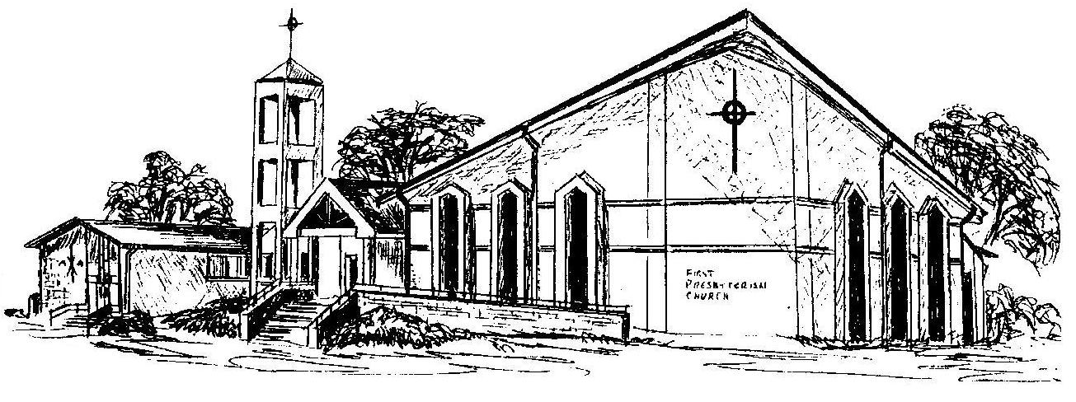

First Presbyterian Church
In the heart of Gardner since 1866 ~ Serving from the heart of God

Welcome - Thank you for joining us for worship today. Please fill out a visitor information card found in the pew racks and place those in the offering plate so that we may follow up with you in the future. Your presence with us today has been a blessing to us, we hope that you have felt the presence of God and the welcome of this congregation.

