Welcome & Announcements, Friendship Information, & Sharing Christ’s Peace

Seconds for Music

Prelude: O God, Thou Faithful God Hegarty

Call to Worship (from Deuteronomy 6:4-8)
Leader: Hear this, People of God. The Lord is our God, the Lord alone.
People: We shall love the Lord our God with all our hearts, all our souls, and all our strength.
Leader: Keep these promises in your hearts, recite them to your children, and talk about these promises wherever you go.
People: We shall love the Lord our God. We shall worship and sing our praise.

*Opening Hymn I Sing the Mighty Power of God Red Hymnal, #59

*Prayer of Confession (Unison)
God of Covenant Grace, we know that you have always kept your promises. You have loved us and provided for us, you have shown us the way to eternal life and joy in each present moment. We also know that we have often failed to respond as you have called us. We have broken your covenant. We have left your people suffering. Forgive us we pray. Renew us again. Inspire us to hear you and to respond in loving commitment, through Jesus Christ our Redeemer. Amen.

*Silent Reflection

*Assurance of Pardon

*Gloria Patri (Glory Be to the Father…) Red Hymnal, #623

Scripture Jeremiah 31:31-34 (page 1227)
John 14:6-7, 15-21, 25-27 (page 1675)
Leader: The word of the Lord.
People: Thanks be to God.

Children's Time
Please join in singing one verse of Jesus Loves Me as the children come forward.

Special Music: You Are My Hiding Place Arr. Rhodes

Sermon “New Covenant” Rev. Kimby Young

*Profession of Faith The Apostle's Creed Red Hymnal, inside back cover

*Hymn: Standing on the Promises Red Hymnal, #271

Pastoral Prayer & Lord’s Prayer: Please Pray for the family of Erma Grotenhuis, Corky Scarlett, Nancy Schulz, Cynthia Miller, the family of Don Speer’s, Kyle Campbell, Ralph Corwin, Gladys Lane, Minnie Ashmore, Norma Boone, Mark Howard, Mr. & Mrs. Brad Hadel, Scott Miller, Clay Simmons, Jano Smoor, John Kuhns, Richard Hatfield, Mark Freund, Jackson Tijerina, DeWald Family, Tara Miller-Palmer, Shirley Wilson

Offertory: Thy Word is a Light Westfall / Ervin
*Doxology Red Hymnal, #625
*Prayer of Dedication

*Closing Hymn: Be Thou My Vision Red Hymnal, #382

*Benediction

Postlude: My Life is in You, Lord Gardner

*Those who are comfortably able will please stand

Kimby Young, Pastor; Pam Wilson, Worship Assistant; Alice Rollf, Organist;
Todd Burd, Music Ministries; Robyn Forkner, Pianist;
Chancel Choir; Heather Rutler, Worship Transcription

Ushers for October 2016
Brian & Denise Bockus; Larry Schick
LeMoyne & Donnie Zimmerman; Brett Wilson

Monday, October 17, PW Meeting All Women invited 7:00 PM
Wednesday, October 19, Chancel Bells 6:00 – 7:00 PM
Wednesday, October 19, Chancel Choir 7:00 – 8:00 PM
Thursday, October 20, Ladies Bible Study 7:00 PM
Saturday, October 22, Set up for Auction & Dinner 12:00 PM
Saturday, October 22, Dinner 6:00 PM; Auction 7:00 PM
On Sunday, October 30, at 10:00 AM Congregational “Election” Meeting to elect Slate of Officers.

Joy Closet Volunteers Needed Cashier every other Thursday morning 10:00AM – 1:00PM and one Monday evening a month 4:00 – 7:00PM.

Boy Scout Jacob Hoffman Creating a Memorial Garden for Eagle Project Buy a brick.
Personalized paving bricks are being sold to memorialize loved ones. Please consider the purchase of one or more of these bricks to make a permanent remembrance in the Memorial Garden. Each brick costs $50.00. Supplement funds are available, if that cost is too high for you. If you are interested in a brick, see Jacob in the Narthex after service, please contact Brett Wilson at brett.wilson@jocogov.org or call him at 913-208-8190.

Operation Christmas Child collection for this month is socks, (boys/girls) underwear, school supplies, bar soap and wash cloths.

New Short-term Basic Bible Study - Pastor Kimby leading - Sundays, 4:30-6 p.m. - The course is aimed at beginners. More advanced students, are welcome to come share expertise. The class has started but it is not too late to join. Anyone is welcome – member or friend. No advance registration is required. Contact Pastor Kimby with questions.

Mission Auction – October 22 – Items needed to Auction off. 6:00 – 6:30 Spaghetti dinner served. Minimum $5.00 donations requested per person. Tickets can be purchased in the church office or call 913-856-4099 for a reservation. 7:00 Auction begins and is free to everyone to attend and bid. Proceeds will support Operation Christmas Child, Johnson County area Care Portal, and Presbyterian International Relief Fund.

Advent Devotional Booklet 2016 – Seeking Submissions - Please consider writing a short reflection to share with the congregation for daily devotionals. Contact pastor Kimby or sign up on the sheet in the narthex. Entries are due by Monday, November 7.

Wacky Dinner November 20th 4-6pm. – consider opening your home for part of the meal. Contact Nancy Falkner to volunteer.

REMEMBER OUR DEPARTED LOVED ONES ALL SAINTS’ DAY SUN., NOV. 6th,
We will honor the memory of our recently departed loved ones during the worship service. Please send in names of your departed loved ones by email, phone, or let the office know by Wednesday, October 19th.

Sunday
October 16th, 2016
9:00 AM

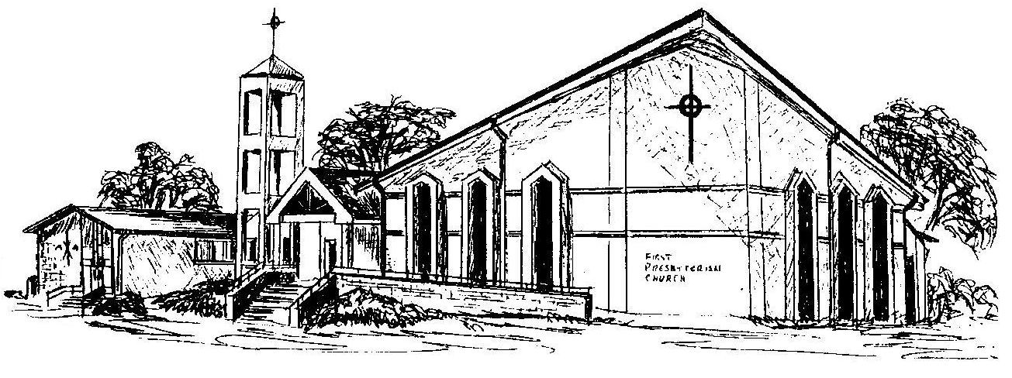

First Presbyterian Church
In the heart of Gardner since 1866 ~ Serving from the heart of God

Welcome - Thank you for joining us for worship today. Please fill out a visitor information card found in the pew racks and place those in the offering plate so that we may follow up with you in the future. Your presence with us today has been a blessing to us, we hope that you have felt the presence of God and the welcome of this congregation.

