Welcome & Announcements, Friendship Information, & Sharing Christ’s Peace
Prelude: “Be Thou My Vision” Arranged by Raney
Let us prepare our hearts and minds for worship.

Call to Worship
Leader: The Spirit of the Lord is upon us!
People: God has anointed us to bring good news!
Leader: We gather to worship this God who calls us to serve.
People: Let us praise God in gratitude and joy.

*Opening Hymn: “Just As I Am” Blue Hymnal, #370

*Prayer of Confession (Unison)
Great God who calls us to greatness, forgive us when we fail to respond. Forgive us when we are afraid to reach out. Forgive us when we put ourselves first. Forgive us when we ignore the needs of others. Forgive us when we sin and fall short of your glory. We pray restore us again. Cleanse us, heal us, and renew us. Send us out to serve as you have called through Jesus Christ our Savior. Amen.

*Silent Reflection

*Assurance of Pardon

*Gloria Patri (Glory Be to the Father…) Blue Hymnal, #567

Scripture “Psalm 133” (page 970)
“Isaiah 61:1-3” (page 1157)
“John 12:1-8” (page 1670)
Leader: The word of the Lord.
People: Thanks be to God.

Children's Time
Please join in singing one verse of Jesus Loves Me as the children come forward.

Special Music: Piano Solo

Sermon “Anointed and Appointed” Rev. Kimby Young

*Profession of Faith “The Apostle's Creed” Blue Hymnal, top page 14
*Hymn “Take My Life” Blue Hymnal, #391 verses 1, 3 and 6
Commissioning of PYF and Anointing of Congregation
“Remember you are God’s beloved child.”

Offertory: “Make Me A Channel of Your Peace” Arranged by Holstein

*Doxology Blue Hymnal, #592

*Prayer of Dedication & Pastoral Prayer Please Pray for Jerry Lane, Jane McGuire, Pam Wilson, Brandon, Hudson Inglehart, Ruth Bowlin, Family of Clay Simmons, John Freund, Stan Knoche, Glenn Schulz, Boston DeWald, Callen Brunker, Beth Ekdohl, Lanny John Turner, Roy Barnett, Larry Bartel, Byron McManus, Margaret Davidson, Brenda Polsen, Naomi Salser, Ann Ferguson, Keith W. Smith, Roland Jack, Rob Kuhauz, Denny Harris, Richard Hatfield, Jackson Tijerina
Communion & Celebration
Invitation
Great Thanksgiving
The Lord’s Prayer
Breaking of Bread
Communion of the People
Prayer of Thanksgiving

*Closing Hymn: “Here I Am Lord” Blue Hymnal, #525

*Benediction

Postlude: “Savior, Like a Shepherd Lead Us” Arranged by Rice
*Those who are comfortably able will please stand

Flowers are given today to the Glory of God, in loving memory of Clay Simmons

Kimby Young, Pastor; PYF, Worship Assistant; Robyn Forkner, Pianist & Special Music;
Heather Rutler, Worship Transcription; Todd Burd, Music Ministries

Ushers July 2017
Tropansky Family; Larry Atwater; George Frame; Cameron & Mike McGuire

Sunday, July 2, Discipleship Pillar Meeting 11:15 AM
Monday, July 3, Congregational Life Meeting 7:00 PM
Tuesday, July 4, Office Closed, Independence Day
Wednesday, July 5, Women’s Group 10:00 AM
Wednesday, July 5, Prayer Group 12:00 PM
Wednesday, July 5, Prayer Group 5:30 PM
Sunday, July 9, Mission Pillar Meeting 11:15 AM

Women's Fellowship Group will meet Wednesday, July 5, at 10:00 AM. Pat Rankin has designed beautiful bags that the Fellowship Morning Group will fill with your items at their July 5th meeting. The bags and items will be delivered in July. Items needed include: Shampoo, Conditioner, Body Wash, Body Lotion, Hair Brushes, Combs, Hairspray, Mouthwash, Adult and Children Toothbrushes, Toothpaste, Women's Deodorant, Ethnic Hair Care Products, Feminine Hygiene Products, Facial Tissue (Kleenex), Baby wipes, Baby Body Wash, Diaper Rash Cream. SafeHome provides shelter for women and children from homes where there is domestic abuse. So often they enter the shelter with only the clothes they are wearing. Thank you for your contributions.

Prayer Circles Starting July 5 – Pastor Kimby will start two midweek prayer opportunities inspired by her week on study leave. Every Wednesday in July and August at noon and 5:30 p.m. a group will gather in the chapel at church to pray. You may come once or any time you are available. If it is your lunch hour from work, you may bring your lunch and join us. Kimby will teach a few prayer forms (ways to pray) but most of the time will be spent in prayer together. Invite a friend. Everyone is welcome.

Johnson County Fair Parade - Saturday, August 5. If you would like to work on a team to put together an entry for the 2017 parade, please contact pastor Kimby Young. There might be free candy for any participants.

College Plus - Group for summer – If you are interested or if you know someone who might be interested, contact Kimby at kimby@fpcgardner.org or 913-481-7076.

Walking Group Forming – You’ll Never Walk Alone
The group could walk once a week, every other week or once a month, depending on interest expressed. This might turn into a group that could lead our church in the fall CROP walk or other walking fundraisers in the area. Contact Kimby if you are interested.

Seekers & Servants Sunday School Class, has just started studying The Applause of Heaven by Max Lucado. It’s a great time to join this group for Summer study.

Sunday
July 2, 2017
9:00 AM
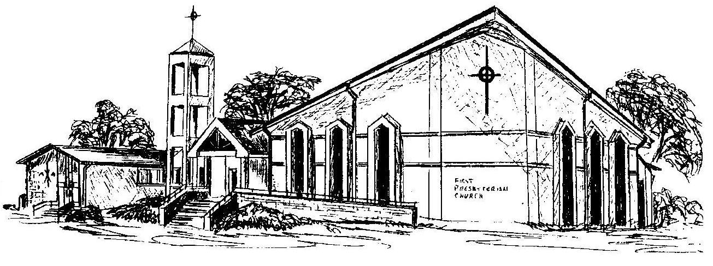

First Presbyterian Church
In the heart of Gardner since 1866 ~ Serving from the heart of God

Welcome - Thank you for joining us for worship today. Please fill out a visitor information card found in the pew racks and place those in the offering plate so that we may follow up with you in the future. Your presence with us today has been a blessing to us, we hope that you have felt the presence of God and the welcome of this congregation.

