Welcome & Announcements, Friendship Information, & Sharing Christ’s Peace

Prelude: “In Christ Alone” Townend / Getty
Let us prepare our hearts and minds for worship.

Call to Worship
Leader: Men and women, boys and girls, old and young, member and guest.
People: We come together to praise God in this sanctuary.
Leader: God has given each of us gifts to share and experiences to bring.
People: We offer what we have to praise God and to serve Jesus Christ.

*Opening Hymn: “I Am Thine, O Lord” Red Hymnal, #358

*Opening Prayer of the Day (Unison)
God of love and laughter, God of good times and bad, we come this morning with grateful hearts for the week just past. For the young people who have filled our hallways; for the leaders of all ages; for the parents and caretakers; for the storytellers and craft leaders; for those who prepared food, prepared plans and prepared rooms; for all these and more we are grateful. Bless us all as we gather today and as we scatter tomorrow. Help us to remember who we are and to whom we belong. We pray in the name of Jesus Christ our Savior. Amen.

*Gloria Patri (Glory Be to the Father…) Red Hymnal, #623

Scripture “1 Peter 2: 2-6; 9-10” (page 1888)
“1 Timothy 4:9-15” (page 1848)
Leader: The word of the Lord.
People: Thanks be to God.

Children's Time -
Please join in singing one verse of Jesus Loves Me as the children come forward.

Reflections on the week of Traveling Day Camp - Overall Theme: I AM
Monday: I Am Created for a Reason; Ephesians 2:10
Tuesday: I Am Loved By God; John 3:16
Wednesday: I Am in Need of a Savior; Romans 3:23-24
Thursday: We Are Gifted with a Purpose; I Peter 4:8
Friday: We Are on a Mission; Colossians 3:17
Sermon: “Who Are We?” Rev. Kimby Young

*Profession of Faith The Apostle's Creed Red Hymnal, inside back cover

*Hymn “Just a Closer Walk With Thee” Red Hymnal, #380

Pastoral Prayer & Lord’s Prayer: Please Pray for the family of Clay Simmons, Stan Knoche, John Freund, Glenn Schulz, Boston DeWald, Callen Brunker, Beth Ekdohl, Lanny John Turner, Roy Barnett, Larry Bartel, Byron McManus, Margaret Davidson, Brenda Polsen, Naomi Salser, Ann Ferguson, Keith W. Smith, Roland Jack, Rob Kuhauz, Denny Harris, Richard Hatfield, Jackson Tijerina, each of our Day Camp children and leaders.
Offertory: “People of God” Watson

*Doxology Red Hymnal, #625

Prayer of Dedication

*Closing Hymn: “We Are God’s People” Red Hymnal, #283

Benediction

Postlude: “Cornerstone” Patillo

*Those who are comfortably able will please stand

Kimby Young, Pastor;
Lynn Moldrup, Worship Assistant; Robyn Forkner, Pianist; Alice Rollf, Organist; Heather Rutler, Worship Transcription; Todd Burd, Music Ministries

Ushers for June 2017
Jerry & Paula Waters; Dave & Diane Sinclair; Larry & Janet Flakus

Monday, June 25, Memorial Committee Meeting 6:00 PM

St. Johns’ Sunday
We offer a special welcome today to our friends from the Gardner Masonic Lodge #65. Today is St. Johns’ Sunday, commemorating the faith and spiritual legacy of St. John the Baptist and St. John the Evangelist, who are the patron saints of the Masons.

Freemasonry is a fraternal organization that arose during the late 16 to early 17 century, Freemasonry now exists in various forms all over the world, with a membership estimated at around five million, including just under two million in the United States and around 480,000 in England, Scotland and Ireland.

Freemasonry uses the metaphors of the stonemasons’ tools, set against the backdrop of King Solomon’s Temple, to convey lessons of morality illustrated by symbols.

Prayer Circles Starting in July – Pastor Kimby will start two midweek prayer opportunities inspired by her week on study leave. Every Wednesday in July and August at noon and 6:00 p.m. a group will gather in the chapel at church to pray. You may come once or any time you are available. If it is your lunch hour from work, you may bring your lunch and join us. Kimby will teach a few prayer forms (ways to pray) but most of the time will be spent in prayer together. Invite a friend. Everyone is welcome.

Johnson County Fair Parade - Saturday, August 5. If you would like to work on a team to put together an entry for the 2017 parade, please contact pastor Kimby Young. There might be free candy for any participants.

College Plus - Group for summer – If you are interested or if you know someone who might be interested, contact Kimby at kimby@fpcgardner.org or 913-481-7076.

Walking Group Forming – You’ll Never Walk Alone
The group could walk once a week, every other week or once a month, depending on interest expressed. This might turn into a group that could lead our church in the fall CROP walk or other walking fundraisers in the area. Contact Kimby if you are interested.

Seekers & Servants Sunday School Class, has just started studying The Applause of Heaven by Max Lucado. It’s a great time to join this group for Summer study.

Thank you to everyone who participated in Traveling Day Camp. Thank you to all who brought food or supplies, all who led stories or crafts, all who contributed in any way and to the youth who worked during the week. Thank you especially to leaders Robin Tropansky, Kim and Karen Liu. Well done!

Sunday, June 25, 2017
9:00 AM

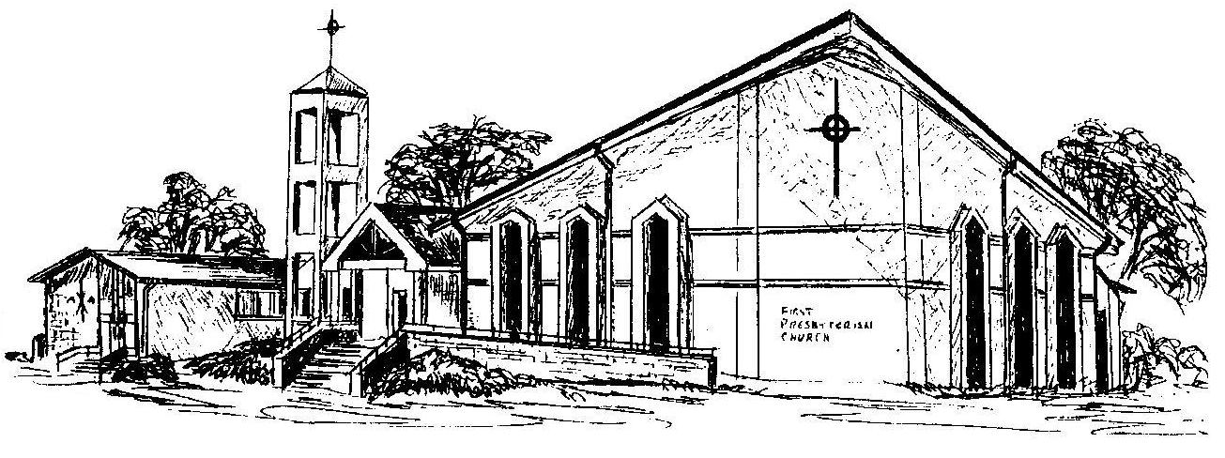

First Presbyterian Church
In the heart of Gardner since 1866 ~ Serving from the heart of God

Welcome - Thank you for joining us for worship today. Please fill out a visitor information card found in the pew racks and place those in the offering plate so that we may follow up with you in the future. Your presence with us today has been a blessing to us, we hope that you have felt the presence of God and the welcome of this congregation.

