Welcome & Announcements, Friendship Information, & Sharing Christ’s Peace
Prelude: “The Holy Father” Medley
Let us prepare our hearts and minds for worship.

Call to Worship
Leader: God is our Father, our Creator, who made the heavens and the earth.
People: We are God’s children, and we are in awe of all God has made.
Leader: Children of God, holy and beloved, let us respond to God’s grace.
People: We sing our praise to God, Father, Son and Holy Spirit.

*Opening Hymn: “God of Our Fathers” Red Hymnal, #573

*Prayer of Confession (Unison) - (adapted from Nick Fawcett, re-worship)
Gracious God, you are the Creator of the ends of the earth, and yet you call us your children. You are greater than we can ever begin to imagine, and yet you invite us to call you “Our Father”. Always you have loved us: forgive our feeble response. Forgive us that we fail to live as your children. Accept our thanks that, despite our willfulness, you refuse to give up on us, working instead to draw us closer. Always you have loved us: help us in our response through Jesus Christ your Son, our Lord. Amen.

*Silent Reflection

*Assurance of Pardon

*Gloria Patri (Glory Be to the Father…) Red Hymnal, #623

Scripture “John 14:8-14” (page 1675)
“Galatians 3:23-29; Galatians 4:1-7” (page 1813)
Leader: The word of the Lord.
People: Thanks be to God.

Children's Time
Please join in singing one verse of Jesus Loves Me as the children come forward.

Special Music: “God of Our Fathers/Faith of Our Fathers” by Warren

Sermon: “Why Do We Call God Father?” Rev. Kimby Young

*Profession of Faith The Apostle's Creed Red Hymnal, inside back cover

*Hymn “This is My Father’s World” Red Hymnal, #58

Pastoral Prayer & Lord’s Prayer: Please Pray for John Freund, Stan Knoche, Pam Wilson, Joni Meyer, Reagan Barnadt, Glenn Schulz, Boston DeWald, Callen Brunker, Beth Ekdohl, Lanny John Turner, Roy Barnett, Larry Bartel, Byron McManus, Margaret Davidson, Brenda Polsen, Naomi Salser, Ann Ferguson, Keith W. Smith, Roland Jack, Rob Kuhauz, Denny Harris, Clay Simmons, Richard Hatfield, Jackson Tijerina
Reception of New Member: Joseph Kioko

Offertory: “Father Welcomes” K. Mayhew

*Doxology Red Hymnal, #625

Prayer of Dedication

*Closing Hymn: “Faith of Our Fathers” Red Hymnal, #279

Benediction

Postlude: “The Faith of Our Fathers” J.W. Peterson
*Those who are comfortably able will please stand

Kimby Young, Pastor; Peggy Beach, Worship Assistant; Robyn Forkner, Pianist
Duet by Karen Elliott and Rhonda Atwater; Alice Rollf, Organist
Heather Rutler, Worship Transcription; Todd Burd, Music Ministries

Ushers for June 2017
Jerry & Paula Waters; Dave & Diane Sinclair; Larry & Janet Flakus

Monday – Friday, June 19-23, Traveling Day Camp

Seekers & Servants Sunday School Class, today will begin studying The Applause of Heaven by Max Lucado.
Parents Night Out - June 24, 6-10 p.m. Sponsored by EPIC middle school. Cost is $10 per child or $25 per family. Reservations by June 22. Contact Nancy: nanfalkner@gmail.com or (913) 945-0629 or Amber: amberc@pmtsoverlandpark.com or (913) 449-5203.

Father’s Day Prayer
As we remember Father's this day, you are invited to write a prayer during our worship service. You may use the paper insert to your bulletin. This can be any kind of prayer:
1. a prayer for or about your father.
2. a prayer as a father for your family.
3. a prayer praising God as Father.
4. a prayer for fathers in the world.
5. anything else.
These will be offered privately during our Pastoral Prayer. You do not have to write a prayer, this is only an option to assist in worship.

Connie going on vacation the week of June 17-26, if you need anything please, contact Kimby at 913-481-7076. The week of June 19-23 Traveling day camp will be here.

Prayer Circles Starting in July – Pastor Kimby will start two midweek prayer opportunities inspired by her week on study leave. Every Wednesday in July and August at noon and 5:30 p.m. a group will gather in the chapel at church to pray. You may come once or any time you are available. If it is your lunch hour from work, you may bring your lunch and join us. Kimby will teach a few prayer forms (ways to pray) but most of the time will be spent in prayer together. Invite a friend. Everyone is welcome.

Johnson County Fair Parade - Saturday, August 5. If you would like to work on a team to put together an entry for the 2017 parade, please contact pastor Kimby Young. There might be free candy for any participants.

College Plus - Group for summer – Now forming. If you are interested or if you know someone who might be interested, contact Kimby at kimby@fpcgardner.org or 913-481-7076.

Walking Group Forming – You’ll Never Walk Alone
The group could walk once a week, every other week or once a month, depending on interest expressed. This might turn into a group that could lead our church in the fall CROP walk or other walking fundraisers in the area. Contact Kimby if you are interested.

Sunday, June 18, 2017
2nd Sunday after Pentecost
9:00 AM

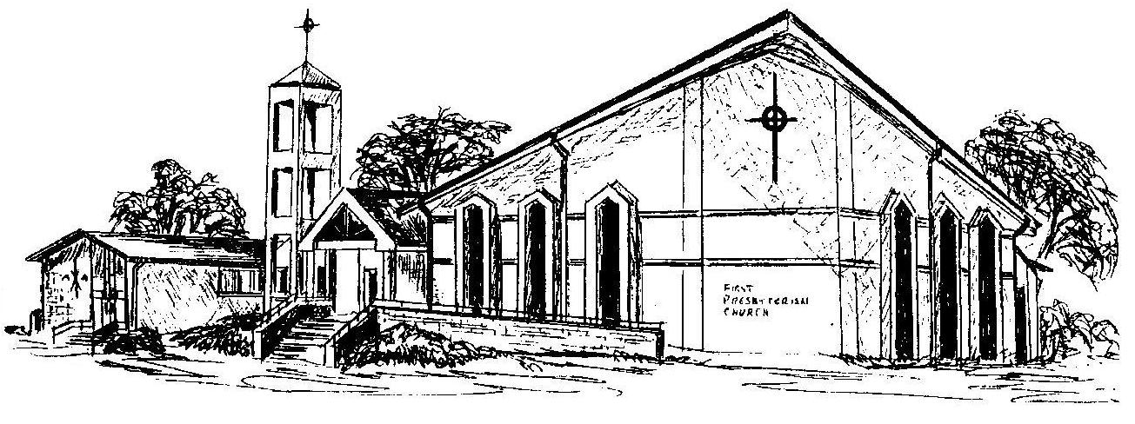

First Presbyterian Church
In the heart of Gardner since 1866 ~ Serving from the heart of God

Welcome - Thank you for joining us for worship today. Please fill out a visitor information card found in the pew racks and place those in the offering plate so that we may follow up with you in the future. Your presence with us today has been a blessing to us, we hope that you have felt the presence of God and the welcome of this congregation.

