Welcome & Announcements, Friendship Information, & Sharing Christ’s Peace
Minute for Mission “Safehome” Paula Waters
Prelude: “Amazing Grace” American Melody by Nielson /Young
Let us prepare our hearts and minds for worship.

Call to Worship
Leader: We worship the God and Father of love, who taught us what love looks like in flesh and
blood, through his Son. Remember the description of godly love found in I Corinthians 13
People: Love is patient, love is kind. It does not envy. It does not boast, it is not proud.
Leader: It is not rude, it is not self-seeking, it is not easily angered, it keeps no record of wrongs.
People: Love does not delight in evil but rejoices with the truth.
Leader: It always protects, always trusts, always hopes, always perseveres.
All: We raise our hearts and voices in adoration and awe to the One who is love.
Amen!
*Opening Hymn: “Come, Christians, Join to Sing” Red Hymnal, #108

Prayer of Confession
Leader: God is a tender and merciful Father, who invites us to ask him for whatever we need. But we must ask with hearts that have been purified by His Spirit. Let us come to him now, so that we may receive his sweet mercy as we confess our sins.
People: (in unison) Holy God, we admit that we fall far short of your holiness. We make no excuses. We are not comparing ourselves to others. We simply come before you as we are: broken, self-centered, weak and sorry for our sins. Please wash us clean in the power of the risen Christ. Make our hearts like his heart, pure and kind. (Silent prayers of confession.)

*Assurance of Pardon
Leader: Scripture assures us time and again that if we confess our sins and are truly sorry, our Father will always forgive us, make us new, and give us strength to overcome temptation. Scripture declares: “If God is on our side, who can ever be against us? ³² Since he did not spare even his own Son for us but gave him up for us all, won’t he also surely give us everything else? ³³ Who dares accuse us whom God has chosen for his own? Will God? No! He is the one who has forgiven us and given us right standing with himself. ³⁴ Who then will condemn us? Will Christ? No! For he is the one who died for us and came back to life again for us and is sitting at the place of highest honor next to God, pleading for us there in heaven.” (Romans 8.31-34)
Let these words penetrate the deepest recesses of our heart, that in Jesus Christ, our sins are forgiven!

*Gloria Patri (Glory Be to the Father…) Red Hymnal, #623

Children's Time Paula Waters
Please join in singing one verse of Jesus Loves Me as the children come forward.
Special Music: “People Need The Lord” by Nelson and McHugh

Sermon: “Jesus, the Anchor of our Soul” Rev. Jodi Mathews
“Hebrews 6:19-20 and Hebrews 13:8”

*Profession of Faith “The Apostle's Creed” Red Hymnal, inside back cover

*Hymn “Great is Thy Faithfulness” Red Hymnal, #4

Pastoral Prayer & Lord’s Prayer: Please Pray for Joni Meyer, Stan Knoche, Ragan Barnadt, Glenn Schulz, Boston DeWald, Callen Brunker, Beth Ekdohl, Lanny John Turner, Roy Barnett, Larry Bartel, Byron McManus, Margaret Davidson, Brenda Polsen, Naomi Salser, Ann Ferguson, Arlene Thompson, Keith W. Smith, Roland Jack, Rob Kuhauz, Denny Harris, Delphine Brawner, Clay Simmons, Richard Hatfield, Jackson Tijerina
Offertory: “Jesus, Savior, Pilot Me” J. Gould / Rasley
*Doxology Red Hymnal, #625

Prayer of Dedication

*Closing Hymn: “My Hope is Built on Nothing Less” Red Hymnal, #404

Benediction

Postlude: “We Have an Anchor” Kirkpatrick
*Those who are comfortably able will please stand

Jodi Mathews, Guest Minister; Paula Waters, Worship Assistant; Robyn Forkner, Pianist
Judy Lenahan, Vera Beach, Janet Flakus, and Helen Stranathan, Quartet; Alice Rollf, Organist
Heather Rutler, Worship Transcription; Todd Burd, Music Ministries

Ushers for June 2017
Jerry & Paula Waters; Dave & Diane Sinclair; Larry & Janet Flakus

Jodi and her husband, Kent, reside in Ottawa, KS where they raised their three children. Jodi served as an interim pastor here at First Presbyterian, Gardner; at Leawood Presbyterian Church in Leawood, KS; at Heritage Presbyterian Church in Olathe; and most recently, at South-Broadland Presbyterian Church in KC, MO. She officially retired in January of this year, and is thoroughly enjoying her garden! (No grandchildren, yet).

Monday June 12: Session 6:30 AM
Tuesday, June 13: Men’s Breakfast Perkins 7:00 AM

Church Photo Directory has arrived. Stop by the table in the narthex to pick up your copy. One copy is free to each household. If you want an extra it will cost $10.00.

Men’s Breakfast at Perkins will be held at 7:00 AM on Tuesday, June 13, at Perkins Restaurant. Our speaker will be on lawn & garden care and maintenance. We hope you can make it.

Ladies of the church Invitation from the Ladies of Edgerton Methodist: Salad Supper on Tuesday, June 20, 6:30 PM, at Edgerton Methodist Church.

Traveling Day Camp June 19-23 Can you help? Signup sheets are in the Narthex, for story tellers, craft leaders, youth helpers, food for our leaders, a few supplies and food for lunch.

Johnson County Fair Parade - Saturday, August 5. If you would like to work on a team to put together an entry for the 2017 parade, please contact pastor Kimby Young. There might be free candy for any participants.

College Plus - Group for summer – Now forming. If you are interested or if you know someone who might be interested, contact Kimby at kimby@fpcgardner.org or 913-481-7076.

Joy Closet In Need of Volunteers, 504 Main St Gardner KS 66030, 913-856-8868
JoyClosetGardner@gmail.com Mon., Tues., & Thurs. 10:00 – 7:00, Sat 10:00 – 2:00 pm

We are in need of more volunteers to help sort through our large selection of donations.
When you first volunteer we train you, which takes about an hour or two, after you are
trained you just come in and work anytime during our open hours. We need the most help
on Saturdays and Thursdays. Must be 14 to volunteer, but we have had some mature 12yr.

If you have a large Group such as a Church Group, Bible Study Group, Book club, 4-H
Group, Community group or Business we would love to have your group come volunteer with
us. You could even pick a day and come Weekly, Monthly, Bi-Monthly or even Quarterly
we would just love to have you volunteer and help us out.

Sunday, June 11, 2017
Trinity Sunday
9:00 AM

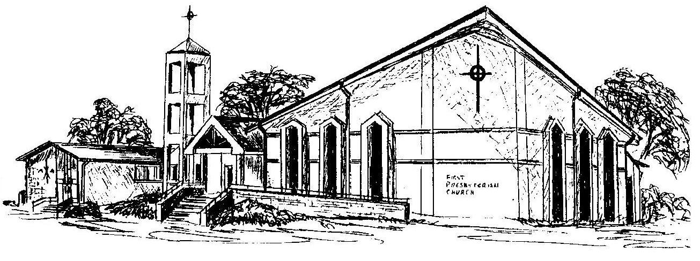

First Presbyterian Church
In the heart of Gardner since 1866 ~ Serving from the heart of God

Welcome - Thank you for joining us for worship today. Please fill out a visitor information card found in the pew racks and place those in the offering plate so that we may follow up with you in the future. Your presence with us today has been a blessing to us, we hope that you have felt the presence of God and the welcome of this congregation.

