Welcome & Announcements, Friendship Information, & Sharing Christ’s Peace
Prelude: “Breathe On Me, Breath Of God” by R. Jackson
Let us prepare our hearts and minds for worship.

Call to Worship
Leader: The Spirit descends like a dove, bringing peace to unite the world.
People: The Spirit comes like a breath, bringing life to renew the people of God.
Leader: The Spirit spreads like fire, bringing energy for witnessing to the love of God.
People: Spirit of the living God, come to us and transform our lives by your power.

*Opening Hymn: “Wind Who Makes All Winds That Blow” Blue Hymnal, #131

*Prayer of Confession (Unison)
Breath of Heaven, you have poured life over us and into us, and we are grateful. Sometimes we fail to respond in gratitude to your urging. We do not use the gifts you have given. We do not encourage the gifts of others. We hear of your movement in other times and places, but we doubt your ability to ignite a fire here and now. Forgive us. Fill us again. Inspire us to dream. Empower us to serve. Revive us to grow, in your grace and to your glory. Amen.

*Silent Reflection

*Assurance of Pardon

*Gloria Patri (Glory Be to the Father…) Blue Hymnal, #567

Scripture “I Corinthians 12:4-14, 27” (page 1785) “Acts 2:1-8, 12, 14, 16-18, 21” (page 1692)
Leader: The word of the Lord.
People: Thanks be to God.

Children's Time
Please join in singing one verse of Jesus Loves Me as the children come forward.

Special Music: "Rushing Wind" by Keith Green

Sermon “Gifts of the Spirit” Rev. Kimby Young
The fruit of the Spirit is love, joy, peace, patience, kindness, generosity, faithfulness, gentleness, and self-control. Galatians 5:22-23
*Profession of Faith “The Apostle's Creed” Blue Hymnal, top page 14

*Hymn “Spirit of the Living God” Blue Hymnal, #322

Offertory: “There Is A Redeemer” by M. Green

*Doxology Blue Hymnal, #592

*Prayer of Dedication & Pastoral Prayer Please Pray for Stan Knoche, George, Reagan Barnadt, Glenn Schulz, Boston DeWald, Callen Brunker, Beth Ekdohl, Lanny John Turner, Roy Barnett, Larry Bartel, Byron McManus, Margaret Davidson, Brenda Polsen, Naomi Salser, Ann Ferguson, Arlene Thompson, Keith W. Smith, Roland Jack, Rob Kuhauz, Denny Harris, Delphine Brawner, Clay Simmons, Richard Hatfield, Jackson Tijerina
Communion & Celebration
Invitation
Great Thanksgiving
The Lord’s Prayer
Breaking of Bread
Communion of the People
Prayer of Thanksgiving

*Closing Hymn: “Come, O Spirit, Dwell Among Us” Blue Hymnal, #129

*Benediction

Postlude: “Spirit of God, Descend Upon My Heart” by Atkinson
*Those who are comfortably able will please stand

Kimby Young, Pastor; Pat Clark, Worship Assistant; Robyn Forkner, Pianist
Mike McGuire, Soloist Special Music; Alice Rollf, Organist
Heather Rutler, Worship Transcription; Todd Burd, Music Ministries

Ushers June 2017
Jerry & Paula Waters;
Dave & Diane Sinclair
Larry & Janet Flakus

Monday, June 5, Congregational Life Meeting 7:00 PM
Wednesday, June 7, Women’s Group 10:00 AM
Thursday, June 8, Mission Pillar 6:30 PM Putting labels on water bottles
Saturday, June 10, Festival on the Trails 12:00 – 5:00 PM Passing out water bottles
Saturday, June 10, Chips Mason’s 12:00 – 5:00 PM
Sunday, June 11, Worship Service 9:00 AM Rev. Jodi Mathews Guest Minister
Monday, June 12, Session 6:30 PM
Tuesday, June 13, Men’s Breakfast Perkin’s

Pentecost Offering (Youth and Young Adult) – June 4 This is one of the four denominationally sponsored special offerings for special causes offered during the year. A gift to the Pentecost Offering helps the church encourage, develop, and support its young people, and also address the needs of at-risk children. 40% of the Pentecost offering is retained by the local church wanting to make an impact in the lives of young people within our own community. The remaining 60% is used to support ministries of the national Presbyterian Mission Agency: for Young Adult Volunteers, Ministries for Youth, and Children at Risk. You may learn more about this offering at http://specialofferings.pcusa.org/pentecost.html

Church Photo Directory has arrived. Stop by the table in the narthex to pick up your copy. One copy is free to each household. If you want an extra it will cost $10.00.

Women's Fellowship Group will meet Wednesday, June 7, at 10:00 AM. We will bake cookies for our June Traveling Camp. Please, bring a batch of cookie dough to bake. We cannot bake anything with any nuts, peanuts, or nut butters.
We will collect Items for SafeHome. Items needed include: Shampoo, Conditioner, Body Wash, Body Lotion, Hair Brushes, Combs, Hairspray, Mouthwash, Adult and Children Toothbrushes, Toothpaste, Women's Deodorant, Ethnic Hair Care Products, Feminine Hygiene Products, Facial Tissue (Kleenex) Baby wipes, Baby Body Wash, Diaper Rash Cream. SafeHome provides shelter for women and children from homes where there is domestic abuse. So often they enter the shelter with only the clothes they are wearing. Pat Rankin has designed beautiful bags that the Fellowship Morning Group will fill with your items at their July 5th meeting. The bags and items will be delivered in July. Thank you for your contributions.

Festival on the Trails – Cooling Station – Help Wanted - Last year we gave out over 600 bottles of water and lots of fans. Volunteer for a shift at the station on June 10. Donate water or money for ice.

Men’s Breakfast will be held at 7:00 AM on Tuesday, June 13, at Perkins Restaurant. Our speaker will be on lawn & garden care and maintenance. We hope you can make it.

Ladies of the church Invitation from the Ladies of Edgerton Methodist: Salad Supper on Tuesday, June 20, 6:30 PM, at Edgerton Methodist Church. RSVP by Thursday, June 15th to Carol Shobe 913-884-6501, Kathy Hill 913-882-9667.

Sunday
June 4, 2017
Pentecost Sunday
9:00 AM
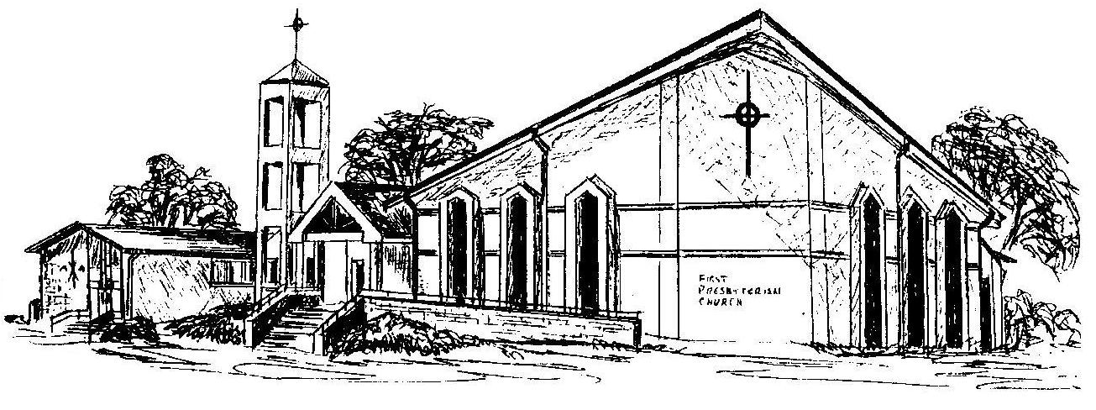

First Presbyterian Church
In the heart of Gardner since 1866 ~ Serving from the heart of God

Welcome - Thank you for joining us for worship today. Please fill out a visitor information card found in the pew racks and place those in the offering plate so that we may follow up with you in the future. Your presence with us today has been a blessing to us, we hope that you have felt the presence of God and the welcome of this congregation.

