Welcome & Announcements, Friendship Information, & Sharing Christ’s Peace
Minute for Mission: “Pentecost”

Prelude: “Crown Him with Many Crowns” Elvey / Neal
Let us prepare our hearts and minds for worship.

Call to Worship
Leader: Remembering, we praise God for all that God has done in our world and in our lives.
People: We rejoice in the life, death and resurrection of our Lord and Savior Jesus Christ.
Leader: This Memorial Day weekend we give thanks for God’s gift of life and for all the ways God has touched our lives.
People: We gather to worship God as we follow Jesus Christ serving in the world.

*Opening Hymn: “Eternal Father Strong to Save” Red Hymnal, #575

*Prayer of Confession (Unison)
God of present, past and future. We come this Memorial Day weekend remembering your call through the ages, and your personal call for each one of us. We are witnesses to your glory and recipients of your grace. And yet we have failed to share your story. We have failed to live your love. Forgive us and inspire us again to tell the great good news of your salvation story. Help us to be your witnesses wherever we may go, through Jesus Christ our Lord. Amen.

*Silent Reflection

*Assurance of Pardon

*Gloria Patri (Glory Be to the Father…) Red Hymnal, #623

Scripture “Luke 24:45-53” (page 1644)
“Acts 1:1-11” (page 1690)
Leader: The word of the Lord.
People: Thanks be to God.

Children's Time
Please join in singing one verse of Jesus Loves Me as the children come forward.
Special Music: “Alleluia/The Majesty and Glory of Your Name” by Mark Hayes

Sermon: “The Kingdom and the Power and the Glory” Rev. Kimby Young

*Profession of Faith The Apostle's Creed Red Hymnal, inside back cover

*Hymn “Rejoice, the Lord is King” Red Hymnal, #228

Pastoral Prayer & Lord’s Prayer: Please Pray for Glenn Schulz, Lauren Boggs, Boston DeWald, Callen Brunker, Beth Ekdohl, Lanny John Turner, Roy Barnett, Larry Bartel, Byron McManus, Margaret Davidson, Brenda Polsen, Naomi Salser, Ann Ferguson, Arlene Thompson, Keith W. Smith, Roland Jack, Rob Kuhauz, Denny Harris, Delphine Brawner, Clay Simmons, Richard Hatfield, Jackson Tijerina
Offertory: “The Lord's Prayer” A. H. Malotte

*Doxology Red Hymnal, #625

Prayer of Dedication

*Closing Hymn: “Battle Hymn of the Republic” Red Hymnal, #569

Benediction

Postlude: “America, the Beautiful” Samuel Ward
*Those who are comfortably able will please stand

Kimby Young, Pastor; Joyce Scarlett, Worship Assistant;
Robyn Forkner, Pianist; Alice Rollf, Organist;
Heather Rutler, Worship Transcription; Todd Burd, Music Ministries

Ushers for May 2017
Brad & Amber Cornell; Brett Wilson; Cindy, Nalleli & Jon Rollf

Sunday, May 28, Mission Pillar Vintage Park Worship Service 3:00 PM
Monday, May 29, Office Closed Memorial Day

Birthday Card Shower for Velma Coiner will turn 97 on Friday, June 1, 2017. Her address is 8585 W. Dakota Ave., Apt # 321, Lakewood, CO 80226.

Wear red on Pentecost, Sunday, June 4. Join the congregation in celebration of the fire of the Holy Spirit.

Pentecost Offering (Youth and Young Adult) – June 4 This is one of the four denominationally sponsored special offerings for special causes offered during the year. A gift to the Pentecost Offering helps the church encourage, develop, and support its young people, and also address the needs of at-risk children. 40% of the Pentecost offering is retained by the local church wanting to make an impact in the lives of young people within our own community. The remaining 60% is used to support ministries of the national Presbyterian Mission Agency: for Young Adult Volunteers, Ministries for Youth, and Children at Risk. You may learn more about this offering at http://specialofferings.pcusa.org/pentecost.html

Pastor Kimby will be on study leave June 5-11 at the Omaha School for Pastors. Connie will have contact information in case of emergency.

Festival on the Trails – Cooling Station – Help Wanted - Last year we gave out over 600 bottles of water and lots of fans. Volunteer for a shift at the station on June 10. Donate water or money for ice.

Johnson County Fair Parade - Saturday, August 5. If you would like to work on a team to put together an entry for the 2017 parade, please contact pastor Kimby Young. There might be free candy for any participants.

College Plus - Group for summer – Now forming. If you are interested or if you know someone who might be interested, contact Kimby at kimby@fpcgardner.org or 913-481-7076.

Traveling Day Camp June 19-23 Can you help? Signup sheets are in the Narthex, for story tellers, craft leaders, youth helpers, food for our leaders, a few supplies and food for lunch.
For lunch food donations, follow this link to sign up.
Monday - http://www.signupgenius.com/go/10c0b4aabab29a1f85-traveling
Tuesday - http://www.signupgenius.com/go/10c0b4aabab29a1f85-traveling1
Wednesday - http://www.signupgenius.com/go/10c0b4aabab29a1f85-traveling2
Thursday - http://www.signupgenius.com/go/10c0b4aabab29a1f85-traveling4
Friday - http://www.signupgenius.com/go/10c0b4aabab29a1f85-traveling3

Sunday, May 28, 2017
Seventh Sunday of Easter
9:00 AM

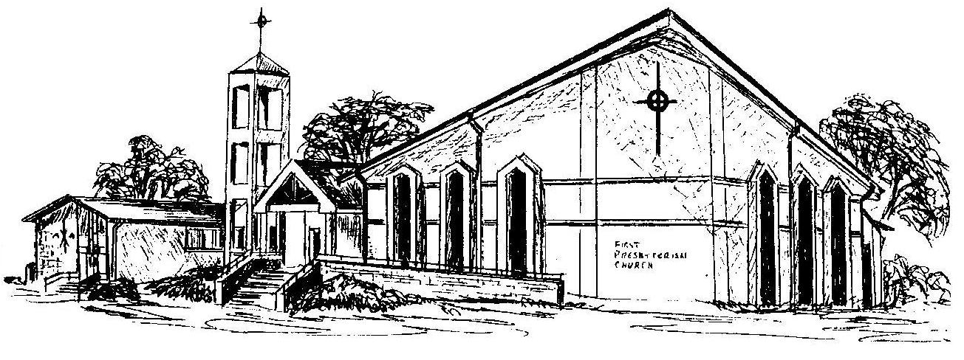

First Presbyterian Church
In the heart of Gardner since 1866 ~ Serving from the heart of God

Welcome - Thank you for joining us for worship today. Please fill out a visitor information card found in the pew racks and place those in the offering plate so that we may follow up with you in the future. Your presence with us today has been a blessing to us, we hope that you have felt the presence of God and the welcome of this congregation.

