Welcome & Announcements, Friendship Information, & Sharing Christ’s Peace
Prelude: “Come, We That Love the Lord” Shea / Williams
Let us prepare our hearts and minds for worship.

Call to Worship
Leader: The Risen Christ calls us to follow. Jesus asks “Do you love me?”
People: Yes, Lord, you know that we love you.
Leader: We are gathered to worship to express our love.
People: We will follow Jesus as we learn how to love God’s people.

*Opening Hymn: “Sing Praise to God who Reigns Above” Red Hymnal, #6

*Prayer of Confession (Unison)
God of Call and Care, we have heard you clearly saying, “Love” and “Follow.” Yet we fail to do either. We are cautious in our caring. We are reluctant in our discipleship. We hold back when we should love abundantly. Forgive us. Inspire us again. Shape us into your people of grace and goodness through Jesus Christ our Lord. Amen.

*Silent Reflection

*Assurance of Pardon

*Gloria Patri (Glory Be to the Father…) Red Hymnal, #623

Bells: “Come Thou Almighty King”

Scripture “Psalm 23” (page 862)
“John 21:15-19” (page1688)
Leader: The word of the Lord.
People: Thanks be to God.

Children's Time Presentation Bible’s to the 4th graders
Please join in singing one verse of Jesus Loves Me as the children come forward.

Special Music: “Praise His Holy Name” by Keith Hampton

Sermon: “Do You Love Me?” Rev. Kimby Young
*Profession of Faith The Apostle's Creed Red Hymnal, inside back cover

*Hymn “Take My Life and Let It Be” Red Hymnal, #379

Pastoral Prayer & Lord’s Prayer: Please Pray for Glenn Schulz, Lauren Boggs, Boston DeWald, Callen Brunker, Beth Ekdohl, Lanny John Turner, Roy Barnett, Larry Bartel, Byron McManus, Margaret Davidson, Brenda Polsen, Naomi Salser, Ann Ferguson, Arlene Thompson, Keith W. Smith, Roland Jack, Rob Kuhauz, Denny Harris, Delphine Brawner, Clay Simmons, Richard Hatfield, Jackson Tijerina
Offertory: “Reach Out and Touch” Brown

*Doxology Red Hymnal, #625

Prayer of Dedication

*Closing Hymn: “They’ll Know We Are Christians By Our Love” Red Hymnal, #284

Benediction

Postlude: “I'll Tell the World That I'm a Christian” B. Fox
*Those who are comfortably able will please stand

Kimby Young, Pastor; Lynn Moldrup, Worship Assistant; Robyn Forkner, Pianist
Dean Faulk, Director of Chancel Choir; Chancel Choir; Alice Rollf, Organist
Robyn McGuire Director of Chancel Bells; Chancel Bells
Heather Rutler, Worship Transcription; Todd Burd, Music Ministries

Ushers for May 2017
Brad & Amber Cornell; Brett Wilson; Cindy, Nalleli & Jon Rollf

Sunday, May 21, PW Birthday Offering
Sunday, May 21, Worship Pillar Meeting 11:15 AM
Monday, May 22, Memorial Committee 6:00 PM
Monday, May 22, Deacons 6:30 PM

Worship Service At Vintage Park In May: 3:00 PM Everyone Is Invited
Sunday, May 21, Deacons
Sunday, May 28, Mission Pillar

Presbyterian Women’s Birthday Offering – Today. The Birthday Offering is a PW offering received in the spring of each year to celebrate the blessings in the lives of Presbyterian Women. We will be dedicating the offering in worship today.

Wear red on Pentecost, Sunday, June 4. Join the congregation in celebration of the fire of the Holy Spirit.

Pastor Kimby will be on study leave June 5-11 at the Omaha School for Pastors. Connie will have contact information in case of emergency.

New Member Inquiry - For any interested in learning more about First Presbyterian Church of Gardner. Please indicate your interest on a visitor card found in the pew rack, or tell Connie Crabbs or Pastor Kimby Young.

Festival on the Trails – Cooling Station – Help Wanted - Last year we gave out over 600 bottles of water and lots of fans. Volunteer for a shift at the station on June 10. Donate water or money for ice.
Johnson County Fair Parade - Saturday, August 5. If you would like to work on a team to put together an entry for the 2017 parade, please contact pastor Kimby Young. There might be free candy for any participants.

College Plus - Group for summer – Now forming. If you are interested or if you know someone who might be interested, contact Kimby at kimby@fpcgardner.org or 913-481-7076.

Traveling Day Camp June 19-23 Can you help? Signup sheets are in the Narthex, for story tellers, craft leaders, youth helpers, food for our leaders, a few supplies and food for lunch.

Sunday, May 21, 2017
Sixth Sunday of Easter
9:00 AM

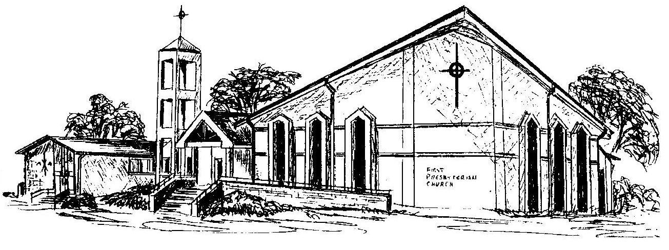

First Presbyterian Church
In the heart of Gardner since 1866 ~ Serving from the heart of God

Welcome - Thank you for joining us for worship today. Please fill out a visitor information card found in the pew racks and place those in the offering plate so that we may follow up with you in the future. Your presence with us today has been a blessing to us, we hope that you have felt the presence of God and the welcome of this congregation.

