Welcome & Announcements, Friendship Information, & Sharing Christ’s Peace
Minute for Mission “PW Birthday” Char Bergene

Prelude: “Praise to the Lord, the Almighty” S. Gesangbuch
Let us prepare our hearts and minds for worship.

Call to Worship
Leader: Mothers and fathers, sisters and brothers, Come.
People: We are the family of God.
Leader: Children of God, we gather to worship the One who loves us.
People: We praise God who calls us to love one another.

*Opening Hymn: “For the Beauty of the Earth” Red Hymnal, #560

*Prayer of Confession (Unison)
Mothering God, we know how you love us, nurture us, guide us and call us into one family of faith. Sometimes we fail to be aware of the diversity among us. Sometimes we overlook the pain or fear, loss or challenge of another. Often we assume too much. Often we hurt one another. Forgive us. Remind us of your gifts to us and your grace for us. Empower us to extend your love to include everyone. We pray in Jesus name. Amen.

*Silent Reflection

*Assurance of Pardon

*Gloria Patri (Glory Be to the Father…) Red Hymnal, #623

Scripture “Ecclesiastes 3:1-8” (page 1037)
“2 Timothy 1:3-7” (page 1852)
Leader: The word of the Lord.
People: Thanks be to God.

Children's Time
Please join in singing one verse of Jesus Loves Me as the children come forward.

Special Music: “Shout to the Lord” by Darlene Zschech

Sermon: “Seasons” Rev. Kimby Young
“Rejoice with those who rejoice; Weep with those who weep.” Romans 12:15

*Profession of Faith The Apostle's Creed Red Hymnal, inside back cover

*Hymn “A Christian Home” Red Hymnal, #535

Pastoral Prayer & Lord’s Prayer: Please Pray for the family of Cheryl Thurston, the family of Norman Klawuhn (9 month’s old), Glenn Schulz, Lauren Boggs, Boston DeWald, Pam Wilson, Callen Brunker, Sharon Frahme, Beth Ekdohl, Cevey Cole Pennington, Delores Guilinger, Lanny John Turner, Roy Barnett, Larry Bartel, Byron McManus, Margaret Davidson, Brenda Polsen, Vespersia Pennington, Naomi Salser, Ann Ferguson, Miah, Cynthia Miller, Arlene Thompson, Keith W. Smith, Roland Jack, Rob Kuhauz, Denny Harris, Delphine Brawner, Kyle Campbell, Clay Simmons, John Kuhns, Richard Hatfield, Jackson Tijerina
Offertory: “Mothers Are a Gift of God” M. Hamer

*Doxology Red Hymnal, #625

Prayer of Dedication

*Closing Hymn: “Now Thank We All Our God” Red Hymnal, # 556

Benediction

Postlude: “A Paean of Praise” J. Rasley
*Those who are comfortably able will please stand

Kimby Young, Pastor; Char Bergene, Worship Assistant; Robyn Forkner, Pianist
Dean Faulk, Director of Chancel Choir; Chancel Choir; Alice Rollf, Organist
Heather Rutler, Worship Transcription; Todd Burd, Music Ministries

Ushers for May 2017
Brad & Amber Cornell; Brett Wilson; Cindy, Nalleli & Jon Rollf

Monday, May 15, Presbyterian Women Meeting 7:00 PM
Monday, May 15, Parents Night Out RSVP ends
Wednesday, May 17, Chancel Bells 6:00 PM; Chancel Choir 7:00 PM
Friday, May 19, Fellowship Hall Reserved
Saturday, May 20, Fellowship Hall Reserved
Saturday, May 20, Parents Night Out 6:00 PM
Sunday, May 21, Worship Pillar Meeting 11:15 AM
Sunday, May 21, PW Birthday Offering

Worship Service At Vintage Park In May: 3:00 PM Everyone Is Invited
Sunday, May 14th, Presbyterian Youth Fellowship (PYF)
Sunday, May 21st, Deacons
Sunday, May 28th, Mission Pillar

New Member Inquiry - For any interested in learning more about First Presbyterian Church of Gardner. Please indicate your interest on a visitor card found in the pew rack, or tell Connie Crabbs or Pastor Kimby Young.

Celebrate Graduation Megan Wetherington and Olga Cocita would like to invite you to come and help celebrate their graduation from GEHS on May 20th from 6-8 pm at our home: 16190 S. Dillie Rd., Gardner, KS

Presbyterian Women’s Birthday Offering – May 21.The Birthday Offering is a PW offering received in the spring of each year to celebrate the blessings in the lives of Presbyterian Women. We will be dedicating the offering in worship on May 21. Contributions may be made before that at any time.

Festival on the Trails – Cooling Station – Help Wanted - Last year we gave out over 600 bottles of water and lots of fans. Volunteer for a shift at the station on June 10. Donate water or money for ice.
Johnson County Fair Parade - Saturday, August 5. If you would like to work on a team to put together an entry for the 2017 parade, please contact pastor Kimby Young. There might be free candy for any participants.

College Plus - Group for summer – Now forming. If you are interested or if you know someone who might be interested, contact Kimby at kimby@fpcgardner.org or 913-481-7076.

Traveling Day Camp June 19-23 Can you help? Signup sheets are in the Narthex, for story tellers, craft leaders, youth helpers, food for our leaders, a few supplies and food for lunch.

Sunday, May 14, 2017
5th Sunday of Easter
9:00 AM

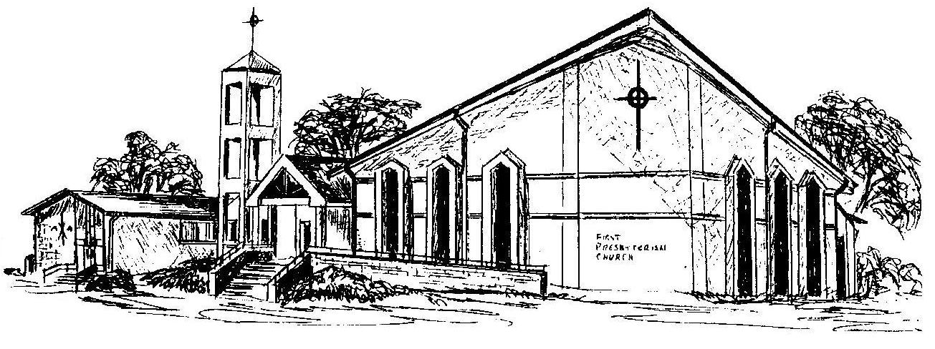

First Presbyterian Church
In the heart of Gardner since 1866 ~ Serving from the heart of God

Welcome - Thank you for joining us for worship today. Please fill out a visitor information card found in the pew racks and place those in the offering plate so that we may follow up with you in the future. Your presence with us today has been a blessing to us, we hope that you have felt the presence of God and the welcome of this congregation.

