Welcome & Announcements, Friendship Information, & Sharing Christ’s Peace
Minute for Mission “Heartland Camp” Michael Megraw
Prelude: “Hail Thee, Festival Day!” R. V. Williams
Let us prepare our hearts and minds for worship.

Call to Worship
Leader: Come to the table all who seek Jesus Christ!
People: We walk in the presence of God all of our days.
Leader: Open your eyes to the grace of God surrounding you.
People: Our hearts burn within us as we recognize Jesus here among us.

*Opening Hymn: “Christ the Lord Is Risen Today!” Blue Hymnal, #113

*Prayer of Confession (Unison)
God of mercy, how often do we walk the roads of life confused and complaining? How often do we not even notice that you are right beside us, comforting and guiding us? Open our eyes to your presence. Open our hearts to your wisdom. Open our lives to your healing. Open our hands to your service. We pray in the name of our Risen Lord, Jesus Christ. Amen.

*Silent Reflection

*Assurance of Pardon

*Gloria Patri (Glory Be to the Father…) Blue Hymnal, #567

Scripture “Luke 24:13-35” (page 1642)
Leader: The word of the Lord.
People: Thanks be to God.

Children's Time – Noisy Offering
Please join in singing one verse of Jesus Loves Me as the children come forward.

Special Music: “We Are the People of God” by Joseph M Martin

Sermon “Easter Eyes” Rev. Kimby Young

*Profession of Faith “The Apostle's Creed” Blue Hymnal, top page 14

*Hymn “Be Known to Us in Breaking Bread” Blue Hymnal, #505

Offertory: “By His Grace” Fry
*Doxology Blue Hymnal, #592

*Prayer of Dedication & Pastoral Prayer Please Pray for the family of Irvin Kneedler, Glenn Schulz, Lauren Boggs, Boston DeWald, Pam Wilson, Callen Brunker, Sharon Frahme, Beth Ekdohl, Cevey Cole Pennington, Delores Guilinger, Lanny John Turner, Roy Barnett, Larry Bartel, Byron McManus, Margaret Davidson, Brenda Polsen, Vespersia Pennington, Naomi Salser, Ann Ferguson, Miah, Cynthia Miller, Arlene Thompson, Keith W. Smith, Roland Jack, Rob Kuhauz, Denny Harris, Delphine Brawner, Kyle Campbell, Clay Simmons, John Kuhns, Richard Hatfield, Jackson Tijerina
Communion & Celebration
Invitation
Great Thanksgiving
The Lord’s Prayer
Breaking of Bread
Communion of the People
Prayer of Thanksgiving

*Closing Hymn: “We Come as Guests Invited” Blue Hymnal, #517

Litany of Sending
Leader: Jesus Christ has risen from the dead!
People: We will go to share this good news!
Leader: Jesus walks with us on our journey of life.
People: We will go with him wherever the road takes us.
Leader: Jesus has opened our eyes.
People: We will love everyone we see.
Leader: Jesus has touched our hearts.
People: We will share that passion of new life in Christ.

*Benediction

Postlude: “Let My Life Praise Him” Tunney/Elliott/Goodine
*Those who are comfortably able will please stand

Kimby Young, Pastor; Sandy Rieger, Worship Assistant; Robyn Forkner, Pianist
Dean Faulk, Director of Chancel Choir; Chancel Choir; Alice Rollf, Organist
Heather Rutler, Worship Transcription; Todd Burd, Music Ministries

Ushers May 2017 Brad & Amber Cornell; Brett Wilson; Cindy, Nalleli & Jon Rollf

Flowers are given today to the Glory of God, in honor of Laura McKaig’s Birthday, given by her family.

Sunday, May 7, Discipleship Pillar Meeting, 11:15 AM
Sunday, May 7, Vintage Worship Service, PW 3:00 PM
Monday, May 8, Session 6:30 PM
Tuesday, May 9, Men’s Breakfast 7:00 AM Perkins
Wednesday, May 10, Choir 7:00 PM
Sunday, May 14, Mission Pillar Meeting 11:15AM
Monday, May 15, RSVP Parents Night Out

Rev. Kimby’s Sunday School will meet today studying Hebrews 12.

First Presbyterian Church Leads Worship Service
At Vintage Park In May:
3:00 PM Everyone Is Invited
Sunday, May 7th, Presbyterian Women (PW)
Sunday, May 14th, Presbyterian Youth Fellowship (PYF)
Sunday, May 21st, Deacons
Sunday, May 28th, Mission Pillar

Men’s Breakfast will be held at 7:00 AM on Tuesday, May 9, at Perkins Restaurant.

New Member Inquiry - A new class will be forming after Easter for any interested in learning more about First Presbyterian Church of Gardner. Please indicate your interest on a visitor card found in the pew rack, or tell Connie Crabbs or Pastor Kimby Young.

Parents Night Out, Saturday, May 20. 6:00 -10:00 PM. See flyer! RSVP required.
Celebrate Graduation Megan Wetherington and Olga Cocita would like to invite you to come and the help celebrate their graduation from GEHS on May 20th from 6-8 pm at our home:16190 S. Dillie Rd.,Gardner, KS 66030
Presbyterian Women’s Birthday Offering – May 21.The Birthday Offering is a PW offering received in the spring of each year to celebrate the blessings in the lives of Presbyterian Women. We will be dedicating the offering in worship on May 21. Contributions may be made before that at any time.
Traveling Day Camp June 19-23 Registration is now open. Go to: http://www.heartlandcamps.org/traveling-day-camps/#forparents to register campers. When you register your child, remember to fill out the health form also. We do not charge any fees for day camp. Sign up soon. We do have a limit on how many campers we can enroll.

Sunday
May 7, 2017
Fourth Sunday of Easter
9:00 AM
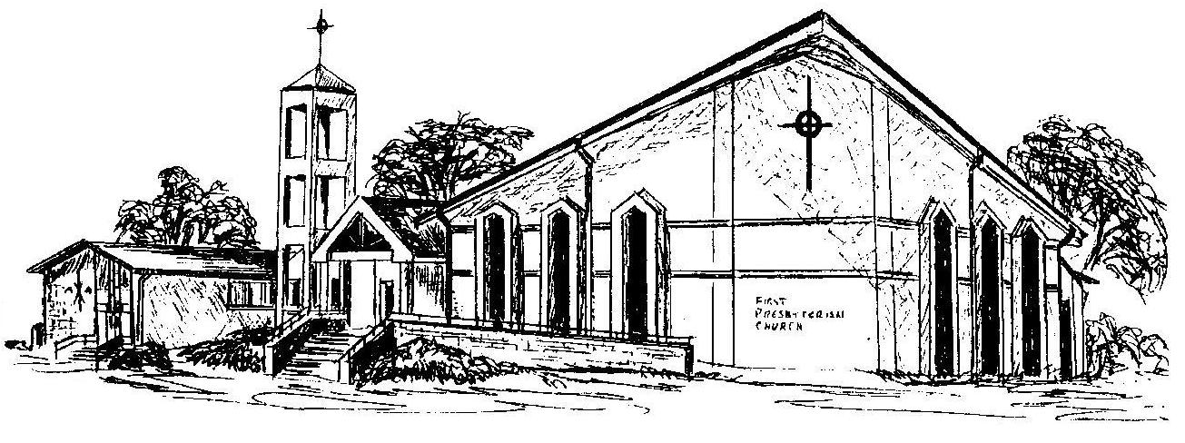

First Presbyterian Church
In the heart of Gardner since 1866 ~ Serving from the heart of God

Welcome - Thank you for joining us for worship today. Please fill out a visitor information card found in the pew racks and place those in the offering plate so that we may follow up with you in the future. Your presence with us today has been a blessing to us, we hope that you have felt the presence of God and the welcome of this congregation.

