Welcome & Announcements, Friendship Information, & Sharing Christ’s Peace
Minute for Mission “Safehome” Donalie Zimmerman
Prelude: “A Modern Medley of Praise” Thompson / Jernigan
Let us prepare our hearts and minds for worship.

Call to Worship
Leader: Children of God, if you are seeking but not finding, Come Here!
People: We will be found by our Risen Lord!
Leader: Beloved and Blessed, if you don’t know where to go or what to do, Come Here!
People: We will journey together in the love of our Creator, serving Jesus Christ!
Leader: Brothers and sisters, if you lift your net and it is empty, Come Here!
People: We will be filled with Christ’s abundance, blessed in the bounty of God’s love!

*Opening Hymn: “Christ is Alive!” Blue Hymnal, #108

*Prayer of Confession (Unison)
Risen Lord, guide and guardian, save us from ourselves. We continue to do the same things over and over, expecting different results. Lead us to new paths of transformation and growth. Risen Lord, save us from doing too much. We run around keeping ourselves busy, but don’t make time for you. We go fishing every day, not noticing you waiting with a meal on the beach. Open our eyes to your presence. Risen Lord, save us from doing too little. We claim to follow you, but neglect your daily calling to serve others. Direct our days, that we may serve you fully and faithfully, in Jesus’ name. Amen

*Silent Reflection

*Assurance of Pardon

*Gloria Patri (Glory Be to the Father…) Blue Hymnal, #567

Scripture “John 21: 1-14” (page1687)
Leader: The word of the Lord.
People: Thanks be to God.

Children's Time
Please join in singing one verse of Jesus Loves Me as the children come forward.
Special Music: “I will Glory in the Cross” Words and Music by Dottie Rambo

Sermon: “Going Fishing” Rev. Kimby Young

*Profession of Faith The Apostle's Creed Blue Hymnal, top page 14

*Hymn “Dear Lord and Father of Mankind” Blue Hymnal #345

High School Senior Recognition

Pastoral Prayer & Lord’s Prayer: Please Pray for Lauren Boggs, Boston DeWald, Pam Wilson, Sharon Frahme, Beth Ekdohl, Cevey Cole Pennington, Delores Guilinger, Callen Brunker, Lanny John Turner, Roy Barnett, Larry Bartel, Byron McManus, Margaret Davidson, Brenda Polsen, Vespersia Pennington, Naomi Salser, Ann Ferguson, Miah, Glenn Schulz, Cynthia Miller, Arlene Thompson, Keith W. Smith, Roland Jack, Rob Kuhauz, Denny Harris, Delphine Brawner, Kyle Campbell, Clay Simmons, John Kuhns, Richard Hatfield, Jackson Tijerina
Offertory: “Thank You, Jesus” Gaither / Hallett
*Doxology Blue Hymnal, #592

Prayer of Dedication

*Closing Hymn: “I Danced in the Morning” Blue Hymnal, #302

Benediction

Postlude: “A Fisher of Men” Salsbury
*Those who are comfortably able will please stand

Flowers are given today to the Glory of God, in honor of Gladys Lane 100th Birthday given by her family.

Kimby Young, Pastor; Marilyn Huffman, Worship Assistant; Robyn Forkner, Pianist
Dean Faulk, Director of Chancel Choir; Chancel Choir; Alice Rollf, Organist
Heather Rutler, Worship Transcription; Todd Burd, Music Ministries

Ushers for April 2017
Harvey Seim; Larry Schick; Debbie Pickell; Mike & Pat Clark; Delores Guilinger
Sunday, April 30, Blessing of Bikes 10:15 AM
Sunday, April 30, PYF Mission Dinner (Chicken & Noodles) 5:00 PM
Monday, May 1, Congregational Life Pillar Meeting 7:00 PM
Wednesday, May 3, Women’s Group 10:00 AM
Wednesday, May 3, Chancel Choir 7:00 PM
Sunday, May 7, Worship Service Noisy Offering 9:00 AM
Sunday, May 7, Discipleship Pillar Meeting 11:15 AM
Sunday, May 7, Vintage Park Worship Service 3:00 PM

New Member Inquiry - A new class will be forming after Easter for any interested in learning more about First Presbyterian Church of Gardner. Please indicate your interest on a visitor card found in the pew rack, or tell Connie Crabbs or Pastor Kimby Young.

Crosses - Thank you to everyone who shared a cross for Lent on the display board in the narthex. You may retrieve your cross any time. At least one cross has gone missing. If yours is also missing, or if you have found a cross, contact Kimby or Connie in the office.

PYF will be hosting a chicken & noodles dinner today. Food will be served from 5:00-6:30 pm and donations will be accepted to help support the mission trip to Washington, D.C. this summer. This great meal prepared and served by the youth will be best enjoyed in the company of your friends and family so bring them along.

Blessing of Bikes and “Bike to Church” Today
At 10:15 a.m., we will gather outside (or in fellowship hall) for a short blessing of our bikes, helmets, pads, tricycles, skateboards, or any other small wheeled vehicle. You do not have to have a bike to participate in the blessing. Many churches designate a day near Earth Day and encourage members to walk or ride bikes to church.

College Scholarships are available for any member of First Presbyterian Church of Gardner, Kansas. If you are interested in applying, please contact Connie Crabbs in the office for an application. Completed applications are due with references on April 30.

Women’s Fellowship Group will meet Wednesday, May 3, at 10:00 AM for Fellowship and Devotions. Bring your items in for Safehome Mission Project.

Traveling Day Camp June 19-23 Registration is now open. Go to: http://www.heartlandcamps.org/traveling-day-camps/#forparents to register campers. When you register your child, remember to fill out the health form also. We do not charge any fees for day camp. Sign up soon. We do have a limit on how many campers we can enroll.

Sunday, April 30, 2017
3rd Sunday of Easter
9:00 AM

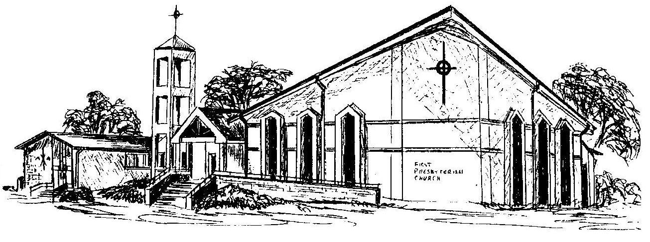

First Presbyterian Church
In the heart of Gardner since 1866 ~ Serving from the heart of God

Welcome - Thank you for joining us for worship today. Please fill out a visitor information card found in the pew racks and place those in the offering plate so that we may follow up with you in the future. Your presence with us today has been a blessing to us, we hope that you have felt the presence of God and the welcome of this congregation.

