Welcome & Announcements, Friendship Information, & Sharing Christ’s Peace
Prelude: “My Lord, What a Morning” Spiritual / arr. Wilson
Let us prepare our hearts and minds for worship.

Call to Worship
Leader: Alleluia! Christ is risen!
People: Christ is risen indeed! Alleluia!
Leader: Be glad and rejoice! Hear the Good News!
People: And the celebration continues!
Leader: We greet the Risen Christ who is here among us.
People: We praise the Risen Christ and worship with great joy.

*Opening Hymn: “Christ is Risen! Shout Hosanna!” Blue Hymnal, #104

*Opening Prayer (Unison)
On the first day of creation, Holy God, You held out Your hands, filled with all the grace we would ever need; and You began to surround us with all that is good and pleasant. On the first day of Easter, Defeater of Death, You walked through the closed doors of our doubts and fears; You held tight until the warmth of your grace softened our hardened hearts. On the first day of following You, Breath of Peace, You opened our eyes to the bright color of hope; You teach us the glad songs of grace. God of wonders, we bring You our Easter worship and praise. Amen.

*Gloria Patri (Glory Be to the Father…) Blue Hymnal, #567

Bells “Breathe on Me, Breath of God”

Scripture “John 20:19-31” (page 1686)
Leader: The word of the Lord.
People: Thanks be to God.

Children's Time
Please join in singing one verse of Jesus Loves Me as the children come forward.

Special Music: “Hosanna Loud Hosanna/All Glory, Laud and Honor” by Lloyd Larson

Sermon: “Breath of God” Rev. Kimby Young

*Profession of Faith The Apostle's Creed Blue Hymnal, top page 14

*Hymn “That Easter Day with Joy Was Bright” Blue Hymnal #121

Pastoral Prayer & Lord’s Prayer: Please Pray for Sharon Frahme, the family Shirley Cooper, the family of Nancy Jenkins, Beth Ekdohl, Cevey Cole Pennington, Delores Guilinger, Callen Brunker, Brooke Miller, Roy Barnett, Larry Bartel, Byron McManus, Margaret Davidson, Brenda Polsen, Pam Wilson, Vespersia Pennington, Naomi Salser, Ann Ferguson, Miah, Glenn Schulz, Cynthia Miller, Arlene Thompson, Keith W. Smith, Roland Jack, Rob Kuhauz, Denny Harris, Delphine Brawner, Kyle Campbell, Clay Simmons, Jano Smoor, John Kuhns, Richard Hatfield, Jackson Tijerina, The DeWald Family
Offertory: “Christ Arose” Lowry / arr. Rasley

*Doxology Blue Hymnal, #592

Prayer of Dedication

*Closing Hymn: “Good Christians All, Rejoice and Sing!” Blue Hymnal, #111

Leader: Have you heard the Good News?
People: Jesus Christ is risen!
Leader: Christ is risen indeed! And Christ has breathed into you and into each of us the breath of new life.
People: We respond with thanksgiving, going out into the world to serve our Risen Lord! Alleluia!
Leader: In the name of the Creator, the Christ, and the Breath of Life. Go in Peace.

Benediction

Postlude: “He Lives” A. H. Ackley
*Those who are comfortably able will please stand

Flowers are given today to the Glory of God, in memory of Timothy Scott Waters by the Waters family.

Kimby Young, Pastor; Larry Schick, Worship Assistant; Robyn Forkner, Pianist
Dean Faulk, Director of Chancel Choir; Chancel Choir; Alice Rollf, Organist
Robyn McGuire Director of Chancel Bells; Chancel Bells
Heather Rutler, Worship Transcription; Todd Burd, Music Ministries

Ushers for April 2017
Harvey Seim; Larry Schick; Debbie Pickell; Mike & Pat Clark; Delores Guilinger
Sunday, April 23, Worship Pillar Meeting, 11:15 AM
Monday, April 24, Deacons 6:30 PM
Tuesday, April 25, Presbytery at First Presbyterian, Leavenworth, KS 9:00 AM
Wednesday, April 26, Choir 7:00 PM
Friday, April 28, Fellowship Hall Reserved
Saturday, April 29, Fellowship Hall Reserved
Sunday, April 30, Blessing of Bikes 10:15 AM
Sunday, April 30, PYF Mission Dinner (Chicken & Noodles) 5:00 PM
Sunday, May 7, Worship Service Noisy Offering, be sure to bring loose coins

New Member Inquiry - A new class will be forming after Easter for any interested in learning more about First Presbyterian Church of Gardner. Please indicate your interest on a visitor card found in the pew rack, or tell Connie Crabbs or Pastor Kimby Young.

Crosses - Thank you to everyone who shared a cross for Lent on the display board in the narthex. You may retrieve your cross any time. At least one cross has gone missing. If yours is also missing, or if you have found a cross, contact Kimby or Connie in the office.

PYF will be hosting a chicken & noodles dinner on Sunday, April 30th. Food will be served from 5:00-6:30 pm and donations will be accepted to help support the mission trip to Washington, D.C. this summer. This great meal prepared and served by the youth will be best enjoyed in the company of your friends and family so bring them along.

High School Seniors will be recognized in worship on Sunday, April 30th. Please join us.

Blessing of Bikes and “Bike to Church” Sunday – April 30
At 10:15 a.m., gather outside (or in fellowship hall) for a short blessing of our bikes, or any other small wheeled vehicle. In connection with this event, you are invited to ride your bikes to church and to dress casually (even wear biking clothes). Many churches designate a day near Earth Day and encourage members to walk or ride bikes to church.

College Scholarships are available for any member of First Presbyterian Church of Gardner, Kansas. If you are interested in applying, please contact Connie Crabbs in the office for an application. Completed applications are due with references on April 30.

Traveling Day Camp June 19-23 Registration is now open. Go to: http://www.heartlandcamps.org/traveling-day-camps/#forparents to register campers. When you register your child, remember to fill out the health form also.
We do not charge any fees for day camp. Sign up soon. We do have a limit on how
many campers we can enroll.

Sunday, April 23, 2017
2nd Sunday of Easter
9:00 AM

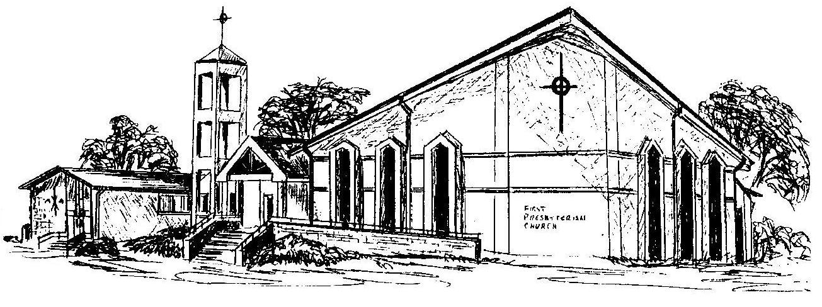

First Presbyterian Church
In the heart of Gardner since 1866 ~ Serving from the heart of God

Welcome - Thank you for joining us for worship today. Please fill out a visitor information card found in the pew racks and place those in the offering plate so that we may follow up with you in the future. Your presence with us today has been a blessing to us, we hope that you have felt the presence of God and the welcome of this congregation.

