Welcome & Announcements, Friendship Information, & Sharing Christ’s Peace
Prelude: “Ah, Holy Jesus” Cruger
Let us prepare our hearts and minds for worship.

Call to Worship
Leader: Jesus said, take up your cross and follow me.
People: We want to follow. Lord, strengthen us for service.
Leader: Jesus said, take this bread, drink from this cup.
People: We receive God’s blessings and seek to share God’s love.

*Opening Hymn: “Lord, Who Throughout These Forty Days” Blue Hymnal, #81

*Prayer of Confession (Unison)
God of Reconciliation and Life, we have been thinking about the cross and all that it means. But we know that we still do not fully understand your call for us. We also know that even when we understand, we often do not have the courage to respond. Forgive us. Heal us. Nourish us. Inspire us. Give us wisdom and strength to take up the cross you set before us and to follow Jesus Christ. Amen.

*Silent Reflection

*Assurance of Pardon

*Gloria Patri (Glory Be to the Father…) Blue Hymnal, #567

Scripture “Isaiah 55:8-13” (page 1149)
“Matthew 16:13-28” (page 1524)
Leader: The word of the Lord.
People: Thanks be to God.

Children's Time
Please join in singing one verse of Jesus Loves Me as the children come forward.

Special Music: “The Whisper” by Susan Bengali Boersma and Craig Courtesy

Sermon “The Way of the Cross: Obedience and Commitment” Rev. Kimby Young

*Profession of Faith “The Apostle's Creed” Blue Hymnal, top page 14

*Hymn “Take Up Your Cross, the Savior Said” Blue Hymnal, #393

Offertory: “I Surrender All” Weeden

*Doxology Blue Hymnal, #592

*Prayer of Dedication & Pastoral Prayer Please Pray for Lanny John Turner, Roy Barnett, Larry Bartel, Byron McManus, Margaret Davidson, Brenda Polsen, Pam Wilson, Vespersia Pennington, Naomi Salser, Ann Ferguson, Miah, Nancy Jenkins, Glenn Schulz, Cynthia Miller, Arlene Thompson, Keith W. Smith, Roland Jack, Rob Kuhauz, Denny Harris, Delphine Brawner, Kyle Campbell, Clay Simmons, Jano Smoor, John Kuhns, Richard Hatfield, Jackson Tijerina, The DeWald Family
Communion & Celebration
Invitation
Great Thanksgiving
The Lord’s Prayer
Breaking of Bread
Communion of the People
Prayer of Thanksgiving

*Closing Hymn: “Hope of the World” Blue Hymnal, #360

*Benediction

Postlude: “Wherever He Leads I'll Go” McKinney
*Those who are comfortably able will please stand

Kimby Young, Pastor; Paula Waters, Worship Assistant; Robyn Forkner, Pianist
Dean Faulk, Director of Chancel Choir; Chancel Choir; Alice Rollf, Organist
Heather Rutler, Worship Transcription; Todd Burd, Music Ministries

Ushers April 2017
Harvey Seim; Larry Schick; Debbie Pickell; Mike & Pat Clark; Delores Guilinger

Communion Servers:
Connie & Ron Crabbs; Wayne Rollf; Larry Flakus; Randy & Sandy Rieger

Sunday, April 2, Discipleship Pillar Meeting 11:15 AM
Sunday, April 2, Kimby’s Bible Study 4:30 PM
Monday, April 3, Congregation Life 7:00 PM; Relay for Life 6:00 PM
Wednesday, April 5, Women’s Group 10:00 AM; Choir 7:00 PM
Thursday, April 6, Women’s Bible Study 7:00 PM
Saturday, April 8, Easter Egg Hunt outside American Legion 11:00 AM
Saturday, April 8, Celebration for Life Scott Miller 2:00 PM
Sunday, April 9, Mission Pillar Meeting 11:15AM
Sunday, April 9, Kimby’s Bible Study 4:30 PM

Holy Week:
Sunday, April 9, Palm Sunday Worship Service 9:00 AM Matthew 21: 1-11
Thursday, April 13, Maundy Thursday Service 7:00 PM
Friday, April 14, Good Friday Service 7:00 PM
Sunday, April 16, Easter Sunday Worship Service 9:00 AM

One Great Hour of Sharing If you would like to give a donation, please earmark on your check OGHS offering.

Women's Fellowship Group will meet Wednesday April 5 at 10:00 AM for Fellowship and Devotions. Again for a joint mission project we will collect Items for SafeHome. This will be a joint effort of the Fellowship Group, PW and our Mission Pillar. During the Months of April, May, and June we ask the congregation to help with this project and bring supplies to fill the bags. Items needed include: Shampoo, Conditioner, Body Wash, Body Lotion, Hair Brushes, Combs, Hairspray, Mouthwash, Adult and Children Toothbrushes, Toothpaste, Women's Deodorant, Ethnic Hair Care Products, Feminine Hygiene Products, Facial Tissue (Kleenex) Baby wipes, Baby Body Wash, Diaper Rash Cream

Men’s Breakfast will be held at 7:00 AM on Tuesday, April 11, at Perkins Restaurant.

Ladies You’re Invited to the Annual Spring Brunch, Saturday, April 22 at 9:30 AM. There will be music, devotions, and great fellowship and food! Our speaker will be Carl Frahme and the theme is: "God and Nature". Call church office to make your reservation. There is a sign-up sheet in the Narthex to help bring food, serve, set-up and various other ways. Promises to be a fun day! Nursery is provided by contacting the church office.

Sunday
April 2, 2017
Fifth Sunday of Lent
9:00 AM
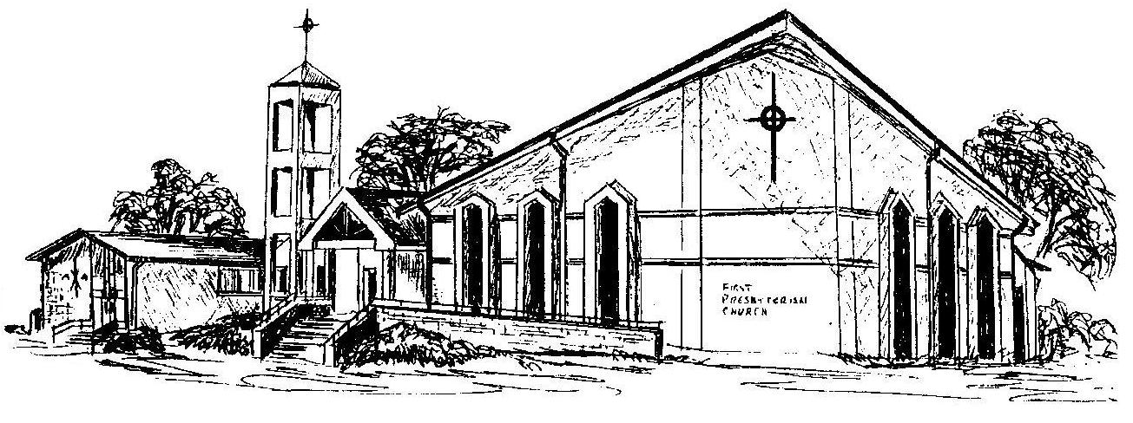

First Presbyterian Church
In the heart of Gardner since 1866 ~ Serving from the heart of God

Welcome - Thank you for joining us for worship today. Please fill out a visitor information card found in the pew racks and place those in the offering plate so that we may follow up with you in the future. Your presence with us today has been a blessing to us, we hope that you have felt the presence of God and the welcome of this congregation.

