Welcome & Announcements, Friendship Information, & Sharing Christ’s Peace
Prelude: “At the Cross” Richolson
Let us prepare our hearts and minds for worship.

Call to Worship
Leader: As we look at the cross of Jesus Christ, we see many things.
People: We see the love of God lived in a man of true compassion – Jesus Christ.
Leader: We see the willingness of Jesus to take on our burdens and to suffer that we might be saved.
People: As we look at the cross, we see God’s grace in action and we respond in grateful praise.

*Opening Hymn “When I Survey the Wondrous Cross” Blue Hymnal, #101

* Prayer of Confession (Unison)
God of Mercy and Compassion, suffering breaks our hearts and we want to turn away. Sometimes we forget that your heart is wounded by the pain we inflict on others, by the ways we ignore the tragedies of our world, by the times we walk away from need when we could offer help. Forgive us for our part in the suffering of the world, and for the pain we cause you by our insensitivity. Remind us of your call to healing and reconciliation. Empower us to share your grace in the world, through Jesus Christ our Lord. Amen.

*Silent Confession

*Assurance of Pardon

*Gloria Patri (Glory Be to the Father…) Blue Hymnal, #567

Bells “God Himself is With Us”

Scripture “Matthew 9: 35-38” (page 1510)
“Matthew 27:27-31” (page 1547)
“Romans 5:1-11” (page 1752)
“1Corinthians 1: 18, 22-25” (page1772)
Leader: The word of the Lord.
People: Thanks be to God.

Children's Time
Please join in singing one verse of Jesus Loves Me as the children come forward.

Special Music “Cry No More” Lyrics by Johanna Anderson music by Dan Forrest
Sermon: “The Way of the Cross: Suffering and Compassion” Rev. Kimby Young

*Profession of Faith The Apostle's Creed Blue Hymnal, top page 14

*Hymn “Beneath the Cross of Jesus” Blue Hymnal, #92

Pastoral Prayer & Lord’s Prayer: Family of Scott Miller, Byron McManus, Margaret Davidson, Brenda Polsen, JoAn Jones, Pam Wilson, Vespersia Pennington, Naomi Salser, Ann Ferguson, Miah, Nancy Jenkins, Glenn Schulz, Cynthia Miller, Arlene Thompson, Keith W. Smith, Roland Jack, Rob Kuhauz, Denny Harris, Delphine Brawner, Kyle Campbell, Minnie Ashmore, Clay Simmons, Jano Smoor, John Kuhns, Richard Hatfield, Mark Freund, Jackson Tijerina, The DeWald Family
Offertory: “The Old Rugged Cross” Bennard

*Doxology Blue Hymnal, #592

*Prayer of Dedication

*Closing Hymn: “When We Are Living (We Belong to God)” Blue Hymnal, #400

*Benediction

Postlude: “Make Me a Channel of Your Peace” Temple
*Those who are comfortably able will please stand

Kimby Young, Pastor; Karen Elliott, Worship Assistant; Robyn Forkner, Pianist;
Dean Faulk, Director of Chancel Choir; Chancel Choir; Alice Rollf, Organist
Robyn McGuire, Director of Chancel Bells; Chancel Bells;
Heather Rutler, Worship Transcription; Todd Burd, Music Ministries

Ushers: March 2017
Corky & Joyce Scarlett; Larry Flakus; Mike & Tina Fraser; Lynn Moldrup

Sunday, March 26, Worship Pillar Meeting 11:15 AM
Sunday, March 26, Kimby’s Bible Study 4:30 PM
Monday, March 27, Deacons 6:30 PM
Tuesday, March 28, Court of Honor 7:00 PM
Wednesday, March 29, Chancel Bells 6:00 PM; Chancel Choir 7:00 PM
Thursday, March 30, Women’s Bible Study 7:00 PM
Saturday, April 1, Boy Scouts Leadership Training 8:00 AM; Court of Honor 3:00 PM
Sunday, April 2, Discipleship Pillar Meeting 11:15 AM
Sunday, April 2, Kimby’s Bible Study 4:30 PM

Sympathy to the family Scott Miller, died Sunday, March 19. Visitation Sunday, March 26, 2:00-4:00 PM at Bruce’s. Celebration of Life Service on Saturday, April 8, 2:00 PM at church.
Bake Sale Fundraiser Today J. J. Brisco – Brazil & Megan Wetherington – Italy are raising money to support their foreign exchange year. Donations are welcome. Table in the narthex.
Women's Fellowship Group will meet Wednesday April 5 at 10:00 AM for Fellowship and Devotions. Again for a joint mission project we will collect Items for SafeHome. This will be a joint effort of the Fellowship Group, PW and our Mission Pillar. During the Months of April, May, and June we ask the congregation to help with this project and bring supplies to fill the bags. Items needed include: Shampoo, Conditioner, Body Wash, Body Lotion, Hair Brushes, Combs, Hairspray, Mouthwash, Adult and Children Toothbrushes, Toothpaste, Women's Deodorant, Ethnic Hair Care Products, Feminine Hygiene Products, Facial Tissue (Kleenex) Baby wipes, Baby Body Wash, Diaper Rash Cream

Sermon Series for Lent: “The Way of the Cross”
April 2 – Obedience and Commitment – Matthew 16:13-28
April 9 – Palm and Passion – Matthew 21:1-11
April 16 – EASTER – Resurrection - John 20:1-18

Holy Week:
Sunday, April 9, Palm Sunday Worship Service 9:00 AM
Thursday, April 13, Maundy Thursday Service 7:00 PM
Friday, April 14, Good Friday Service 7:00 PM
Sunday, April 16, Easter Sunday Worship Service 9:00 AM

Ladies You’re Invited to the Annual Spring Brunch, Saturday, April 22 at 9:30 AM. There will be music, devotions, and great fellowship and food! Our speaker will be Carl Frahme and the theme is: "God and Nature". Call church office to make your reservation. There is a sign-up sheet in the Narthex to help bring food, serve, set-up and various other ways. Promises to be a fun day! Nursery is provided by contacting the church office.

Sunday, March 26, 2017
Fourth Sunday in Lent
9:00 AM

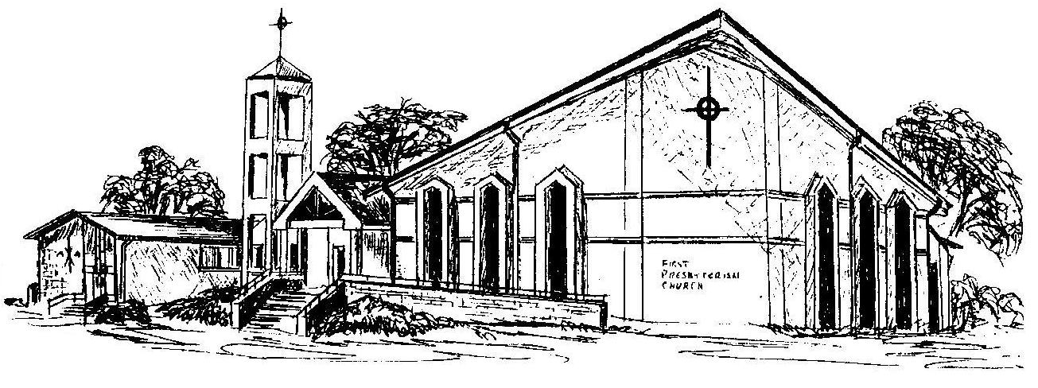

First Presbyterian Church
In the heart of Gardner since 1866 ~ Serving from the heart of God

Welcome - Thank you for joining us for worship today. Please fill out a visitor information card found in the pew racks and place those in the offering plate so that we may follow up with you in the future. Your presence with us today has been a blessing to us, we hope that you have felt the presence of God and the welcome of this congregation.

