Welcome & Announcements, Friendship Information, & Sharing Christ’s Peace
Prelude: “As the Deer” Nystrom
Let us prepare our hearts and minds for worship.

Call to Worship
Leader: Marked by a cross, cherished and forgiven,
People: We belong to God.
Leader: Called by a cross, challenged and empowered,
People: We belong to God.
Leader: Saved by a cross, reborn and filled with God’s Spirit,
People: We belong to God.

*Opening Hymn “Great is Thy Faithfulness” Red Hymnal, #43

* Litany of Confession (Psalm 51)
Leader: Have mercy on me, O God, according to your steadfast love;
People: according to your abundant mercy blot out my transgressions.
Leader: Wash me thoroughly from my iniquity, and cleanse me from my sin!
People: For I know my transgressions, and my sin is ever before me.
Leader: Against you, you only, have I sinned, and done what is evil in your sight, so that you are justified in your sentence and blameless in your judgment.
People: Behold I was born into iniquity, and I have been sinful since my mother conceived me.
Leader: Behold you desire truth in the inward being; therefore teach me wisdom in my secret heart.
People: Purge me with hyssop, and I shall be clean; wash me and I shall be whiter than snow.
Leader: Make me hear with joy and gladness; let the bones which you have broken rejoice.
People: Hide your face from my sins, and blot out all my iniquities.
Leader: Create in me a clean heart, O God, and put a new and right spirit within me.
People: Cast me not away from your presence, and take not your Holy Spirit from me.
Leader: Restore to me the joy of your salvation, and sustain in me a willing spirit.
People: Then I will teach transgressors your ways, and sinners will return to you.
Leader: Deliver me from death, God of my salvation, and my tongue will sing aloud of your deliverance.
People: O Lord, open my lips, and my mouth shall show forth your praise.
Leader: For you have no delight in sacrifice; were I to give a burnt offering, you would not be pleased.
People: The sacrifice acceptable to God is a broken spirt; a broken and contrite heart, O God, you will not refuse.

*Silent Confession

*Assurance of Pardon
*Gloria Patri (Glory Be to the Father…) Red Hymnal, #623

Scripture “Matthew 18:15-35” (page 1527)
Leader: The word of the Lord.
People: Thanks be to God.

Children's Time
Please join in singing one verse of Jesus Loves Me as the children come forward.

Special Music "Face The Cross" by David Lantz, III

Sermon: “The Way of the Cross: Repentance and Forgiveness” Rev. Kimby Young

*Profession of Faith The Apostle's Creed Red Hymnal, inside back cover

*Hymn “My Faith Looks Up to Thee” Red Hymnal, #410

Pastoral Prayer & Lord’s Prayer: Family of Minnie Ashmore, Margaret Davidson, Brenda Polsen, JoAn Jones, Pam Wilson, Vespersia Pennington, Naomi Salser, Ann Ferguson, Miah, Nancy Jenkins, Glenn Schulz, Scott & Cynthia Miller, Arlene Thompson, Keith W. Smith, Roland Jack, Rob Kuhauz, Denny Harris, Delphine Brawner, Kyle Campbell, Minnie Ashmore, Clay Simmons, Jano Smoor, John Kuhns, Richard Hatfield, Mark Freund, Jackson Tijerina, The DeWald Family
Offertory: “I Come to the Cross” Somma and Batstone

*Doxology Red Hymnal, #625

*Prayer of Dedication

*Closing Hymn: “Amazing Grace” Red Hymnal, #202

*Benediction

Postlude: “Cleanse Me” Maori Melody / arr. B.D. Ackley
*Those who are comfortably able will please stand

Kimby Young, Pastor; Bill Danner, Worship Assistant; Robyn Forkner, Pianist;
Dean Faulk, Director of Chancel Choir; Chancel Choir; Alice Rollf, Organist
Heather Rutler, Worship Transcription; Todd Burd, Music Ministries;

Ushers: March 2017
Corky & Joyce Scarlett; Larry Flakus; Mike & Tina Fraser; Lynn Moldrup

Sunday, March 19, Discipleship Pillar Meeting 11:15 AM
Sunday, March 19, Kimby’s Bible Study 4:30 PM
Monday, March 20, PW Meeting 7:00 PM
Wednesday, March 22, Chancel Bells 6:00 – 7:00 PM
Wednesday, March 22, Chancel Choir 7:00 – 8:00 PM
Thursday, March 23, PW Bible Study 7:00 PM
Sunday, March 26, Worship Service 9:00 AM
Sunday, March 26, Worship Pillar Meeting 11:15 AM

New Interim Choir Director: Dean Faulk has been hired as choir director during Todd Burd's medical leave. Dean lives in Olathe and works full time at Kansas City Life Insurance Company. He served for 11 years as Assistant Music Director, primary pianist and director of two choirs for Spirit of Hope Metropolitan Community Church in Kansas City. He has extensive musical experience in the church and community. Welcome Dean!

Sunday Evening Bible Study Class – 4:30 - 6:00 pm. Pastor Kimby is leading a short introduction to the New Testament. Guests and non-members are welcome.

Ladies Bible Study
Come join the new women’s Bible Study on Thursday, 7:00 PM. The study is based on the book by Liz Curtis Higgs “The Women of Easter”. Hope to see you at the study!

Sermon Series for Lent: “The Way of the Cross”
March 26 – Suffering and Compassion – Matthew 27:27-31; Romans 5:1-11
April 2 – Obedience and Commitment – Matthew 16:13-28
April 9 – Palm and Passion – Matthew 21:1-11
April 16 – EASTER – Resurrection - John 20:1-18

Holy Week:
Sunday, April 9, Palm Sunday Worship Service 9:00 AM
Thursday, April 13, Maundy Thursday Service 7:00 PM
Friday, April 14, Good Friday Service 7:00 PM
Sunday, April 16, Easter Sunday Worship Service 9:00 AM

Sunday, March 19, 2017
Third Sunday in Lent
9:00 AM

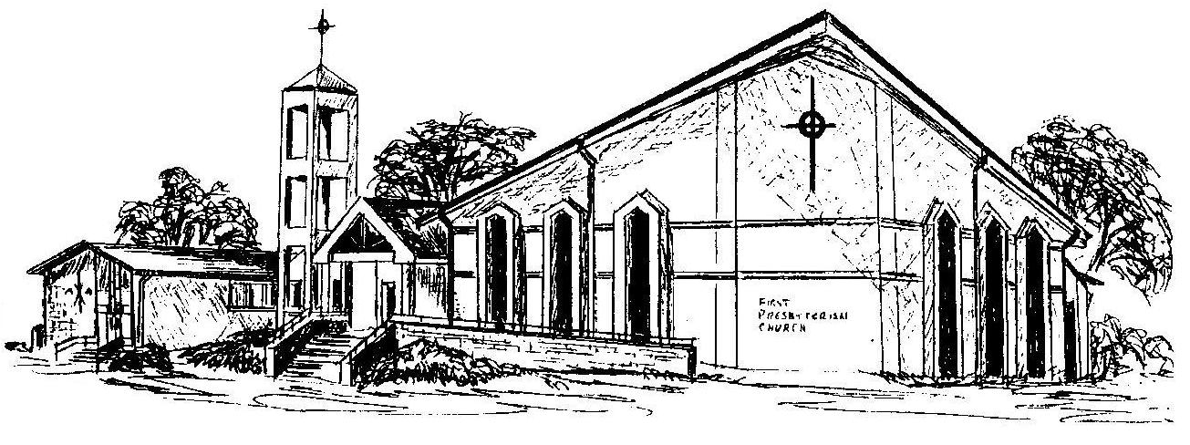

First Presbyterian Church
In the heart of Gardner since 1866 ~ Serving from the heart of God

Welcome - Thank you for joining us for worship today. Please fill out a visitor information card found in the pew racks and place those in the offering plate so that we may follow up with you in the future. Your presence with us today has been a blessing to us, we hope that you have felt the presence of God and the welcome of this congregation.

