Welcome & Announcements, Friendship Information, & Sharing Christ’s Peace
Prelude: “When I Survey the Wondrous Cross” Mason / arr. Fettke
Let us prepare our hearts and minds for worship.

Call to Worship
Leader: For forty years, the people of Israel wandered in the wilderness.
People: We sometimes wander today and often wonder where we are being called.
Leader: For forty days, Jesus listened in the desert and wrestled with the sin of humanity.
People: We sometimes listen and sometimes fail to hear wrestling with our own limitations.
Leader: For forty days and six Sundays of Lent, we intentionally turn toward God, seeking to follow Jesus Christ.
People: For all of our days and all of our years, God welcomes and guides us, comforts and calls us. As this Lenten season continues, let us worship God.

*Opening Hymn “How Great Thou Art” Red Hymnal, #4

* Prayer of Confession (Unison)
God of Salvation, we surround ourselves with crosses and yet we do not often pause to grasp the depth of meaning in the cross. The separation caused by sin was bridged by Jesus’ actions. Yet barriers remain. Brokenness continues. Sin captures us again. Forgive us and heal us. Remind us of your cross and of your grace in Jesus Christ our Savior. Amen.

*Silent Confession

*Assurance of Pardon

*Gloria Patri (Glory Be to the Father…) Red Hymnal, #623

Scripture “Deuteronomy 6: 1-9” (page 284)
“Luke 9:18-27” (page 1609)
Leader: The word of the Lord.
People: Thanks be to God.

Children's Time
Please join in singing one verse of Jesus Loves Me as the children come forward.

Special Music “Open My Eyes” Gilbert Martin
Sermon: “The Way of the Cross: Discipleship and Devotion” Rev. Kimby Young

*Profession of Faith The Apostle's Creed Red Hymnal, inside back cover

*Hymn “Where He Leads Me” Red Hymnal, #373 verses 1 & 3

Pastoral Prayer & Lord’s Prayer: Margaret Davidson, Brenda Polsen, JoAn Jones, Pam Wilson, Vespersia Pennington, Naomi Salser, Ann Ferguson, Miah, Nancy Jenkins, Glenn Schulz, Scott & Cynthia Miller, Arlene Thompson, Keith W. Smith, Roland Jack, Rob Kuhauz, Denny Harris, Delphine Brawner, Kyle Campbell, Minnie Ashmore, Clay Simmons, Jano Smoor, John Kuhns, Richard Hatfield, Mark Freund, Jackson Tijerina, The DeWald Family
Offertory: “When I Survey the Wondrous Cross” Appalachian Folk Melody / arr. James

*Doxology Red Hymnal, #625

*Prayer of Dedication

*Closing Hymn: “I Am Thine, O Lord” Red Hymnal, #358

*Benediction

Postlude: “Jesus, I My Cross Have Taken” Mozart / arr. Main

*Those who are comfortably able will please stand

Kimby Young, Pastor; Kim Allen, Worship Assistant;
Guy Cauthon, Director of Chancel Choir; Chancel Choir;
Heather Rutler, Worship Transcription;
Robyn Forkner, Pianist; Todd Burd, Music Ministries; Alice Rollf, Organist

Ushers: March 2017
Corky & Joyce Scarlett; Larry Flakus
Mike & Tina Fraser; Lynn Moldrup

Sunday, March 12, Mission Pillar Meeting 11:15 AM
Sunday, March 12, Kimby’s Bible Study 4:30 PM
Monday, March 13, Session 6:30 PM
Tuesday, March 14, Men’s Breakfast at Perkins 7:00 AM
Wednesday, March 15, Bells 6:00 PM, Choir 7:00 PM
Thursday, March 16, Women’s Bible Study 7:00 PM
Saturday, March 18, Boy Scout Merits Badges 8:30 AM
Sunday, March 19, Discipleship Pillar Meeting 11:15 AM

Men’s Breakfast at Perkins
The First Presbyterian Men’s Breakfast will be held at 7:00 AM on Tuesday, March 14, at Perkins Restaurant. A tax consultant will discuss tax preparation. We hope you can come.

Sunday Evening Bible Study Class – 4:30 - 6:00 pm. Pastor Kimby is leading a short introduction to the New Testament. Guests and non-members are welcome.

Ladies Bible Study
Come join the new women’s Bible Study on Thursday, 7:00 PM. The study is based on the book by Liz Curtis Higgs “The Women of Easter”. Hope to see you at the study!

PW Meeting on Monday, March 20 at 7:00 PM.

Sermon Series for Lent: “The Way of the Cross”
March 19 – Repentance and Forgiveness – Matthew 18:15-35
March 26 – Suffering and Compassion – Matthew 27:27-31; Romans 5:1-11
April 2 – Obedience and Commitment – Matthew 16:13-28
April 9 – Palm and Passion – Matthew 21:1-11
April 16 – EASTER – Resurrection - John 20:1-18

Holy Week:
Sunday, April 9, Palm Sunday Worship Service 9:00 AM
Thursday, April 13, Maundy Thursday Service 7:00 PM
Friday, April 14, Good Friday Service 7:00 PM
Sunday, April 16, Easter Sunday Worship Service 9:00 AM

Sunday, March 12, 2017
Second Sunday in Lent
9:00 AM

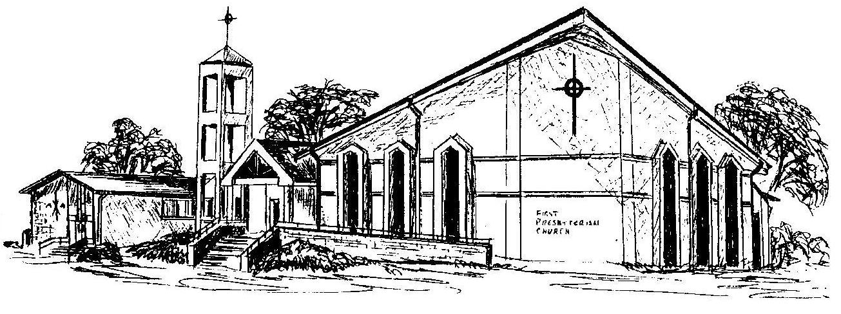

First Presbyterian Church
In the heart of Gardner since 1866 ~ Serving from the heart of God

Welcome - Thank you for joining us for worship today. Please fill out a visitor information card found in the pew racks and place those in the offering plate so that we may follow up with you in the future. Your presence with us today has been a blessing to us, we hope that you have felt the presence of God and the welcome of this congregation.

