Welcome & Announcements, Friendship Information, & Sharing Christ’s Peace
Prelude: “Near the Cross” Doane / arr. S. Poole
Let us prepare our hearts and minds for worship.

Call to Worship
Leader: People of God – men and women, boys and girls – come in praise and celebration.
People: We come, rejoicing in the gifts of God, given to each of us and shared by all of us.
Leader: Come, children of God, receive the bounty and blessing of God this day.
People: Word and song, bread and cup, community and care – we celebrate God’s gifts.

*Opening Hymn “Called as Partners in Christ’s Service” Blue Hymnal, #343

*Prayer of Confession (Unison)
Gracious Creator, you have made each of us unique and beautiful, gifted in varying ways. Yet sometimes we fail to value each other in all our diversity and particularity. Sometimes we limit the roles and choices of others. Sometimes we hold ourselves back from full potential. Sometimes we deny your calling. Forgive us. Empower us to see one another as you see us. Inspire us to encourage one another. Help us to create communities where all may serve you faithfully. By your grace and to your glory. Amen.

*Silent Reflection

*Assurance of Pardon

*Gloria Patri (Glory Be to the Father…) Blue Hymnal, #579

Scripture “Judges 4:4-7” (page 377)
“Romans 16:1-7” (page 1768)
Leader: The word of the Lord.
People: Thanks be to God.

Children's Time
Please join in singing one verse of Jesus Loves Me as the children come forward.

Special Music: "Many Gifts, One Spirit”

Sermon "Teamwork" Rev. Dr. Barbara Sherer

*Profession of Faith The Apostle's Creed Blue Hymnal, top page 14

*Hymn “We All Are One in Mission” Blue Hymnal, #435

Offertory: “Make Us One” C. Cymbala

*Doxology Blue Hymnal, #592

*Prayer of Dedication & Pastoral Prayer Please Pray for Family of Bernita Wetherington, JoAn Jones, Pam Wilson, Family of Marylee McElfresh, Vespersia Pennington, Family of Bob Johnson, Naomi Salser, Ann Ferguson, Miah, Nancy Jenkins, Glenn Schulz, Scott & Cynthia Miller, Arlene Thompson, Keith W. Smith, Roland Jack, Rob Kuhauz, Denny Harris, Delphine Brawner, Kyle Campbell, Minnie Ashmore, Clay Simmons, Jano Smoor, John Kuhns, Richard Hatfield, Mark Freund, Jackson Tijerina, The DeWald Family
Communion & Celebration
Invitation
Great Thanksgiving
The Lord’s Prayer
Breaking of Bread
Communion of the People
Prayer of Thanksgiving

*Closing Hymn: “I Come With Joy” Blue Hymnal, #507

*Benediction

Postlude: “Tell the World” M. Skidmore
*Those who are comfortably able will please stand

Rev. Dr. Barbara Sherer, Pastor; Kimby Young, Pastor; Chancel Choir;
Connie Thomas, Worship Assistant; Robyn Forkner, Pianist;
Todd Burd, Music Ministries; Alice Rollf, Organist;
Guy Cauthon, Director of Chancel Choir; Heather Rutler, Worship Transcription

Flowers are given today to the Glory of God in Honor of Mary Barbara Allen’s birthday, given by members of her family.
Ushers March 2017
Corky & Joyce Scarlett; Larry Flakus; Mike & Tina Fraser; Lynn Moldrup

Congregational Life Pillar Meeting, March 6 at 7:00 PM
Bell Choir 6:00 – 7:00 PM; Chancel Choir 7:00 – 8:00 PM
Women’s Bible Study, March 9, 7:00 PM
Mission Pillar Meeting, March 12, 11:15 AM

Celebration of Gifts of Women today - March 5 - We welcome guest preacher Rev. Dr. Barbara Sherer who is an Army Colonel and the Senior Chaplain at Ft. Leavenworth, KS. She has served on active duty since 1992 in a variety of appointments including Somalia, Korea, Germany, Kuwait and Iraq. She has served as the Senior Chaplain at the United States Military Academy at West Point, which included pastor for the Academy’s "Cadet Chapel." She has been Deputy Commandant of the United States Army Chaplain Center and School.

Sunday Evening Bible Study Class – 4:30 - 6:00 pm. Pastor Kimby will lead a short introduction to the New Testament. Guests and non-members are welcome.

Ladies Bible Study
Come join the new women’s Bible Study on Thursday, 7:00 PM. The study is based on the book by Liz Curtis Higgs “The Women of Easter”. Hope to see you at the study!

Daylight Savings Time Begins, Sunday, March 12. Remember to spring forward one hour.

Men’s Breakfast at Perkins
Breakfast will be held at 7:00 AM on Tuesday, March 14, at Perkins Restaurant. The topic a tax consultant will discuss tax preparation. We hope you can make it.

Sermon Series for Lent: “The Way of the Cross”
March 12 – Discipleship and Devotion – Luke 9:18-27
March 19 – Repentance and Forgiveness – Matthew 18:15-35
March 26 – Suffering and Compassion – Matthew 27:27-31; Romans 5:1-11
April 2 – Obedience and Commitment – Matthew 16:13-28
April 9 – Palm and Passion – Matthew 21:1-11
April 16 – EASTER – Resurrection - John 20:1-18

Sunday
March 5, 2017
Gifts of Women Sunday
9:00 AM
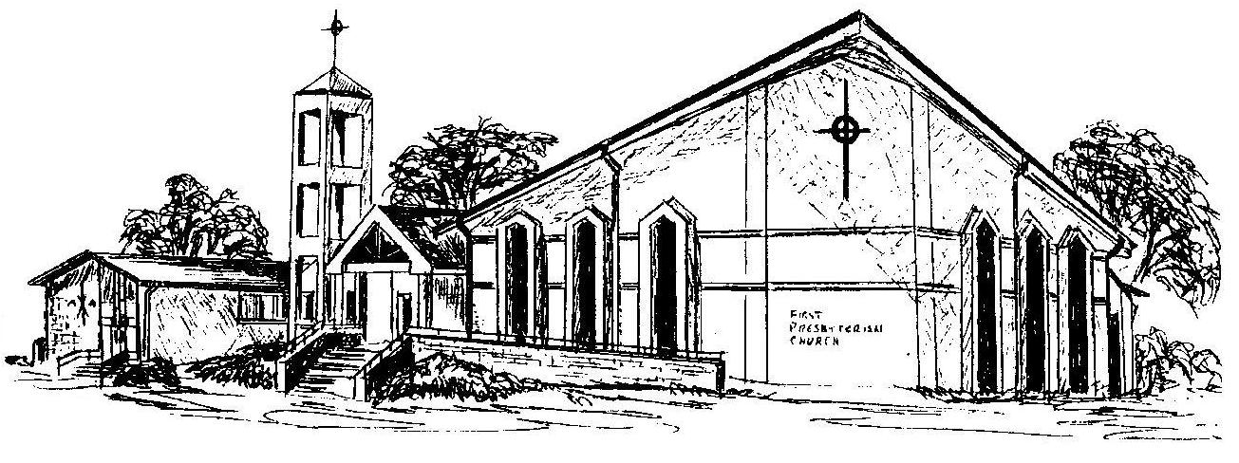

First Presbyterian Church
In the heart of Gardner since 1866 ~ Serving from the heart of God

Welcome - Thank you for joining us for worship today. Please fill out a visitor information card found in the pew racks and place those in the offering plate so that we may follow up with you in the future. Your presence with us today has been a blessing to us, we hope that you have felt the presence of God and the welcome of this congregation.

