Welcome & Announcements, Friendship Information, & Sharing Christ’s Peace
Bells: “All Hail the Power of Jesus' Name”
Let us prepare our hearts and minds for worship.

Call to Worship
Leader: God who waits on the mountain of holiness -
People: Our Awesome God calls us.
Leader: God who shines in cloud and fire -
People: Our Brilliant God stirs us.
Leader: Arise, People of God, respond to God’s movement among us.
People: With confidence in God, we gather to worship and serve.

*Opening Hymn “Holy, Holy, Holy” Red Hymnal, #262

* Prayer of Confession (Unison)
God of transfiguration and transformation, we seek an experience of your presence. We seek revelation and truth, mystery and power, wisdom and purpose. Stay with us always, as we worship here, and as we go out in the world to share the challenge of living our faith. Turn our fear to courage and our confusion to confidence. Shine in our hearts and in our lives, as your glory shines in the face of Christ. Amen.

*Silent Confession

*Assurance of Pardon

*Gloria Patri (Glory Be to the Father…) Red Hymnal, #623

Scripture Exodus 24:15-18 (page 125)
2 Kings 2:9-12 (page 571)
Matthew 17:1-9 (page 1524)
Leader: The word of the Lord.
People: Thanks be to God.

Children's Time
Please join in singing one verse of Jesus Loves Me as the children come forward.

Special Music “Higher Ground”

Sermon: “Arise and Be Not Afraid” Rev. Kimby Young
*Profession of Faith The Apostle's Creed Red Hymnal, inside back cover

*Hymn “Immortal Invisible” Red Hymnal, #25

Pastoral Prayer & Lord’s Prayer: Pam Wilson, Vespersia Pennington, Family of Bob Johnson, Marylee McElfresh, Family of Jason Bohn, Brad Brown and family, Ann Ferguson, Miah, Nancy Jenkins, Glenn Schulz, Scott & Cynthia Miller, Arlene Thompson, Keith W. Smith, Roland Jack, Rob Kuhauz, Denny Harris, Delphine Brawner, Carla Betik, Kyle Campbell, Minnie Ashmore, Mark Howard, Mr. & Mrs. Brad Hadel, Clay Simmons, Jano Smoor, John Kuhns, Richard Hatfield, Mark Freund, Jackson Tijerina, The DeWald Family, Austin W. Pennington

Offertory:

*Doxology Red Hymnal, #625

*Prayer of Dedication

*Closing Hymn: “Joyful, Joyful, We Adore Thee” Red Hymnal, #1

*Benediction

Postlude:

*Those who are comfortably able will please stand

Kimby Young, Pastor; Lynn Moldrup, Worship Assistant;
Becky Kunard, Pianist; Guy Cauthon, Director of Chancel Choir; Chancel Choir;
Heather Rutler, Worship Transcription
Robyn McGuire, Director of Chancel Bells; Chancel Bells
Robyn Forkner, Pianist; Todd Burd, Music Ministries; Alice Rollf, Organist

Ushers:
Jerry & Paula Waters; Phil Lenahan; Andy & Lois Barber; John Forkner

Deacons:
Janet Flakus, Carl & Sharon Frahme, Mike & Tina Fraser, Judy Lenahan, Sandy Nellor, Debbie Pickell, Julie Sutton, Marilyn Huffman, Denise Bockus, Jessica Brunker,
Vern Knabe, Linda Wolf, Joyce Pattrick
Sunday, February 26: Donuts with Deacons after Worship Service
Sunday, February 26: Celebration of Life Service Tom Rendleman, 2:00 PM
Sunday, February 26: Kimby’s Evening Bible Study 4:30 PM
Wednesday, March 1: Women’s Group 10:00 AM
Wednesday, March 1: Ash Wednesday 7:00 PM
Thursday, March 2: Women’s Bible Study 7:00 PM
Friday, March 3: World Day of Prayer 1:00 PM

Sunday Evening Bible Study Class – 4:30 - 6:00 pm. Pastor Kimby will lead a short introduction to the New Testament. Guests and non-members are welcome.

Donuts with Deacons will be today after worship stop by to meet your 2017 Deacon, in the narthex.

Women’s Group meets on Wednesday, March 1 at 10:00 AM. They have Devotions and Fellowship. All women are welcome!

Ash Wednesday is Wednesday, March 1. Plan to join us for Worship & imposition of ashes at 7:00 PM in the sanctuary.

World Day of Prayer will be held in the sanctuary on Friday, March 3, 2017, at 1:00 PM.

LADIES BIBLE STUDY
Come join the new women’s Bible Study on Thursday, 7:00 PM. The study is based on the book by Liz Curtis Higgs “The Women of Easter”. Hope to see you at the study!

Celebration of Gifts of Women Sunday - March 5 - We will welcome guest preacher Rev. Dr. Barbara Sherer who is an Army Colonel and the Senior Chaplain at Ft. Leavenworth, KS. She has served on active duty since 1992 in a variety of appointments including Somalia, Korea, Germany, Kuwait and Iraq. She has served as the Senior Chaplain at the United States Military Academy at West Point, which included pastor for the Academy’s "Cadet Chapel." She has been Deputy Commandant of the United States Army Chaplain Center and School.

DVDs (videos) & CDs (audio/music only) of Cooper McGuire’s Jan. 8th Concert are now available in the church office. So, if you missed the concert (or want to hear it again), please stop in. Donations toward costs are appreciated, but not necessary.

Sunday, February 26, 2017
9:00 AM

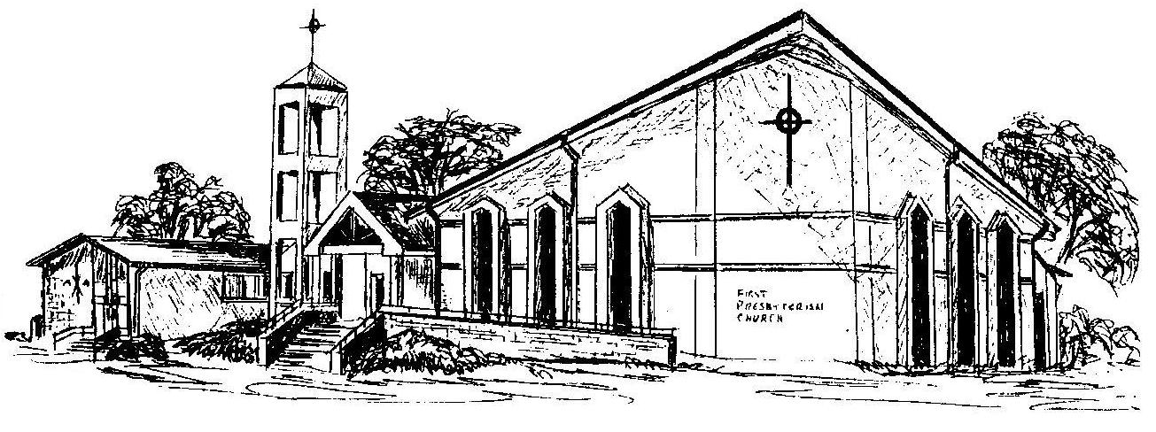

First Presbyterian Church
In the heart of Gardner since 1866 ~ Serving from the heart of God

Welcome - Thank you for joining us for worship today. Please fill out a visitor information card found in the pew racks and place those in the offering plate so that we may follow up with you in the future. Your presence with us today has been a blessing to us, we hope that you have felt the presence of God and the welcome of this congregation.

