Welcome & Announcements, Friendship Information, & Sharing Christ’s Peace
Prelude: “Jesus, Your Name” Chapman
“Jesus, Name Above All Names” Cain
Let us prepare our hearts and minds for worship.

Call to Worship
Leader: Blessed are they who seek God, whose hearts are set on God’s way of love.
People: We are blessed to be God’s beloved children, surrounded by grace and goodness.
Leader: Blessed are they who follow Jesus Christ, who share God’s gifts freely and fully.
People: We are blessed to serve as children of God, reaching out to others with the love of Christ.

*Opening Hymn “Morning Has Broken” Red Hymnal, #60

* Prayer of Confession (Unison)
Welcoming God of Grace, you invite all of us into your presence, now and for eternity. You teach us the way of love and life. You show us how to serve. You ask us to follow Jesus. We are slow to learn. We are reluctant to shine your light. We are cautious in sharing your gifts. Forgive us. Teach us again. Help us to seek you and to serve you, in the name of Jesus Christ. Amen.

*Silent Confession

*Assurance of Pardon

*Gloria Patri (Glory Be to the Father…) Red Hymnal, #623

Scripture Matthew 5:1-10; 5:13-16; 5:43-48; 6:33-34; 7:7-8; 7:24-29 (page 1501)
Leader: The word of the Lord.
People: Thanks be to God.

Children's Time
Please join in singing one verse of Jesus Loves Me as the children come forward.

Special Music “Change My Heart, O God”

Sermon: “Teaching a Way of Life” Rev. Kimby Young

*Profession of Faith The Apostle's Creed Red Hymnal, inside back cover

*Hymn “How Firm a Foundation” Red Hymnal, #275

Pastoral Prayer & Lord’s Prayer: Bob Johnson, Ann Ferguson, Miah, Nancy Jenkins, Glenn Schulz, Scott & Cynthia Miller, Arlene Thompson, Keith W. Smith, Roland Jack, Rob Kuhauz, Denny Harris, Delphine Brawner, Carla Betik, Kyle Campbell, Minnie Ashmore, Mark Howard, Mr. & Mrs. Brad Hadel, Clay Simmons, Jano Smoor, John Kuhns, Richard Hatfield, Mark Freund, Jackson Tijerina, The DeWald Family, Austin W. Pennington

Offertory: “Seek Ye First” Lafferty

*Doxology Red Hymnal, # 625

*Prayer of Dedication

*Closing Hymn: “Trust and Obey” Red Hymnal, #349

*Benediction

Postlude: “All Hail the Power of Jesus' Name” Holden

*Those who are comfortably able will please stand

Kimby Young, Pastor; Karl Allen, Worship Assistants;
Robyn Forkner, Pianist; Todd Burd, Music Ministries; Alice Rollf, Organist;
Guy Cauthon, Director; Chancel Choir; Heather Rutler, Worship Transcription

Ushers:
Jerry & Paula Waters; Phil Lenahan
Andy & Lois Barber; John Forkner

Sunday, February 19: Discipleship Pillar Meeting 11:15 AM
Sunday, February 19: Kimby’s Evening Bible Study 4:30 PM
Monday, February 20: PW Meeting 7:00 PM
Wednesday, February 22: Bell Choir 6-7 PM; Choir 7-8 PM
Thursday, February 23: Women’s Bible Study 7:00 PM
Saturday, February 25: Presbytery Grace Covenant, Overland Park
Sunday, February 26: Donuts with Deacons after Worship Service
Sunday, February 26: Memorial Service Tom Rendleman 2:00 – 4:00 PM
Sunday, February 26: Kimby’s Evening Bible Study 4:30 PM

Photo Directory Pictures will be taken this week. Monday – Thursday. A few spots are open, several tomorrow. The company Remember Church Directories is now doing all scheduling. If you need to make or change an appointment, call 866-557-2253.

Sunday Evening Bible Study Class – 4:30-6:00 pm – 8 weeks – Starting February 19 and ending on Palm Sunday - Pastor Kimby will lead a short introduction to the New Testament. Guests and non-members are welcome.

Donuts with Deacons will be next Sunday, February 26. After worship stop by to meet your 2017 Deacon, in the narthex.

Ash Wednesday is Wednesday, March 1. Plan to join us for Worship & imposition of ashes at 7:00 PM in the sanctuary.

World Day of Prayer will be held in the sanctuary on Friday, March 3, 2017, at 1:00 PM.

Celebration of Gifts of Women Sunday - March 5 - We will welcome guest preacher Rev. Dr. Barbara Sherer who is an Army Colonel and the Senior Chaplain at Ft. Leavenworth, KS. She has served on active duty since 1992 in a variety of appointments including Somalia, Korea, Germany, Kuwait and Iraq. She has served as the Senior Chaplain at the United States Military Academy at West Point, which included pastor for the Academy’s "Cadet Chapel." She has been Deputy Commandant of the United States Army Chaplain Center and School.

DVDs (videos) & CDs (audio/music only) of Cooper McGuire’s Jan. 8th Concert are now available in the church office. So, if you missed the concert (or want to hear it again), please stop in. Donations toward costs are appreciated, but not necessary.

Sunday, February 19, 2017
9:00 AM

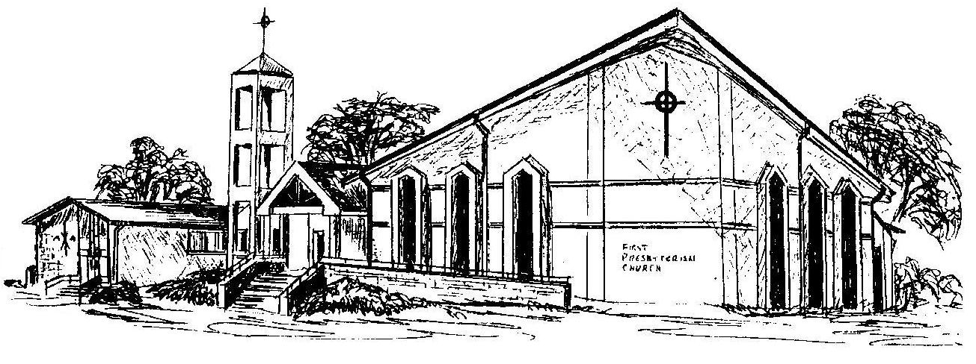

First Presbyterian Church
In the heart of Gardner since 1866 ~ Serving from the heart of God

Welcome - Thank you for joining us for worship today. Please fill out a visitor information card found in the pew racks and place those in the offering plate so that we may follow up with you in the future. Your presence with us today has been a blessing to us, we hope that you have felt the presence of God and the welcome of this congregation.

