Welcome & Announcements, Friendship Information, & Sharing Christ’s Peace

Prelude: “I Sing the Mighty Power of God” Am. Folk Hymn / arr. Price
Let us prepare our hearts and minds for worship.

Call to Worship
Leader: Come, you who seek to know God. Come, follow Jesus of Nazareth!
People: Come, you who are hungry and thirsty. Come, be filled by the Spirit of God!
Leader: Come, you who are strong and gifted. Come, serve the Lord of Lords!
People: Come, you who are broken and beaten. Come, receive the gifts of God’s grace!

*Opening Hymn “Dear Lord and Father” Red Hymnal, #427

* Prayer of Confession (Unison)
God of goodness, we hear your call to follow, and we want to respond. But sometimes we are afraid. Sometimes we are distracted. Sometimes we are confused or conflicted. And sometimes we willfully choose our own way. Forgive us our sins and failures. Call us again. Renew us by your Spirit. Empower us to be your disciples, following Jesus Christ in the way of love. Amen.

*Silent Confession

*Assurance of Pardon

*Gloria Patri (Glory Be to the Father…) Red Hymnal, #623

Scripture Matthew 4:18-21 (page 1500)
Matthew 9:9-13 (page 1509)
Leader: The word of the Lord.
People: Thanks be to God.

Children's Time
Please join in singing one verse of Jesus Loves Me as the children come forward.

Special Music “Take My Life”

Sermon: “Come, Follow Me” Rev. Kimby Young

*Profession of Faith The Apostle's Creed Red Hymnal, inside back cover

*Hymn “Jesus Calls Us” Red Hymnal, #375

Pastoral Prayer & Lord’s Prayer: Ann Ferguson, Miah, Nancy Jenkins, Glenn Schulz, Scott & Cynthia Miller, Arlene Thompson, Keith W. Smith, Roland Jack, Rob Kuhauz, Denny Harris, Delphine Brawner, Carla Betik, Kyle Campbell, Minnie Ashmore, Mark Howard, Mr. & Mrs. Brad Hadel, Clay Simmons, Jano Smoor, John Kuhns, Richard Hatfield, Mark Freund, Jackson Tijerina, The DeWald Family, Austin W. Pennington

Offertory: “Following Thee” Frick

*Doxology Red Hymnal, # 625

*Prayer of Dedication

*Closing Hymn: “O Jesus I Have Promised” Red Hymnal, #369

*Benediction

Postlude: “We Are Called” Haas

ANNUAL CONGREGATIONAL MEETING has been called by Session today, at the end of regular worship service.

CONGREGATIONAL BRUNCH Join us in Fellowship Hall. Everyone is welcome.

USHER TRAINING immediately following the Congregational meeting.

*Those who are comfortably able will please stand

Kimby Young, Pastor; Jo Lynn Clark, Worship Assistants;
Robyn Forkner, Pianist; Todd Burd, Music Ministries; Alice Rollf, Organist;
Guy Cauthon, Director; Chancel Choir; Heather Rutler, Worship Transcription

Ushers:
Jerry & Paula Waters; Phil Lenahan
Andy & Lois Barber; John Forkner

Sunday, February 12: No Sunday School today
Sunday, February 12: Mission Pillar Meeting 11:15 AM
Monday, February 13: Session and Deacons 6:30 PM
Tuesday, February 14: Men’s Breakfast 7:00 AM Perkins
Wednesday, February 15: Bell Choir 6-7 PM; Choir 7-8 PM
Friday, February 17: World Day of Prayer Meeting Planning 1:30 PM

LADIES BIBLE STUDY
We will be starting a new study! The study will consist of 6 weeks, beginning February 23.

Men’s Breakfast at Perkins
Breakfast will be held at 7:00 AM on Tuesday, February 14, at Perkins Restaurant. The topic of “Mother Nature’s Materials” will be presented by Carl Frahme. At this meeting the women are invited.

Sunday Evening Bible Study Class – 4:30-6:00 pm – 8 weeks – Starting February 19 and ending on Palm Sunday - Pastor Kimby will lead a short introduction to the New Testament. Guests and non-members are welcome.

Photo Directory Sign Ups – New day added Professional pictures will be taken on February 20, 21, 22 and 23. Please sign up in the narthex today. This is the last day to sign up at church. Future reservations are only thru the directory company.

Donuts with Deacons will be Sunday, February 26. After worship stop by to meet your 2017 Deacon, in the narthex.

Ash Wednesday is Wednesday, March 1. Plan to join us for Worship & imposition of ashes at 7:00 PM in the sanctuary.

World Day of Prayer
World Day of Prayer will be held in the sanctuary on Friday, March 3, 2017, at 1:00 PM.

DVDs (videos) & CDs (audio/music only) of Cooper McGuire’s Jan. 8th Concert are now available in the church office. So, if you missed the concert (or want to hear it again), please stop in. Donations toward costs are appreciated, but not necessary.

Sunday, February 12, 2017
Congregational Meeting
9:00 AM

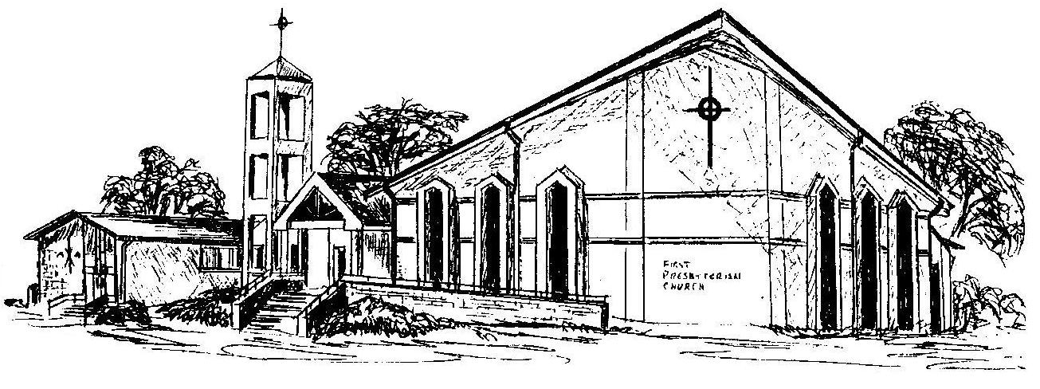

First Presbyterian Church
In the heart of Gardner since 1866 ~ Serving from the heart of God

Welcome - Thank you for joining us for worship today. Please fill out a visitor information card found in the pew racks and place those in the offering plate so that we may follow up with you in the future. Your presence with us today has been a blessing to us, we hope that you have felt the presence of God and the welcome of this congregation.

